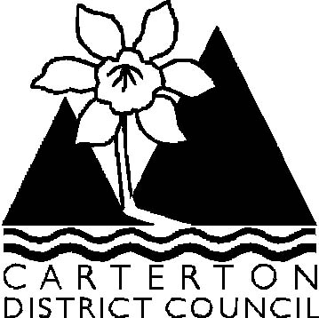

Ordinary Council Meeting

Agenda

Wednesday 27 August 2008 at 9.30 am
in the
Council Chambers, Holloway Street, Carterton

Agenda

- Apologies

- Leave of Absence

- Conflict of Interest Declaration

- Notification of General Business/Late Items

- Public Forum

6. Hear Submissions – Proposed Change to Road Name

7. Confirmation of Minutes of the Ordinary Meeting dated 23 July 2008

Officer Recommendation

That the minutes of the Ordinary Meeting dated 23 July 2008 as circulated be be taken as read and adopted as a Council record.

8. Consideration of Minutes from Committees

8.1 Confirmation of Minutes Rural Travel Fund Allocation Committee dated
23 July 2008

Officer Recommendation

That the minutes of the Rural Travel Fund Allocation Committee dated 23 July 2008 as circulated be taken as read and adopted as a Council record.

9. Officer Reports & Correspondence Received

9.1 Chief Executive’s Report
9.2 Roading Report
9.3 Operations - Special Projects Report
9.4 Operations – General Report
9.5 Community & Recreation Services Report
9.6 Library Monthly Report
9.7 Planning & Regulatory Monthly Report
9.8 Financial Report June 2008
9.9 Artificial Grass in Practice Nets
9.10 Terms of Reference – Wairarapa Library Service Committee
9.11 Results of Survey of Residents
9.12 Wairarapa Chamber of Commerce – Update on Current Activities

10. Elected Member Reports to Council

10.1 Mayoral Diary July/August 2008
10.2 Does Carterton Need a New Skate Park?
10.3 Representation on Outside Bodies

11. General Business/Late Items

12. Public Excluded

Officer Recommendation

That the public be excluded from the following proceedings of the meeting. The general subject matter, reasons and specific grounds under Section 48(1) Local Government Official Information & Meetings Act 1987 are as follows:

Subject Matter

Confirmation of Public Excluded Portion of July 2008 Ordinary Meeting

Reasons

Commercial Sensitivity
Confidentially of Council’s vote for the positions

Grounds Under Section 48(1)

Section 7(2)(b)(ii) and (i)
Section 7(a)

Colin Wright
Chief Executive Officer

