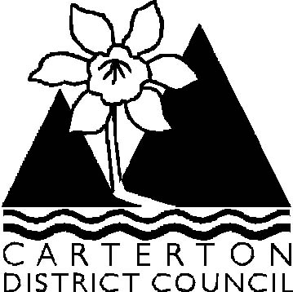

Ordinary Council Meeting

Agenda

Wednesday 26 August 2009 at 9.30 am
in the
Council Chambers, Holloway Street, Carterton

Agenda

- Apologies

- Leave of Absence

- Conflict of Interest Declaration

- Notification of General Business/Late Items

- Public Forum

6. Confirmation of the Minutes of the Ordinary Meeting dated 22 July 2009

Officer Recommendation

That the minutes of the Ordinary Meeting dated 22 July 2009 as circulated be taken
as read and adopted as a Council record.

7. Confirmation of Minutes of Committee Meetings

7.1 Wairarapa Library Service Committee dated 16 July 2009

Officer Recommendation

That the minutes of the Wairarapa Library Services Committee dated 16 July 2009 as
Circulated be taken as read and adopted as a Council record.

8. Officer Reports & Correspondence Received

8.1 Chief Executive’s Report
8.2 Roading Report
8.3 Operations - Special Projects Report – S Clark unavailable to attend meeting.
8.4 Operations – General Report
8.5 Library Report
8.6 Community Facilities Report
8.7 Planning & Regulatory Report
8.8 Financial Report to 30 June 2009
8.9 Petition from Carterton District Residents & Ratepayers Association
8.10 Amendment to Parking Bylaw
8.11 Delegation of Authority to Planning Commissioners
8.12 Destination Wairarapa – Quarterly Report 1 April – 30 June 2009
8.13 Trails Wairarapa – Request for Funding
8.14 Audit NZ – Audit of the LTCCP 2009-19
8.15 Hon Dr. Nick Smith – Resource Consent Processing Timeframes
8.16 Draft South Carterton Structure Plan for Adoption (To be Circulated)

9. Elected Member Reports to Council

9.1 Mayoral Diary July/August 2009 & Correspondence
9.2 Elected Members Reports on Outside Organisations & Portfolios

10. General Business/Late Items

Colin Wright
Chief Executive Officer

Note: At 12 noon, Citizenship Ceremony for 10 new New Zealanders and presentation to April Campbell, Charles Rooking Carter Achievers Award followed by light lunch.

