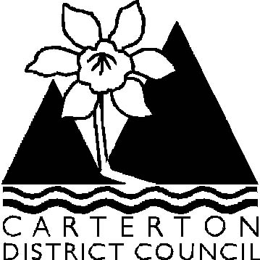

Ordinary Council Meeting

Agenda

Wednesday 17 December 2008 at 9.30 am
in the
Council Chambers, Holloway Street, Carterton

Agenda

- Apologies

- Leave of Absence

- Conflict of Interest Declaration

- Notification of General Business/Late Items

- Public Forum

No requests to attend the Public Forum have been received.

6. Confirmation of Minutes of the Ordinary Meeting dated 26 November 2008

Officer Recommendation

That the minutes of the Ordinary Meeting dated 26 November 2008 as circulated be taken as read and adopted as a Council record.

7. Confirmation of Minutes of Special Meeting of the Carterton District Council

Officer Recommendation

That the minutes of the Special Meeting of the Carterton District Council
dated 8 December 2008 as circulated be taken as read and adopted as a
Council record.

8. Confirmation of Minutes from Committees

8.1 Confirmation of Minutes of the Wairarapa Library Service Committee dated 19 November 2008

Officer Recommendation

That the minutes of the Wairarapa Library Service Committee dated 19 November 2008 as circulated be taken as read and adopted as a Council record.

9. Officer Reports & Correspondence Received

9.1 Chief Executive’s Report
9.2 Roading Report
9.3 Operations - Special Projects Report
9.4 Operations – General Report
9.5 Library Report
9.6 Community & Recreation Services Report
9.7 Planning & Regulatory Report
9.8 Policy on New Water Supply Connections in Rural Areas
9.9 Draft Waingawa Structure Plan
9.10 Pathways to Resilient Communities Event – Cr. Greathead
9.11 The Carterton District Residents & Ratepayers Assn – Request to Meet
Council
9.12 Wairarapa Summer Shakespeare Trust – Sponsorship – Summer Shakespeare 2009 – “Henry V”

10. Elected Member Reports to Council

10.1 Mayoral Diary November/December 2008
10.2 Reports from Elected Members on Outside Organisations

11. General Business/Late Items

12. Public Excluded

Officer Recommendation

That the public be excluded from the following proceedings of the meeting. The general subject matter, reasons and specific grounds under Section 48(1) Local Government Official Information & Meetings Act 1987 are as follows:

Subject Matter

12.1 Confirmation of Public Excluded Portion of Ordinary Meeting Minutes
dated 26 November 2008
12.2 Waiohine Crusher Land
12.3 Tenders - CDC Wastewater Reticulation Renewals 2008/09 (To Be Circulated)
12.4 Oral Update from CEO – Forestry
12.5 Oral Update from CEO – Servicing for Waingawa

Reasons

12.1 To enable Council to deliberate in private on the accuracy of the minutes
12.2 To enable the Council to consider and carry out commercial negotiations
12.3 To enable the Council to consider and carry out commercial negotiations.
12.4 To enable the Council to consider and carry out commercial negotiations.
12.5 To enable the Council to consider and carry out commercial negotiations.

Grounds Under Section 48(1)

12.1 Clause 48(1)(d)
12.2 Clause 7(i)
12.3 Clause 7(i)
12.4 Clause 7(i)
12.5 Clause 7(i)

Colin Wright
Chief Executive Officer

