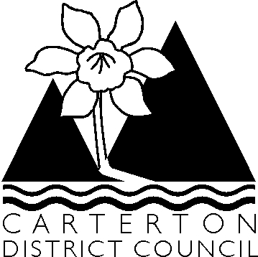

13 October 2009

Chairman & Members of the Water Race Committee

NOTICE IS HEREBY GIVEN that there will be a meeting of the Water Race Committee in the Council Chambers, Holloway Street, Carterton on Thursday 22 October 2009 at 2.30 pm.

Agenda

1. Apologies

2. Conflict of Interest Declarations

3. Minutes of Previous Meeting held on 9 February 2009

4. Water Race issues at Booth property

5. Greater Wellington Regional Council – Classification of water races and natural water courses (map to be tabled at meeting)

6. Correspondence from Gawith Burridge on behalf of C & J Engel

7 General Business

Colin Wright
Chief Executive

