Carterton District Council
Liquor Control Bylaw 2005
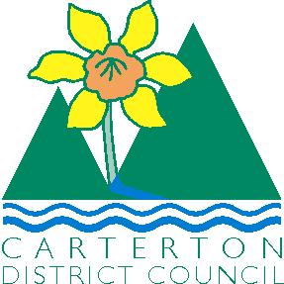

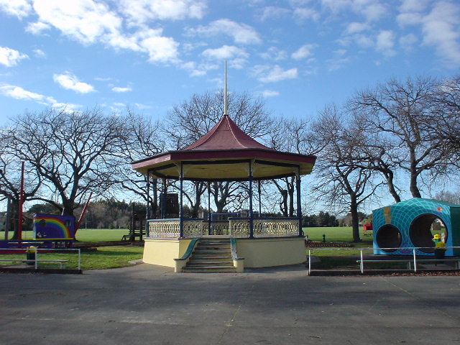

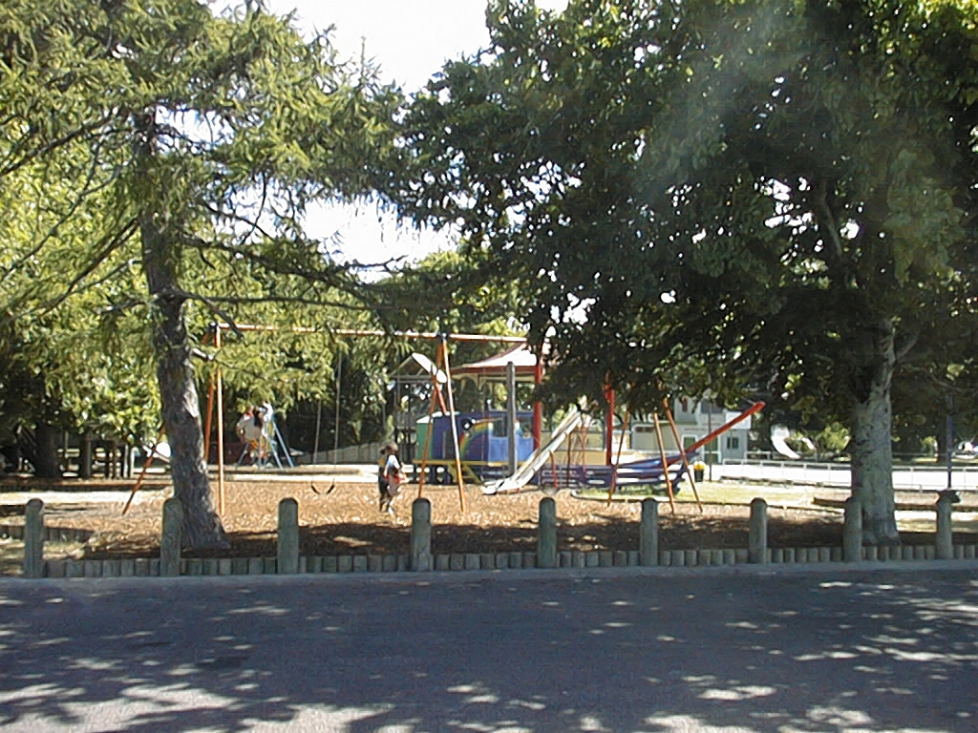

CARTERTON DISTRICT COUNCIL
LIQUOR CONTROL BYLAW 2005

Concerns relating to offences carried out by youth resulting from the consumption of
Alcohol have been conveyed to Council. Whilst the offences are significant, of major concern is the number of underage youth engaged in the consumption of alcohol within the Carrington Park area. Council after considering this matter has resolved to make a Liquor Control Bylaw prohibiting the consumption of alcohol within the Carrington Park Public area.

M.F. Hautler

Manager Planning & Regulatory

CARTERTON DISTRICT COUNCIL
LIQUOR CONTROL BYLAW 2005

The bylaw was made on 20th July 2005 and has been subject to a review on 18th September 2007 and adopted on 26th September 2007.

The bylaw with amendments shall be operative from 10th October 2007

Unless revoked or reviewed sooner, it shall be reviewed no later than 9th October 2017. If not reviewed by 9th October 2017, this bylaw terminates on 10th October 2019.

……………………………………………………
Mayor

………………………………………………….
Chief Executive Officer

10th October 2007
……………………………..
Date

CARTERTON DISTRICT COUNCIL LIQUOR CONTROL BYLAW 2005

1. Introduction
Pursuant to Sections 83, 145 and 147 Local Government Act 2002 the Carterton District Council makes this bylaw to The Control of Alcohol within the Carrington Park area.

2. Title
The title of this bylaw is the Carterton District Council Liquor Control Bylaw 2005.

3. Date the Control of Alcohol within the Carrington Park area comes into force

The Liquor Control described in the schedules comes into force on the date specified in the timetable.

4. Interpretation:

Carrington Park means that area as defined on the map contained within Schedule 1.

Liquor has the meaning given to it in the Sale of Liquor Act 1989

Public place
(a) Means a place—
(i) that is under the control of the territorial authority; and
(ii) that is open to, or being used by, the public, whether or not there is a charge for admission; and
(b) Includes—
(i) a road, whether or not the road is under the control of a territorial authority; and
(ii) Any part of a public place.

5. Control of Alcohol within the Carrington Park Area

CARTERTON DISTRICT COUNCIL LIQUOR CONTROL BYLAW 2005

That the Carterton District Council adopts the Liquor Control Bylaw 2005 as follows:

The bylaw gives effect under the Local Government Act 2002 to the resolution adopted by the Council under the special consultative procedure.

This part of the bylaw controls the consumption and possession of liquor in public places within the Carterton District Area. The bylaw includes a process to obtain prior Council written permission to authorise events that would otherwise breach the bylaw. The Council will erect signage to communicate the terms of the bylaw to the public.

The purpose of this bylaw is to address concerns relating to potential criminal offending and safety concerns that are linked to the possession or consumption of alcohol in public places. It is a proactive restriction to limit alcohol in public areas to increase perceptions of safety and to reduce offending

The bylaw is introduced pursuant to s147 of the Local Government Act 2002 - this section should be read together with this part of the bylaw as it contains relevant definitions and the situations when this bylaw control will not apply (particularly relating to the transportation of unopened liquor). Pursuant to s169 and s170 of the Local Government Act 2002, the Police can enforce this part of the bylaw. Further details on the statutory provisions are provided as a note at the end of this part of the bylaw.

CARTERTON DISTRICT COUNCIL LIQUOR CONTROL BY LAW 2005

1 Definitions
Carrington Park Prohibited Area means the general area of Carrington Park, and defined as Lot 1 DP 59134 Pt Sections 4, 5, Pt Lot 2 DP 1024 Carterton Township. The area is depicted in the attached schedule, but excluding:

a) Any area that is subject to a road encroachment issued by the Council;

b) Any licensed premises that occupies a paved area on legal road or Council land where permission to occupy has been granted by the Council.

2 Liquor Prohibition

2.1 Within the Carrington Park prohibited area, the consumption or possession of liquor in a public place (including while in a vehicle), is prohibited at all times

2.2 In addition to the prohibitions in Clause 2. above, the Council by resolution may order a prohibition of alcohol consumption or possession of liquor (including while in a vehicle) or prohibit vehicles in a public place within the Carterton District for certain specified times and/or within certain specified public places and areas within the Carterton District. The prohibition must be notified in the appropriate newspaper at least 14 days in advance of the special event. The Police powers of search under s170(2) of the Local Government Act 2002 applies to these events

3 Council Permission

3.1 Any person may apply in writing to the Council for prior written permission for any activity that would be in breach of any prohibition under this part of the bylaw.

  - A special licence may be issued under the Sale of Liquor Act 1989 in respect of any location or event, and subject to the terms of that special licence will include waivers and dispensation according to those terms.

4 Signage

4.1 The Council will erect signage within public places covered by this bylaw to provide information to the public on the terms of the bylaw. The size, location and terms of this signage shall be at Council's discretion. To avoid any doubt, the absence of signage in any public place does not authorise breach of this part of the bylaw. '

5 Offences

5.1 Everyone commits an offence who:

a) Consumes or possesses any liquor in a public place in breach of a prohibition under this part of the bylaw; and

b) Breaches, or permits a breach of, the terms of any Council permission granted pursuant to clause 3 of this bylaw.

Note: This bylaw is introduced pursuant to the specific empowering provisions of the Local Government Act 2002 that provide for bylaws for liquor control purposes. This bylaw does not repeat or paraphrase those statutory provisions, and accordingly those provisions should be read in conjunction with this bylaw. In particular, the following provisions are noted:

Section 147 empowers the Council to make this bylaw. It also defines 'liquor' and 'public place', In addition, s147(3) sets out a number of specific exemptions when the bylaw will not apply with respect to the transportation of unopened bottles or containers.

Section 169 provides the Police with powers of search and seizure, without warrant, to enforce the bylaw. The Police are responsible for enforcing the bylaw.

Section 170 sets out certain conditions imposed on the Police powers of search under s169.

This bylaw has no effect on any other Police powers of search, seizure and arrest or any other statutory offences.
Schedule 1 – Carrington Park Prohibited Area

Schedule 1 – Carrington Park - Prohibited Area
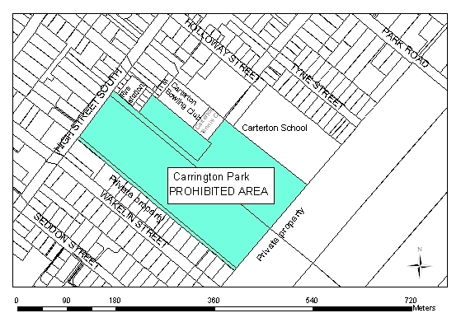 | - The area bounded by High Street South, being the west boundary, Carterton Fire Station, Carterton School, Carterton Bowling Club and Carterton Tennis Club on the north boundary and private properties on the east and south boundaries.
For the avoidance of doubt, this area includes the entire legal road reserve of the streets which form the boundary of the area specified above, up to the boundaries with adjoining properties and including the carriageway, berms and footpaths. Where the public place meets or is crossed by another road, the boundary of the public place shall be deemed to continue in an unbroken straight line across the other road.
The foregoing Draft Bylaw was made by resolution passed at the meeting of the Carterton District Council held on Wednesday 18th May 2005.

