Carterton District Council
Skateboard, Roller Skates, Scooters and Similar Devises Bylaw 2005

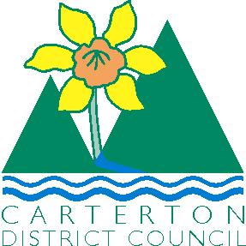


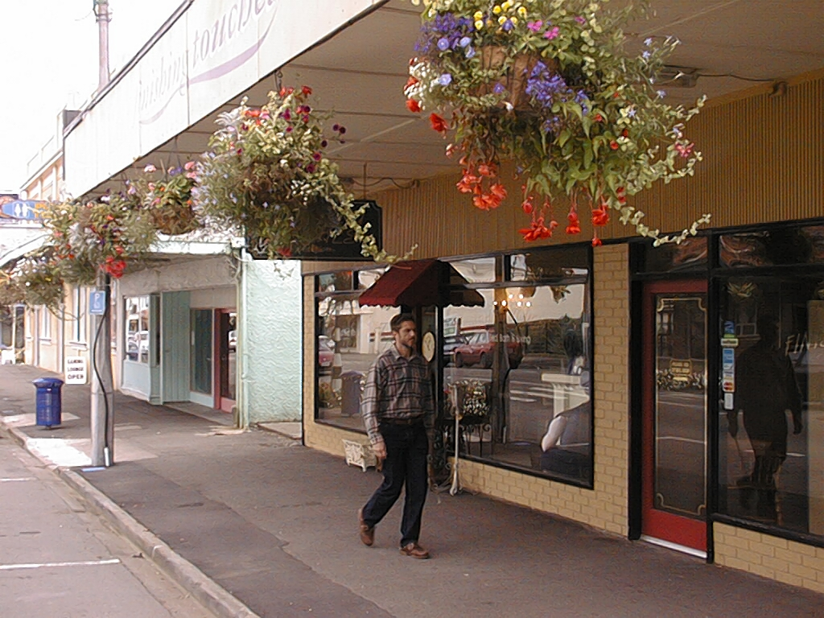


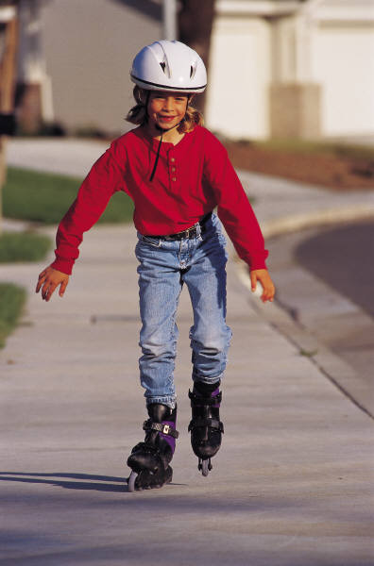
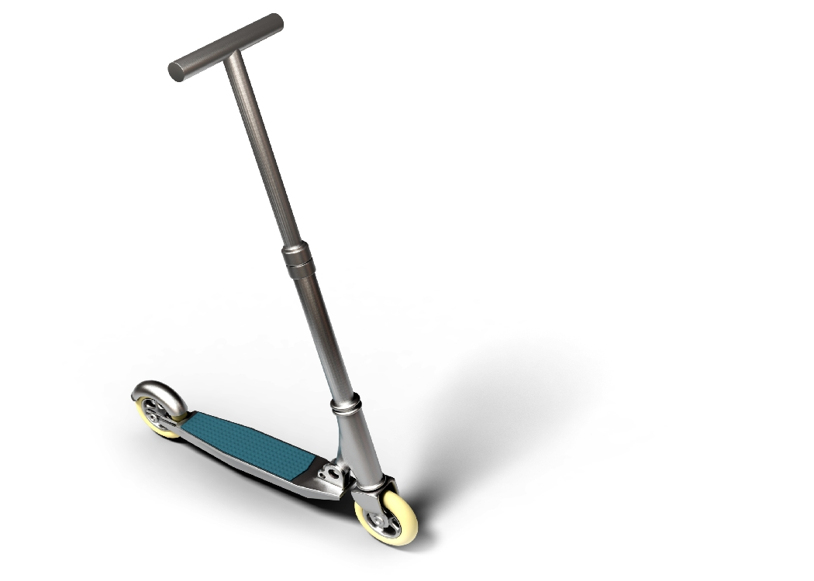

To Find Out More about Carterton District Council’s Skateboard, Roller Skates, Scooters and Similar Devises Bylaw 2005
PLEASE READ ON
CARTERTON DISTRICT COUNCIL SKATEBOARD, ROLLER SKATES, SCOOTERS AND SIMILAR DEVISES BYLAW 2005

Time Table for Council Making Skateboard, Roller Skates, Scooters and Similar Devises Bylaw 2005

Concerns relating to safety issues within the central business area and reserves have prompted Council to again give the matter further consideration. Council has therefore resolved to prohibit such activity in these areas as prohibited by the bylaw, to provide for pedestrian safety. Council has provided a substantial facility within the confines of Carrington Park to engage in Skateboard, Roller Skate and Scooter activities.

20th July 2005 Adoption of Draft Bylaw

23rd July 2005 Public Notification of Draft Bylaw and calling of Submissions

19th August 2005 Submissions Close

13th September 2005 Submissions heard and considered

21st September 2005 Bylaw Adopted

19th October 2005 Bylaw takes effect

M. F. Hautler

Manager Planning & Regulatory

Carterton District Council Skateboard, Roller Skates, Scooters and Similar Devises Bylaw 2005

1. Introduction:

Pursuant to Sections 83, 145 and of the Local Government Act 2002 Carterton District Council makes this bylaw to prohibit the use of Skateboards, Roller Skates, Scooters and similar devices within areas defined in Part 2 of the bylaw for the protection and safety of pedestrians.

2. Title:

The title of this bylaw is the Carterton District Council Skateboard, Roller Skates, Scooters and Similar Devises Bylaw 2005.

3. Date the Carterton District Council Skateboard, Roller Skates, Scooters and Similar Devises Bylaw 2005 comes into place:

This Bylaw comes into force on Wednesday 19th of October 2005.

CARTERTON DISTRICT COUNCIL SKATEBOARD, ROLLER SKATES, SCOOTERS AND SIMILAR DEVISES BYLAW 2005

The bylaw was made on 19th October 2005 and has been subject to a review on 18th September 2007 and adopted on 26th September 2007.

The bylaw with amendments shall be operative from 10th October 2007

Unless revoked or reviewed sooner, it shall be reviewed no later than 9th October 2017. If not reviewed by 9th October 2017, this bylaw terminates on 10th October 2019.

……………………………………………………
Mayor

………………………………………………….
Chief Executive Officer

10th October 2007
………………………………..
Date

CARTERTON DISTRICT SKATEBOARDS, ROLLER SKATES, SCOOTERS AND SIMILAR DEVICES BYLAW 2005.

- SHORT TITLE, COMMENCEMENT AND APPLICATION

  - This Bylaw may be cited as the Carterton District Skateboards, Roller Skates, Scooters and Similar Devices Bylaw 2005.

  - This Bylaw shall come into force on Wednesday 19th October 2005.

- INTERPRETATION

In this Bylaw, unless the context otherwise requires, -

“AUTHORISED OFFICER” means any Police Constable or any officer of the Council appointed especially or generally by the Council to enforce this Bylaw.

“COUNCIL” means the Carterton District Council.

“PROHIBITED AREA” means those streets, footpaths and public places as may be determined from time to time by resolution of Council. As defined in part 2 of this Bylaw and notified by way of signage.

PUBLIC PLACE''—
(a) Means a place—
(i) that is under the control of the territorial authority; and
(ii) that is open to, or being used by, the public, whether or not there is a charge for admission; and

(b) Includes—
(i) A road, whether or not the road is under the control of a territorial authority; and
(ii) Any part of a public place.

“ROLLER SKATES” means a wheeled device either single wheeled, dual wheeled or multi-wheeled, and includes such devices with the wheels placed either in line or separated by axles where such device is controlled or propelled by gravity and/or by the muscular energy of the rider or user thereof.

“SCOOTERS” means a two wheeled or a multiple wheeled device controlled or propelled by gravity and/or by the muscular energy of the rider or the user thereof but does not include a bicycle, a tricycle, a wheelchair, a baby carriage, an invalid carriage or a mobility carriage

“SKATEBOARD” means a wheeled device controlled or propelled by gravity and/or by the muscular energy of the rider or the user thereof but does not include a bicycle, a tricycle, a wheelchair, a baby carriage or an invalid carriage or a mobility carriage

- OFFENCES

  - No person shall ride or use a skateboard, a scooter, or roller skates, or any similar device in any public place in such a manner as to cause annoyance, inconvenience or obstruction to any person or in such a manner as to cause danger to any person.

  - No person shall ride or use a skateboard, a scooter, or roller skates, or any similar device in a prohibited area.

  - Every person who commits an offence against this Bylaw is liable to have the skateboard, scooter, roller skates, or other similar device so used, impounded by an authorised officer.

  - If an authorised officer is satisfied, whether from his or her own observations or otherwise, that an offence has been committed against this Bylaw, he or she may immediately seize and impound the skateboard, the scooter, the roller skates, or similar device concerned (hereinafter referred to as “the impounded device”).

  - The Council shall keep the impounded device in a secure place provided for that purpose.

  - Any person claiming the return of the impounded device shall:

(i) Satisfy the Council or an authorised officer that he or she is the owner of or is otherwise entitled to the custody and control of the impounded device, and

(ii) Supply the Council or authorised officer with their name and address, and

(iii) Pay to the Council such fee as is prescribed from time to time by resolution of Council. As prescribed in Part 3 of this Bylaw

  - The Council may retain possession of the impounded device for any period of up to seven days from the date of seizure thereof, as the Council in its discretion may determine.

  - Upon the expiration of any period of retention of the impounded device pursuant to clause 3(g) of this Bylaw and upon satisfaction of the requirements contained in clause 3(f) of this Bylaw the Council shall release the impounded device to the person entitled thereto.

  - If any scooter, skateboard, roller skates, or other similar device seized and impounded under clause 3(d) of this Bylaw is not claimed by the person entitled thereto and all outstanding fees paid within three months, Council may dispose of such scooter, skateboard, roller skates, or other similar device, as it sees fit.

4. REGISTER

- The Council shall keep a register and enter details of every impounded device and every person claiming the impounded device.

- The Council may from time to time by resolution alter the amount of the fee payable under clause 3(f) of this Bylaw.

(c) Nothing contained in this Bylaw shall render the Council or any officer liable in damages or otherwise to any person in respect of any impounded device or the retention thereof and, without limiting the generality of this clause, the Council or officer shall not be liable in respect of the release of any impounded device to a person other than the true owner thereof.

Resolution of the Council pursuant to the provisions of the Carterton District Skateboards, Roller Skates and Similar Devices Bylaw 2001.

  - Part 2 PROHIBITED AREA

- The length of High Street from Pembroke/High Streets intersection, to Matador Motel (High Street north).
- Within the confines of Memorial Square
- Within the confines of Millennium Park
.
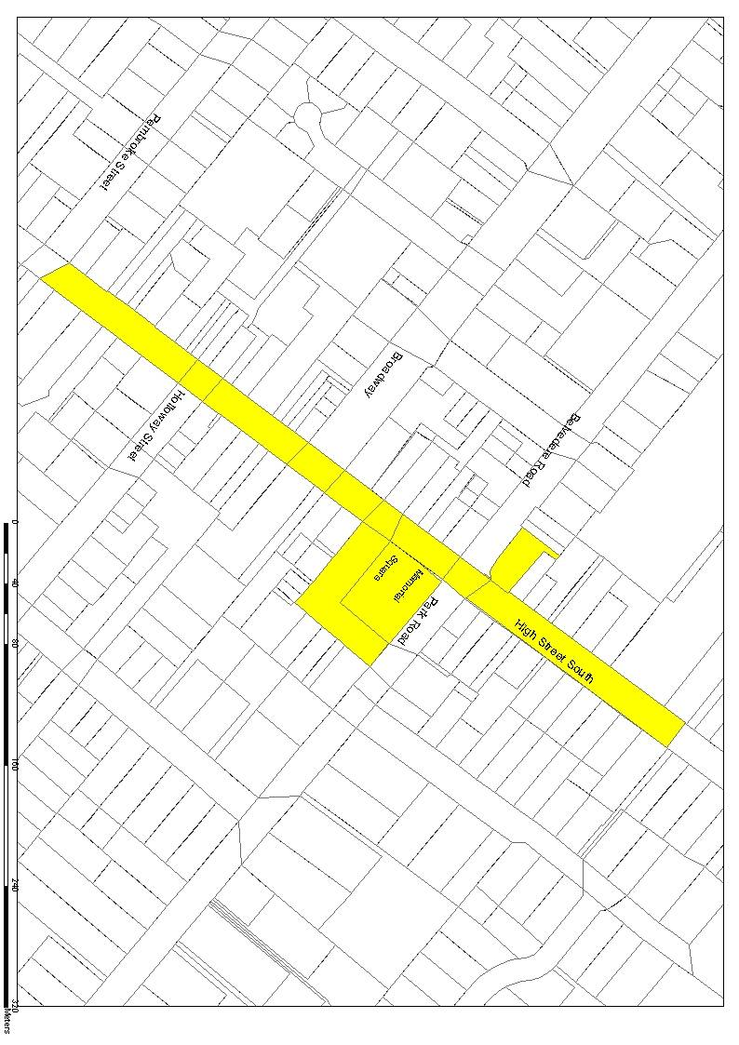
The portions of streets which are constituted as prohibited areas are:

(ii) Part 3(f)(iii)

The fee to be paid to Council for claiming an impounded device shall be:-

$nil for first seizure and release
$35.00 for second seizure and release
$50.00 for third and/or subsequent seizure and release

MAYOR

CHIEF EXECUTIVE OFFICER

