Carterton South Structure Plan

Information Sheet 3
What is a Structure Plan & why is it needed?

A structure plan is a plan to provide a framework to guide the development of an area. The preparation of a Structure Plan for the South Carterton area (refer Figure One attached) is in response to the submissions from members of the community on the Proposed Wairarapa Combined District Plan who sought retention of the low density character area and better long term planning for the area.

Background
Opus International Consultants has been engaged by Carterton District Council to prepare a draft ‘Structure Plan’ for the currently semi-rural areas within the central western area and southern parts of the Carterton urban area. The aim of the draft Structure Plan is to provide a framework to guide the development of this area ensuring that infrastructure connections are provided for and protected, open spaces are identified, and an ‘urban form’ is created for the township which accords with the aspirations of the community and reinforces community character and identity.

On completion, the draft Structure Plan together with a report detailing the rationale behind the plan and the outcomes of community consultation, will be provided to Council. This report will detail the means by which the Plan can be implemented.

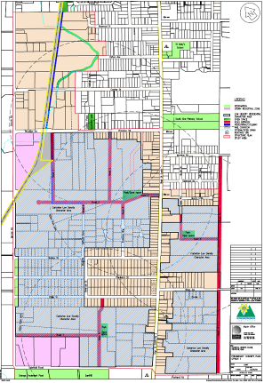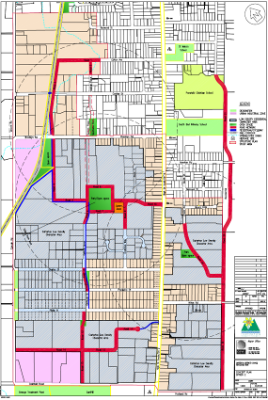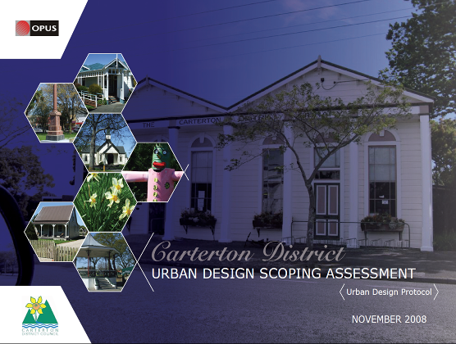
Options 1 and 2 and the Carterton Urban design Scoping Report

We have been providing updates in ‘The Carterton Crier’ for those people wishing to remain updated throughout the past few months. The Urban Design Scoping Report has also been completed which will provide some further insight for the project.

New Aerial Photo
Last years consultation ‘open week’ in the main street highlighted a need to source updated aerial photos, to more accurately display the current situation with respect to actual development in the structure plan area.

A new photo was received by the project team earlier this year and has been used to further develop the structure plan following feedback from open-week participants.

Where can I see the latest draft plans?
A copy of the latest draft of the structure plan is attached to this Information Sheet. Larger copies of the draft structure plan together with a range of background information used in its development and other interpretive information was available at the Charrette held on Wednesday 20 May 2009 which was attended by a number of interested people.

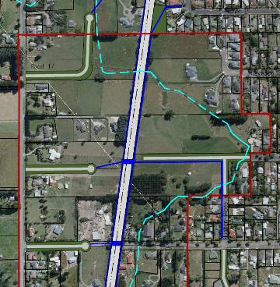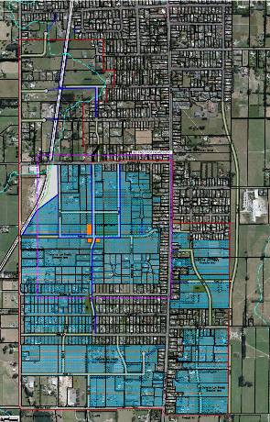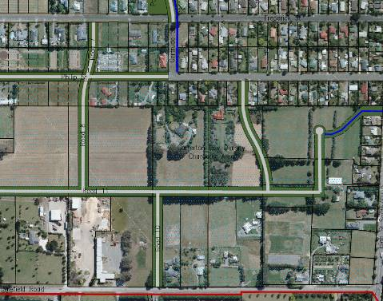

Copies of the latest draft structure plans and accompanying information will also be available at the Council offices while the development of the structure plan continues.

Ongoing Consultation - The ‘Charrette’ and its purpose.

Carterton District Council is keen to facilitate further community and stakeholder involvement and opportunity for input into the development of the structure plan.

‘A charrette is an intensive workshop where participants receive baseline information, learn from others perspectives, grapple with alternatives, weight choices, set priorities and reach conclusions’

On 20 May 2009 a ‘charrette’ was run from 2pm to 8.30pm in the community centre, providing another opportunity for community involvement and feedback. The purpose of the charrette was to provide stakeholders and the wider community with an opportunity to spend some time with background information (such as the community and stakeholder responses listed below) and to brainstorm possible alternatives for the structure plan.

Copies of the structure plan and indicative cross-sections showing how the above-ground layout of streets might retain semi-rural characteristics together with a range of other information and material were provided. Attendees had the opportunity to ‘draft’ their suggestions with respect to the arrangement of structure plan features, and some valuable responses with respect to the location of roads and public open space have been recorded from this process.

The three members of the project team also recorded a number of suggestions, comments and concerns that have been taken on-board and will be reported to Carterton District Council as part of the development of the final structure plan.

How do I comment from this point on and what will happen with my comments?

Comments on the draft structure plan can be made via the comment form attached (a copy of the comment form was also available from the charrette), or via email (edita@cdc.govt.nz), or posted to Carterton District Council (Freepost 165185, PO Box 9, Carterton). Your comments on the draft Structure Plans will be taken into account as the final draft Plan is refined, and as the supporting report (rationale) is being developed.

How can I continue to be informed?
Project updates will continue to be placed in the Carterton Crier, or alternately you can contact Edita Babos at Carterton District Council via the contact details above if you want to receive updates by email, or simply if you have a question or query about the draft structure plan or its progress.

Examples of typical community and stakeholder responses

- Up-to-date aerial photo needed. New houses in line of road lines.
- Currently not many safe places to walk dogs. Would like the central park and other areas dog friendly.
- Do not require any more schools.
- The existing semirural character is important, questions the need for residential development, creation of schools and green areas.
- Maintain the semirural character, ensure adequate provision of “urban services”, eg water, wastewater.
- Low density nature of housing is threatened by continual subdivision into small sections. Further restrictions on minimum lot size should be imposed.
- The park in Philip Street extended to Frederick Street.
- Walkers would appreciate the north-south pedestrian links between the existing long east-west roads.
- Question the number of road links onto Brooklyn Road.
- New commercial zone and school are unnecessary.
- Road network focused on safety and attractive design to increase property desirability.
- Create a “sense of place” - value the history of Carterton – character defined by native trees and notable exotics
- Need to maintain small town feel.
- Trees planted/maintained on side streets by Council help to make the community special.
- Supports the creation of cycle routes, overbridges and commercial area.
- Good things about community are the quietness, little traffic and assurance of personal safety.
- Support the proposed roads for the area between Philip Street and Dalefield Road on Option 2/3.
- Roads through Rexwood Estate would ruin the small town lifestyle they have and would be a road to nowhere.
- More parks/open spaces need to be included.
- Supports the principle of undertaking of the structure plan, but study should spread to the wider Carterton area.
- North-south transport links away from SH2 are important.
- Need to maintain semi-rural environment, which the plan degrades by adding roads.
- Submitter would like to see a Poletown “village centre” area created (Lincoln, Charles, Gertrude - Philip).
- Prefer option 3 for provision of open spaces/parks, walkways and road linkages.
- Great to see open space in town.
- Would like to see a dairy, café/restaurant, indoor pool, sheltered bus stops, cycle ways on road
- South Carterton Householders are acutely aware of lack of facilities in southern area. Children travel to north of town for recreation and spending their money. Developing a ‘village’ in south area would be a good start to creating opportunities for them doing this closer to home.
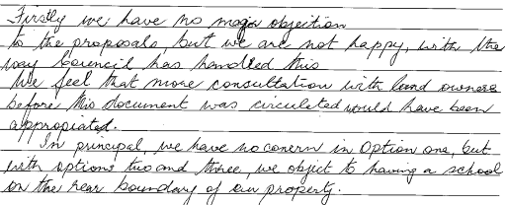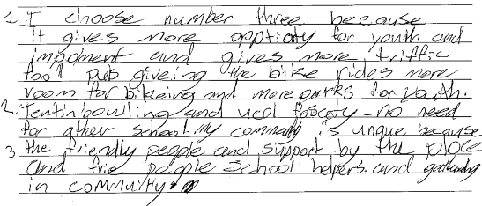


Adapted from IAP2’s Techniques for Public Participation

