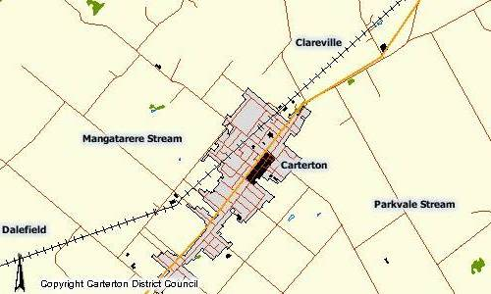
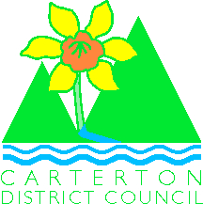

Carterton District Council
Land Information Memorandum

Carterton District Council
Ph: 06 379 6626
Fax: 06 379 832
Email: suzannez@cdc.govt.nz

What is a Land Information Memorandum (LIM)?

A LIM Provides information the council holds about the property. It will show whether existing works have received council consent and whether the council requires any remedial work. A LIM report will also give you information about any site characteristics (such as contamination, propensity to flooding, etc.) and zoning details. When purchasing a property the Standard Agreement for Sale and Purchase (which your Lawyer will provide) includes a LIM condition, provided you select it on the front page.

Fireplaces and Codes of Compliance
If you do not have a code of compliance for a fireplace it could invalidate your insurance on the property (e.g. if the burner causes fire damage). If there is no “code of compliance” indicating that a final inspection has been completed the owners of the property will need to contact the Carterton District Council to arrange a final inspection of the work. If the Building Control Officer decides that the duration between the time the fireplace was installed and the final inspection is requested is too great the inspector may not be able to complete a final inspection. In which case the owner may ask a plumber to inspect the fireplace and provide a letter stating that the fireplace has been installed to the manufacturers specifications – this letter can then be passed on to the council, recorded on computer records for the property and placed in the property file.

Please remember, the LIM provides information from records held by Council.

A Land Information Memorandum is a report prepared by the Council at your request. It provides:

- Official address, Legal description and area of site
- Information on special land features or characteristics including potential:

    - Erosion
    - Avulsion (removal of land by water action)
    - Falling debris
    - Subsidence
    - Slippage
    - Alluvion (The deposition of silt from flooding)
    - Inundation (Flooding)

- Presence of hazardous contaminants which are likely to be
Relevant to the land and is known by Council.
- Information on private and public storm water and sewage drains as shown in the council records
- Information relating to Government Valuation and any
rates (including water and miscellaneous accounts) owing in relation to the land
- Information concerning any consent, certificate, notice, order or requisition affecting the land or any building on the land previously issued by the Council (whether previously issued by the Building Act 2004, Resource Management Act 1991 or any other Act).
- Information concerning any certificate issued by a building certifier pursuant to the Building Act 2004
- The Zone in which the land is located.
- Information which in terms of any other Act has been notified to the Council by any other Statutory Organisation (i.e. Historic Places Trust or the Department of Conservation) which has the power to classify buildings for any purpose.
- Information which has been notified to the Council by any network utility operator under the Building Act 2004.
- The Memorandum may also include:
Such other information concerning the land which the Council considers – at its discretion – to be relevant.

When will I need a Land Information Memorandum (LIM)?

If you are considering purchasing a property, it is recommended that you obtain a LIM before finalising the purchase. You will find a LIM very useful in assisting in deciding whether the land is worth purchasing and free from any restrictions.

What is the Cost of a Land Information Memorandum (LIM)?

Full payment must be made with all LIM applications work will not begin on collating a LIM until full payment is received.

The cost of a LIM is $150.00 for a non urgent LIM
$200.00 for an urgent LIM
No refund will be made for cancelled LIMs

How do I obtain a Land Information Memorandum (LIM)?

Lim Request forms are available from the Carterton District Council Offices on Holloway Street Carterton or from the Carterton District Council website http://cartertondc.co.nz/

Online forms: Click on “Regulatory” in the Menu and then “Resource / Building Consent” to open up the selection of forms including one for LIM applications. You should forward your application, with the appropriate fee of $150.00 or $200.00 to the Council.

How long will take to obtain a Land Information Memorandum (LIM)?

The statutory time frame for issuing a LIM is 10 working days. Working days are suspended for Public Holidays. If you request an urgent LIM this will be processed within 3 days.

Please be sure that all the information requested is included to enable us to return the memorandum to you as quickly as possible.

