Carterton District Council
Parking Restriction Bylaw 2006


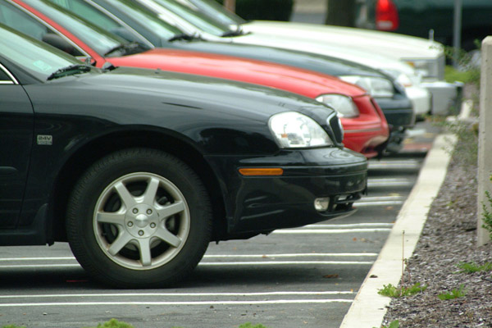

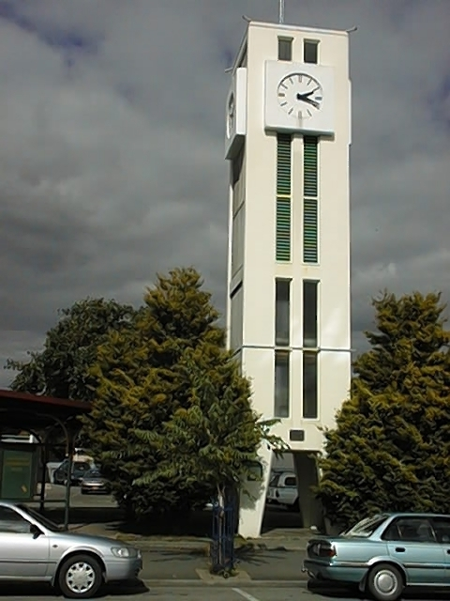

TO FIND OUT MORE ABOUT CARTERTON DISTRICT COUNCIL’S PARKING RESTRICTION
BYLAW 2006 PLEASE READ ON

CARTERTON DISTRICT COUNCIL

PARKING RESTRICTIONS 2006

Council periodically receives a number of complaints relating to excessive duration of parking in restricted areas. In further investigating the matter it was revealed that some previous parking restriction signage to be missing or in a bad state of repair resulting in some confusion to the extent of the restrictive areas.

Time Table for Council Making the Parking Restriction Bylaw

22nd February 2006 Adoption of Draft Bylaw
24th February 2006 Public Notification of Draft Bylaw and calling of submissions
24th March 2006 Submissions Close
11th April 2006 Submissions heard and considered
26th April 2006 Bylaw Adopted
24th May 2006 Bylaw takes effect

August 2013 Reviewed and Amendments Proposed

M.F. Hautler

Manager Planning & Regulatory

CARTERTON DISTRICT COUNCIL PARKING RESTRICTION BYLAW 2006

1. Introduction
Pursuant to Sections 83 and, 145 of the Local Government Act 2002 the Carterton District Council makes this bylaw to Parking Restrictions within the Carterton Central business area.
As per The Land Transport Act 1998 Sec 22AB

2. Title
The title of this bylaw is the Carterton District Parking Restrictions Bylaw 2006.

3. Date the Parking Restrictions within the Carterton District area comes into force

The Parking Restrictions described in the schedules comes into force on the date specified in the timetable being 24th May 2006

4. Interpretation:
Enforcement Officer means any officer appointed under section 208 Land Transport Act 1998; or any officer appointed under section 177 Local Government Act 2002.

Parking means
(a) in relation to a portion of a road where parking is for the time being governed by the location of parking machines placed under the authority of a bylaw of a local authority, the stopping or standing of a vehicle on that portion of the road for any period exceeding 5 minutes:
(b) in relation to any other portion of a road, the stopping or standing of a vehicle (other than a vehicle picking up or setting down passengers in a loading zone or reserved parking area, and entitled to do so) on that portion of the road

Parking Warden – a Council Officer appointed under section 128D of The Land Transport Act 1998

Restricted Parking means a street area where a time restriction applies to any parked vehicle.

CARTERTON DISTRICT COUNCIL PARKING RESTRICTIONS BYLAW 2006

That the Carterton District Council adopts the Parking Restrictions Bylaw as follows:

The bylaw gives effect under the Local Government Act 2002 to the resolution adopted by the Council under the special consultative procedure.

This part of the bylaw places parking restrictions within the Central Business area of the Carterton District Township. The Council will erect signage to communicate the terms of allowable parking duration within the restricted parking areas.

The purpose of this bylaw is to address concerns relating to excessive duration of vehicle parking within restricted areas.

The bylaw is introduced pursuant to s146(b) (vi) of the Local Government Act 2002 - this section should be read together with this part of the bylaw.

CARTERTON DISTRICT COUNCIL PARKING RESTRICTIONS BYLAW 2006

1 Definitions
Restricted Parking relates to roadside reserve as contained within schedule 1

2 Signage

2.1 The Council will erect signage by road reserve within areas covered in schedule 1 by this bylaw to provide information to the public on the terms of the bylaw. The size, location and terms of this signage shall be in accordance with the requirements of The Land Transport Rule 54002 (sec12)

To avoid any doubt the absence of signage in any public place does not authorise breach of this part of the bylaw.
3 Offences

3.1 Everyone commits an offence who:
As per The Land (Transport Rule) 2004 Section 6.4

a) Where an offence is committed in relation to Sec 6.4 The Land (Transport Rule) 2004 an infringement notice will be issued pursuant to section 139 Land Transport Act 1998

c) The fee to be paid to Council for each infringement shall be as prescribed in the Land Transport (Offences and Penalties) Regulations 1999 Schedule 1b
part 1

d) All Infringement Fees shall be processed as per Section 141 of the Land Transport Act 1998

Note: This bylaw is introduced pursuant to the specific empowering provisions of the Local Government Act 2002 that provide for bylaws. This bylaw does not repeat or paraphrase those statutory provisions, and accordingly those provisions should be read in conjunction with this bylaw. In particular, the following provisions are noted:

Section 113 Land Transport Act 1998 provides a Law Enforcement Officer with powers to enforce the bylaw

This bylaw has no effect on any other Police powers of search, seizure and arrest or any other statutory offences

Schedule 1 – Restricted Parking Areas
- Western Side of High Street High Street between Victoria Street and Pembroke Street 90 mins parking Monday –Friday 7am – 6pm, Saturday 7am – 1pm
High Street between Pembroke Street within the 2 marked parking areas out front of the current Carterton Pharmacy (Pt. Lot 23 DP 753) 15 mins Parking Monday –Friday 7am – 6pm, Saturday 7am – 1pm
High Street from the end of the 15 min parking outside Carterton Pharmacy (Pt. Lot 23 DP 753) to Broadway 90 mins Parking Monday –Friday 7am – 6pm, Saturday 7am – 1pm
High Street between Broadway and Belvedere Road 90 mins Parking Monday –Friday 7am – 6pm, Saturday 7am – 1pm
High Street between Belvedere Road and 155 High Street North 90 mins Parking Monday –Friday 7am – 6pm, Saturday 7am – 1pm
Eastern Side of High Street Wakelin Street to Carrington Park Drive way 90 mins parking Monday –Friday 7am – 6pm, Saturday 7am – 1pm
- High Street High Street adjacent to New Zealand Post Office Building 5 mins Parking Monday –Friday 7am – 6pm, Saturday 7am – 1pm
Holloway Street to Park Road 90 mins Parking Monday –Friday 7am – 6pm, Saturday 7am – 1pm
Park Road intersection to 156 High Street South Lot 1 DP 13212. 90 mins parking Monday –Friday 7am – 6pm, Saturday 7am – 1pm
- Park Road On the northern side, 29.5 meters east of High Street intersection to 49.5 meters east, 90 mins parking Monday –Friday 7am – 6pm, Saturday 7am – 1pm
On the southern side of road to match – i.e. the first bay of angle parks by the square 90 mins parking Monday –Friday 7am – 6pm, Saturday 7am – 1pm
- Pembroke Street Pembroke Street South Side, from High Street intersection to (Supermarket Car park Pembroke Street Entrance)15 mins Parking Monday –Friday 7am – 6pm, Saturday 7am – 1pm
- Belvedere Road Belvedere Road South side, from High Street intersection to Masson Street 90 mins parking Monday –Friday 7am – 6pm, Saturday 7am – 1pm Belvedere Road North side, from High Street to opposite Masson Street 90 mins parking Monday –Friday 7am – 6pm, Saturday 7am – 1pm
- Holloway Street
On Northern side of the road from High Street to Nelson Crescent 30 mins parking Monday –Friday 7am – 6pm, Saturday 7am – 1pm
On the Southern Side of the road from High Street the first Park (Disability Parking)
On the Southern Side of the road from High Street the first Park past the disability car park 5mins parking Monday –Friday 7am – 6pm, Saturday 7am – 1pm
On the Southern Side of the road from High Street between the 5 min parking restriction and the Police Station 30mins parking Monday –Friday 7am – 6pm, Saturday 7am – 1pm

Disability Car Parks
One Located in Nelson Crescent Car Park
One located in Broadway outside IDEA Services
Three Located in Holloway Street two outside Library Events Centre, and One beside New Zealand Post Office Building (Video Ezy)

The foregoing Bylaw and amendments was made by a resolution passed at the meeting of the Carterton District Council held on Wednesday 26th February 2006 and 19th December 2007. And Wednesday 26th August 2009, October 2013

