

ANNUAL PLAN
2008-09

Adopted by Council 25 June 2008

Index

Purpose of the Annual Plan | 4
Mayor’s & Chief Executive’s Introduction | 5
Major Projects & Plans for 2008/09 | 8
Proposed Major Renewals & Capital Expenditure 2008/09 | 10
Significant Variations from the Long Term Council Community Plan | 12
How Your Rates will be Spent | 14
Significant Activities
A Guide to How to Read the Significant Activities Section | 17
Governance | 18
Economic, Cultural & Community Development | 20
Roads, Streets & Bridges | 23
Urban Water | 25
Rural Water Services | 28
Stormwater | 30
Wastewater | 32
Waste Management | 34
Parks & Reserves | 36
Community Amenities | 38
Property | 40
Resource Management & Planning | 42
Public Protection | 44
Corporate Services | 46
Operations | 47
Professional Services | 48
Garage | 49
Prospective Financial Statements
Statement of Accounting Policies | 51
Prospective Statement of Financial Performance | 64
Prospective Statement of Movements in Equity | 65
Prospective Statement of Financial Position | 66
Prospective Statement of Cashflows | 67
Prospective Reconciliation of Net Surplus to Operating Activities | 68
Prospective Operating Funding Statement | 69
Prospective Capital Funding Statement | 70
Funding Impact Statement and Fees & Charges
Funding Impact Statement | 73
Rates & Charges | 77
Schedule of Fees & Charges | 78
General Information
Elected Member Directory | 86
Staff Directory | 87
Submission Form | 89

Purpose of the Annual Plan

The Annual Plan is the Council’s plan and budget for the 2008-09 financial year commencing on 1 July 2008.

This Annual Plan covers year three of the 2006-16 Amended Long Term Council Community Plan.

The Annual Plan must be prepared in accordance with Section 95 Local Government Act and must:

- Contain the annual budget and funding impact statement for the year to which the annual plan relates; and
- Identify any variation from the financial statements and funding impact statement included in the local authorities long term council community plan in respect of the year; and
- Support the long term council community plan in providing integrated decision-making and co-ordination of the resources of the local authority; and
- Contribute to the accountability of the local authority to the community; and
- extend opportunities for participation by the public in decision-making processes relating to the costs and funding of activities to be undertaken by the local authority.

The Annual Plan can be described as a budgeting instrument. Its focus is on financial matters in the year of the Annual Plan and not on the role, scope, service levels and priority of the Long Term Council Community Plan, and any subsequent amendments.

The Annual Plan’s primary purpose is to provide the accountability base for the setting and assessing of rates. Rates cannot be set until the Annual Plan is adopted.

Mayor’s & Chief Executive’s Introduction

We have pleasure in introducing the Carterton District Council’s Annual Plan for the 2008/09 financial year. The Annual Plan summarises the activities to be undertaken and sets the budget for the coming financial year from 1 July 2008.

This Annual Plan is based on the proposed activities included in the Council’s Long Term Council Community Plan (LTCCP) and in particular the information in the LTCCP relating to the 2008/09 year. These activities have been modified by Council to reflect the Council’s current priorities and the latest information available.

In this financial year Council is planning to begin or undertake several major projects aimed at improving the infrastructure of the District. To fund these projects and the normal operating and maintenance activities requires an average increase in rates of 7.61%. The actual rates for individual properties will vary depending upon the targeted rates that are applicable, the differential rating category, and the valuation of each property.

Unlike central government, councils need to increase their rates each year just to maintain the status quo because of inflation. Unfortunately, cost increases in the last year for many council related activities like roading, have been greater than the consumer price index.

Details relating to the Council’s planned activities and finances are contained in the Annual Plan document. Some of the more significant activities are as follows.

- A joint contract with Transit NZ is being prepared for a major upgrading of the main highway and footpaths through the central business area. This will substantially improve the appearance of the centre of Carterton. The works will also involve the replacement of the sewer, landscaping, and the construction of a roundabout at the Park Road / Belvedere Road intersection with High St. Extensive consultation on the portion of the proposals that are the Council’s responsibility was undertaken in 2005. The work is planned for construction in the spring and summer of 2008 and further information, particularly for businesses in the area, will be provided nearer the construction period.

- Council has recently obtained a $300,000 subsidy from Government to assist with a significant upgrade to the town water system. The proposed works consist of an additional reservoir at the Kaipaitangata water treatment plant, UV treatment processes at the Kaipaitangata and supplementary groundwater supply plants, and a new telemetry system. These additions, which are planned to occur over two years, will improve the quality, reliability, and summer time capacity of the system. Some of this work will be funded by the infrastructure contributions that now come from new subdivisions.

- As earlier indicated in the Long Term Plan, a fairer system for paying for water is being introduced from 1 July. Properties connected to the town water supply, whether residential, commercial, industrial or rural, will be entitled to up to 300 cubic metres (300,000 litres) of water per year. Usage above this amount will incur an additional charge based on $1.50 per cubic metre. Most residential properties are expected to use less than 300 cubic metres in a year. This change should make consumers more conscious of their water usage and any wastage.

- Changes have been made to the classification for rural water race rates. There are several hundred kilometres of water race channel in the Taratahi and Carrington networks to be operated and maintained. A revised basis for the rates that fund this work has been developed so that there is a fairer basis overall for collecting rates from those property holders who are on the water race networks.

- Council is budgeting to spend over three million dollars in the coming year to maintain the roading network at its present standard, plus make some minor improvements in some areas. Roading continues to be the Council’s largest expenditure item with 430 kilometres of roading in the District. There are 278 kilometres of sealed roads and 152 kilometres unsealed. Ninety three percent of the roads are in the rural area and 7% in the urban area.

- The resource consents for the discharge from the Wastewater Treatment Plant in Dalefield Road expire in 2009. Council is currently investigating ways of improving the treatment processes so that the effluent can be irrigated over nearby farm land during the warmer months of the year rather than being discharged to the Mangaterere River. This year’s budget includes a provision to obtain new resource consents and make a start on construction.

- Provision has also been made for some work to improve the performance of the sludge digester at the Wastewater Treatment Plant.

- Some of the older sewer pipelines in Carterton suffer from infiltration during times of high water tables. A start is being made on a long term programme of replacing those pipelines that are in poor condition.

- Significant improvements have already been made to the storm water drainage system on the eastern side of Carterton in the last few months and further improvements to the rural part of this system are planned for the 2008/09 financial year.

- Council works closely with the other councils and forestry interests in the Wairarapa Rural Fire District. The budget for rural fire is increasing as a government subsidy no longer applies.

- Planning for a new community building in Holloway Street is continuing although construction is not expected to commence this financial year. Such a building is intended to replace the 120 year old Municipal Hall, provide meeting rooms for a variety of community uses, robust space for youth activities, a home for historical archives and the Carterton Information Centre, and an expansion of the library.

- A new drain is planned for construction at the Clareville cemetery to avoid the flooding that occurred there in 2006.

- The allocation for community grants this year will be $20125. In addition, new or increased grants are proposed for Aratoi, the Carterton Information Centre, the Carterton Soccer Club to assist with lights in Howard Booth Park, the Wairarapa A & P Association, the Wairarapa Sports Artificial Trust and a grant towards terminal facilities at Hood aerodrome as without a suitable terminal there will be no airliner service to the Wairarapa.

- Decisions on the new Combined District Plan have recently been made by the three Wairarapa councils and a financial provision needs to be made in the budget for this year to consider appeals to the Environment Court.

- The new Combined District Plan substantially increases the area of industrial zoned land at Waingawa. This was a strategic decision of the three Wairarapa councils to concentrate future industrial development in this area. Council will be considering the appropriate means of servicing this land in conjunction with the Masterton District Council.

- Costs for recycling and waste management are increasing and the Council has increased the charges at the Dalefield Road transfer station in line with the charges that will be applying in the neighbouring council districts.

Council is budgeting for a surplus of $1,543,576 for the 2009 financial year. This surplus is required for accounting purposes to fund a number of transactions/projects that do not appear in the prospective statement of financial performance ie. loan repayments, grants/subsidies/donations for capital projects and contributing to reserve funds. The income for these transactions/projects is recorded in the statement of financial performance whereas the payments are recorded in the statement of financial position.

This income is partially offset by expenditure items that is not fully funded by rates, ie. revaluations, bad debts, expenditure recovered over the life of projects and depreciation. The expenditure for these transactions is recorded in the statement of financial performance and a reduction is recorded in the statement of financial position.

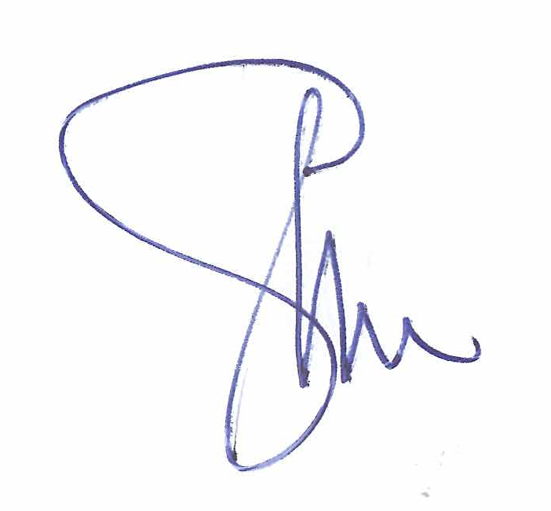



Gary McPhee Colin Wright
Mayor Chief Executive

Projects & Plans for 2008/09

New Long Term Council Community Plan

A significant project for the Council over the year will be the complete review of Council’s Amended LTCCP.

Under the Local Government Act, Council is required to review its LTCCP every three years.

This project will include a complete review of Council’s strategic direction, community outcomes and asset management plans.

CBD Re-Vitalisation Stage II

This project has been carried forward from the 2007/08 year to enable Council’s proposed works to be completed in a joint contract with Transit New Zealand.

Council recognises that there will be some disruption to residents and businesses in the affected area however felt that a joint contract would be more cost effective and less disruptive than if the contracts were completed separately.

The works will comprise:

- Upgrade of the footpaths on both sides of High Street from Pembroke Street to just beyond the Belvedere/Park Roads intersection.

- Broadway footpaths on both sides from the High Street intersection to the end of the Marquis of Normanby building.

- New under-verandah lighting.

- Hanging basket and garden irrigation system.

- Landscaping of the green spaces at the clock tower and entrance to South Wairarapa Veterinary Services.

- Renewal of the kerb and channel on both sides of High Street from Pembroke Street to just beyond the Belvedere/Park Roads intersection.

- Replacement of the High Street sewer in a larger size from Park Road to south of Pembroke Street.

- Replacement of some water laterals in the CBD area.

- Resurfacing of State Highway II in the CBD area.

- Installation of a roundabout at the Park/Belvedere Road intersection.

Council has set aside $400,000 for this project to be funded $120,000 from CBD Special Reserves and $280,000 by loan over 20 years. The sewer and water replacements will be funded separately from depreciation reserves.

Introduction of Charges for Metered Water

Council is introducing an element of users pays for water from the reticulated water supply from 1 July 2008. All users will receive up to 300 cubic metres per year paid through their rates. Use above 300 cubic metres in a year will be charged for at $1.50 per cubic metre (1000 litres) and will be invoiced separately. This will apply to all users on the water supply system whether residential, rural, industrial, or commercial.

Most residential users will use less than 300 cubic metres; some substantially less. Hence it will only be the higher users who receive an additional charge.

Council anticipates that the introduction of this charge for higher users should make consumers more aware of their water usage and encourage them to take appropriate steps to save water.

Council is required to treat and deliver water to consumers at acceptable Ministry of Health standards. The cost and standard required to be met keeps rising with consumers expectations.

.
Water Treatment Upgrade

Council has received a Government grant of $300,000 for assistance with the upgrade of various items in the water treatment system, specifically; the telemetry system, additional treated water storage reservoir at the Kaipatangata, enhanced treatment of both the Kaipatangata and Frederick Street bore water sources with UV irradiation, which will inactivate protozoan cysts such as Giardia and Cryptosporidium, and operator training. A condition of the subsidy is that these works must be completed inside a two (calendar year) time frame. During the coming year, it is proposed to complete the reservoir, telemetry upgrade and operator training and commence the water treatment upgrade at the Kaipatangata. The residual work to complete the Kaipatangata treatment and install treatment at the bore plant will be undertaken in the 2009/10 financial year.

On completion, there will be a lower risk of disease transmission, more storage of treated water, better control and feedback available from the treatment plants, and a higher level of operator training.

Wastewater Treatment & Disposal Upgrade

The Wastewater Treatment Plant consent to discharge to land and to the Mangaterere River expires in March 2009. Prior to this time designs must be completed and consent applied for and gained for a new treatment system. The proposed upgrade is to treat to a high standard using ultra filtration technology, and then during summer time, irrigate the highly treated wastewater onto pasture owned by others. When land irrigation is not possible, due to wet weather and low moisture uptake capacity from the soils, the upgraded treatment plant will still be able to produce a very high qualify effluent which will be discharged through the existing wetland/stream discharge pathway.

Completion East Side Stormwater Upgrade

The second stage of the east side stormwater upgrade will be completed during the coming year. The work will involve cleaning and increasing the size of pipe and culverts from Hilton Road through to Waihakeke Road and down to the Waiohine River. Funding from a loan has been allowed for in the 2008-09 financial year.

Review of Water Race Classification System

The aim of the review was to:
- Establish a fair and equitable charging system.

It is proposed that the new classification system will be as follows:

- Stock Water Classes A & B
- Rural Water Service Charge (on all properties which has a water race on it)
- Industrial
- Irrigation (assessed on a case by case basis between Council and GWRC)

A rural water services charge is being introduced to ensure that small rural properties are paying a reasonable share towards the cost of providing the service.

Properties which are irrigated from the water race or a natural water course which is feed by the water race system will now attract a charge. This charge will ensure properties that are gaining benefit from the water will pay a fair share towards the maintenance of the system.

Stock water will be charged on a similar basis to what is currently occurring.

Major Renewal & Capital Expenditure 2008/09

Significant  Activity  Area | Carried Forward from 2007/08 | Amended  LTCCP  2008/09 | Annual Plan 2008/09
Economic, Cultural & Community Development  CBD Re-Vitalisation Stage II  Library Books  Library Floor Renewal | $400,000 | $48,457  $53.097 | $400,000  $48,457
Roads, Streets & Footpaths  Drainage Renewals – Kerb & Channel Replacements  Unsubsidised Footpath Resurfacing  Minor Safety Works  Pavement Rehabilitation  Reseals  Traffic Services  Unsealed Road Metalling |  | $83,782  $82,240  $150,088  $337,698  $398,144  $121,304  $456,432 | $85,000  $82,000  $197,000  $340,000  $386,000  $121,000  $510,000
Urban Water  Water Model Investigatory Works  New Values (Better Network Isolation)  New Water Source Waingawa  Phillip Street Main  Kaipatangata Plant UV Filter Treatment  Replace laterals in High St CBD before upgrade of road  Supplementary Plant UV Treatment  New Reservoir | $145,000  $67,000  $130,000 | $52,000  $5,200  $104,000  $11,400 | $20,000  $5,000  $299,900  $67,000  $153,700  $153,000
Stormwater  East Side Drainage (Park/Richmond Rds/Waihakeke)  New Open Drainage Channel at Cemetery |  | $135,200  $31,200 | $135,200  $31,200
Wastewater  High St – Park Rd to Wakelin St - CBD  Sewer Replacement Garrison St (Victoria to Rexwood Streets)  Kent St Extension  Kent St (West of Rail Line)  Wyndham St Sewer Replacement  Grout Manholes  Wastewater Treatment Plant Digester Upgrade  Upgrade Wastewater Treatment & Disposal | $183,000  $45,364 | $40,209  $134,030  $107,224  $5,155  $46,395  $309,300 | $183,000  $45,364  $134,030  $5,155  $50,000  $750,000
Waste Management  Install Recycling Shed |  | $37,116
Parks & Reserves  Carrington Park – Play Equipment  South End Park – Play Equipment  Carrington & Howard Booth Parks – Drinking Fountains |  | $30,870  $20,580 | $30,870  $9,000
Community Amenities  Cemetery – Landscaping  Baths – Paint Facilities |  | $4,322  $26,548 | $4,322  $26,548
Property  Community Facility  Holiday Park – Solar Heating |  | $1,000,000 | $500,000  $6,000
Public Protection  Dog Pound – New Building | $35,000 |  | $35,000
Corporate Services  Telephone System Replacement  Electronic Document & Records Management System  Office Building Refurbishment |  |  | $30,000  $80,000  $120,000

Significant Variations from the Long Term Council Community Plan

Section 95(5)(b) Local Government Act 2002 requires Council to identify any variation from the financial statements and funding impact statement included in the local authority’s long term council community plan in respect of the year.

The Annual Plan for 2008/09 shows an increase in the total rates requirement of 10.11%. This equates to an average increase per ratepayer of 7.61% after allowing for an estimated increase in the rating database of 2.5% due to growth.

The Amended Long Term Council Community Plan proposed an increase of 6.7%.

There are a range of variations to what was proposed in the Amended Long Term Council Community Plan and these can be explained as follows:

Economic, Cultural & Community Development

New or revised grants are proposed as follows:

- An increase in community grants back to the previous level of $20,125.
- An increase of $10,000 in the grant for the Carterton Information Centre.
- A $5,000 grant to the Carterton Soccer Club to assist with the installation of lights in Howard Booth Park.
- $12,000 towards terminal facilities at Hood Aerodrome that are suitable for a regular airline service.
- A $10,000 grant to the Wairarapa A & P Association to assist with operating the Clareville Complex.
- A $30,000 grant to the Wairarapa Sports Artificial Trust to assist with installation of a new artificial turf at the Clareville Complex.

The Library floor renewal has been deferred and will be completed as part of the proposed community facility development.

Urban Water

Council will receive additional income (subsidy) of $200,000 from the Ministry of Health to be used in the 2008/09 year towards the water treatment upgrade. Due to receipt of this subsidy and the conditions attached to it, Council has brought forward proposed capital expenditure to complete the first year of a two year upgrade programme..

The proposed investigation into a new water source at Waingawa of $104,000 has been deferred pending the outcome of discussions with Masterton District Council regarding infrastructural servicing of the Waingawa Industrial Park.

Wastewater

Capital expenditure to complete the wastewater treatment and disposal upgrade has been brought forward to enable works to be commenced prior to Council’s consent to discharge to land and the Mangaterere Stream expires in March 2009.

Due to this work sewer replacements proposed to occur in Wyndham and Kent Streets have been deferred.

Parks & Reserves

The upgrade of the Carrington Park restrooms has been deferred pending the completion of a review of restroom facilities in the district.

Property

Forestry income has increased to take into account completion of harvesting not carried out in the 2008/09 year. Operating expenses for pensioner housing has increased due to a revaluation of the pensioner housing stock being completed in 2007. Capital expenditure for the proposed new community facility has been reduced to $500,000 as construction is not expected to commence in the 2008/09 year.

Corporate Services

Expenditure is proposed to rise to take into account costs associated with the development of the 2009-19 Long Term Council Community Plan and additional financial management costs. Increases in this activity area have a flow on effect to all activities areas with increases in support overhead charges.

Additional capital expenditure has been included to enable alteration to Council’s administration building, installation of an electronic document management system and upgrade of the telephone system. These changes are aimed at improving efficiency.

As indicated in the Amended Long Term Council Community Plan Council proposes to change the way in which it collects its targeted rates for urban water and rural water services from 1 July 2008. These can be explained as follows:

Urban Water

The targeted water rate included in rates, will allow for the use of up to 300 cubic metres of water per year, where properties have been fitted with a water meter or meters. Usage above 300 cubic metres will attract an additional charge. Previously properties connected to the urban water supply had an unlimited use of water.

Rural Water

Council has completed a review of the classification classes used for charging for non-potable water from the Carrington and Taratahi Water Races. This has resulted in the introduction of a new system which spreads the costs of maintaining the systems fairly across beneficiaries.

How Your Rates will be Spent

Total rates to be collected for the 2008/09 is $5,928,572. Hereunder is the breakdown of how the money is collected across the differential rating classes.

This money will be spent on the following activities:

Operating Expenses for Each Activity (Day to Day Running Costs)

Capital Expenditure for Each Activity

Projected to cost $5,412,156.

Significant Activities

A Guide to How to Read Significant Activity Section

This section explains the Council’s Significant Activities and how they contribute to the future of the district and to the community outcomes.

This section shows how Council manages, delivers and funds the activities it is involved in.

The Annual Plan 2008/09 is based on Year 3 of the Council’s Amended LTCCP.

Scope & Nature of the Activity

This section gives a brief description of the services or activities provided.

Why Council Undertakes this Activity

This section gives the reason/s for providing the service or activity.

Community Outcomes to which the Activity Contributes

The table provided for each activity identifies the main community outcomes that the activity contributes to and the way in which Council contributes towards furthering the outcomes.

What Role will Council Play in Achieving the Community Outcomes

This section sets out the role Council will play in achieving the community outcomes.

How we Manage the Activity

This section gives an explanation of how Council intends to manage the activity to achieve the level of service set for the activity.

Levels of Service and Performance Measures

This section says what level of service the Council will provide for a particular activity and how performance will be measured.

Financial Summary

The financial summary for each activity provides details of the budget and funding requirements for the year.

Governance

Scope & Nature of Activity

This activity includes the following services and programmes:

- Elected member salaries and expenses.
- Electoral expenses.
- Council and Committee expenses and other cost of democracy expenses.
- Public communication expenses.

Why Council Undertakes this Activity

The purpose of the Governance activity is to enable democratic decision-making at a local level which promotes the social, economic, environmental and cultural wellbeing of the Carterton community now and into the future.

Community Outcomes to which the Activity Contributes

Community Outcomes | How Governance Contributes
Clean land, water and air for present and future generations. | By ensuring compliance with the requirements of the Resource Management Act.
A safe, healthy and educated community. | By encouraging the community to be active, safe and healthy.
Access to transport and communication systems that best meets the needs of the district. | By encouraging the community to be actively involved in Council decision-making processes.  By providing and improving the district’s roading network.
A buoyant local economy. | By ensuring District Plan/Resource Management Act requirements meet statutory timeframes.

What Role will Council Play in Achieving the Community Outcomes

Advocate | √
Funder | √
Service Provider | √
Regulator | √
Facilitator | √
Monitor | √

How we Manage the Activity

The level of service for this activity is governed by the statutory requirements set out in the Local Government Act 2002, the Official Information & Meetings Act 1987 and the Local Government Electoral Act 2001.

Level of Service & Performance Measures

Level of Service | Performance Indicators
Control capital and operations expenditure to complete all activities within allocated budgets. | Expenditure for the Governance activity is within budget agreed with Council.
Undertaken necessary decision-making in relation to the compilation of the Long Term Council Community Plan and Annual Plans. | Adoption of the Long Term Council Community Plan and Annual Plans within statutory timeframes, with an unqualified audit opinion for the Long Term Council Community Plan.
Undertake effective monitoring of financial and non-financial performance of the Council. | Adoption of the Annual Report within statutory timeframes, with an unqualified audit opinion.


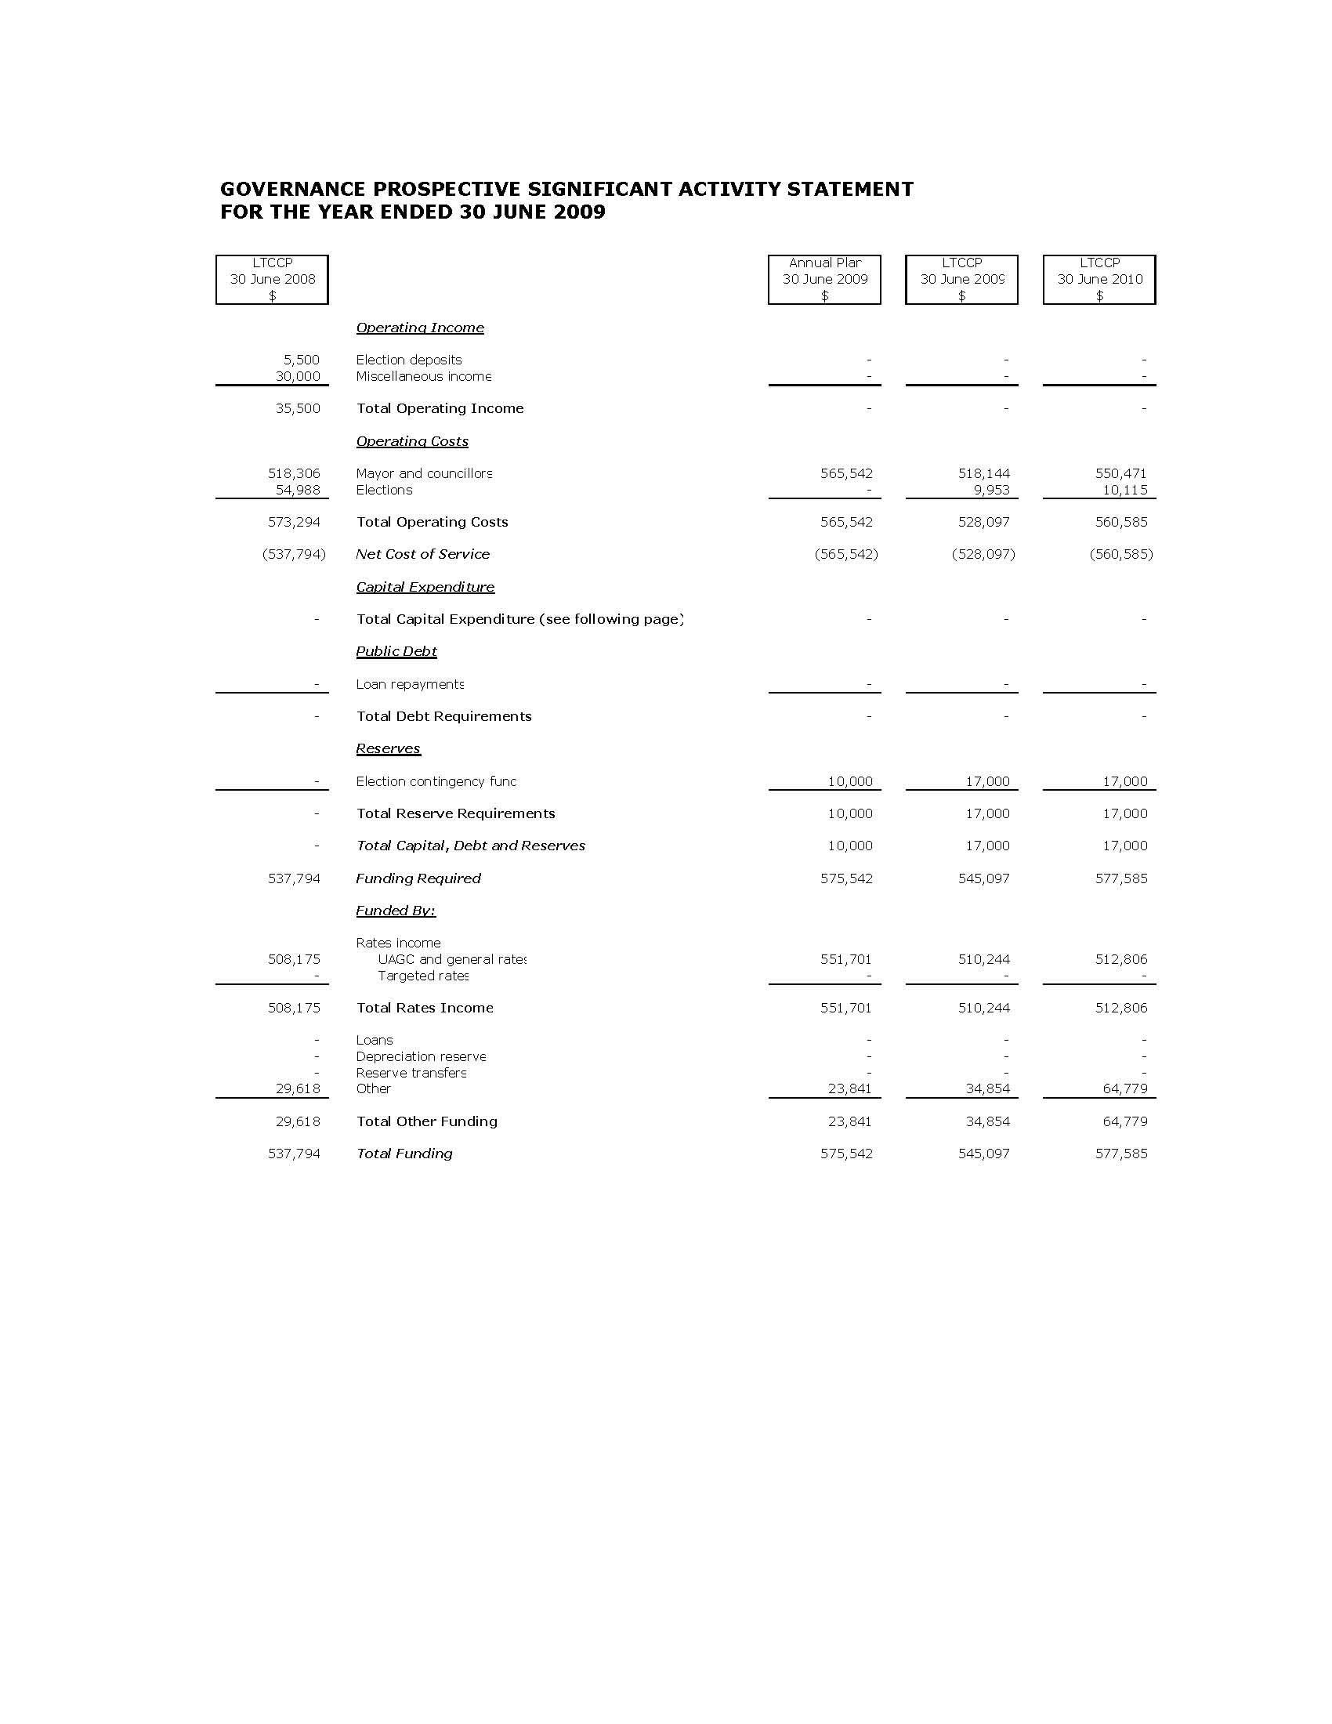
Economic, Cultural & Community Development

Scope & Nature of Activity

This activity includes the following services and programmes:

Economic

- Tourism and economic development support, including grants to Destination Wairarapa and the Carterton Information Centre & Gallery.
- Event support, including the Daffodil Carnival, Balloon Fiesta and community events.
- General promotion of the Carterton District.

Cultural

- Provision of library services, including written and recorded material, CDs, magazines and access to electronic information.
- Provision of school holiday programmes.
- Funding to Aratoi.
- Participating in the ongoing development and implementation of the Wairarapa Arts, Culture and Heritage Strategy.
- Creative Communities Fund

Community Development

- Community support, including the funding of South Wairarapa Safer Community Council, Wairarapa Healthy Homes and Council’s Community Grants Scheme.
- Participation in the ongoing development and implementation of the Wairarapa Physical Activity Plan.
- Provision of annual scholarships to UCOL and the Taratahi Agricultural Training Centre.
- Rural Travel Fund
- Climate Change and Energy Efficiency Initiatives.

Why Council undertakes this Activity

Economic

Economic growth is vital to the development of the district and region. Council contributes to economic development initiatives to encourage business growth, employment and tourism in the district and region.

Cultural & Community Development

Access to cultural and community development activities and services contributes to the cultural and social wellbeing of the community. Council contributes because it is part of the social fabric which makes the Carterton community vibrant and a great place to live in.

Community Outcomes to which the Activity Contributes

Community Outcomes | How Economic, Cultural & Community Development Contributes
A buoyant local economy. | By contributing to the economic development of the district.
Access to transport and communication systems that best meet the needs of the district. | By providing public access to information services via the Public Library.
A safe, healthy and educated community. | By contributing to the social wellbeing of the community.

What Role will Council Plan in Achieving the Community Outcomes

Advocate | √
Funder | √
Service Provider | √
Facilitator | √
Monitor | √

How we Manage the Activity

Cultural

Council aims to maintain the Library and its services in good condition to maintain the existing level of service.

Economic & Community Development

The majority of activities covered under the heading of Economic and Community Development are either contributions Council makes in conjunction with the region’s other territorial local authorities to organisations to provide agreed services to the Wairarapa region, or funding provided by Council which has to meet the criteria set for that particular funding.

Levels of Service & Performance Measures

Level of Service | Performance Indicator
Control capital and operational expenditure to complete all activities within allocated budgets. | Expenditure is within budget as agreed with Council.
Provide a quality library/information service to customers and grow the customer base. | The number of people who are library users’ increase by 2% over the previous year.
Provide financial support to community based organisations that contribute to the social wellbeing of the Carterton community. | To distribute the community grants budget in accordance with the Council’s Community Grants Policy.
Encourage the Carterton community to be healthy and active. | Progress on the implementation of the Wairarapa Physical Activity Plan is reported by 30 June.
Encourage engagement and participation in the arts, heritage and culture of the region. | Progress on the implementation of the Wairarapa Arts, Culture & Heritage Strategy is reported by 30 June.
Provide financial support to economic development based organisations that contribute to the economic wellbeing of the Carterton community. | To distribute an annual grant to Destination Wairarapa in accordance with the parameters agreed between Destination Wairarapa and Council.

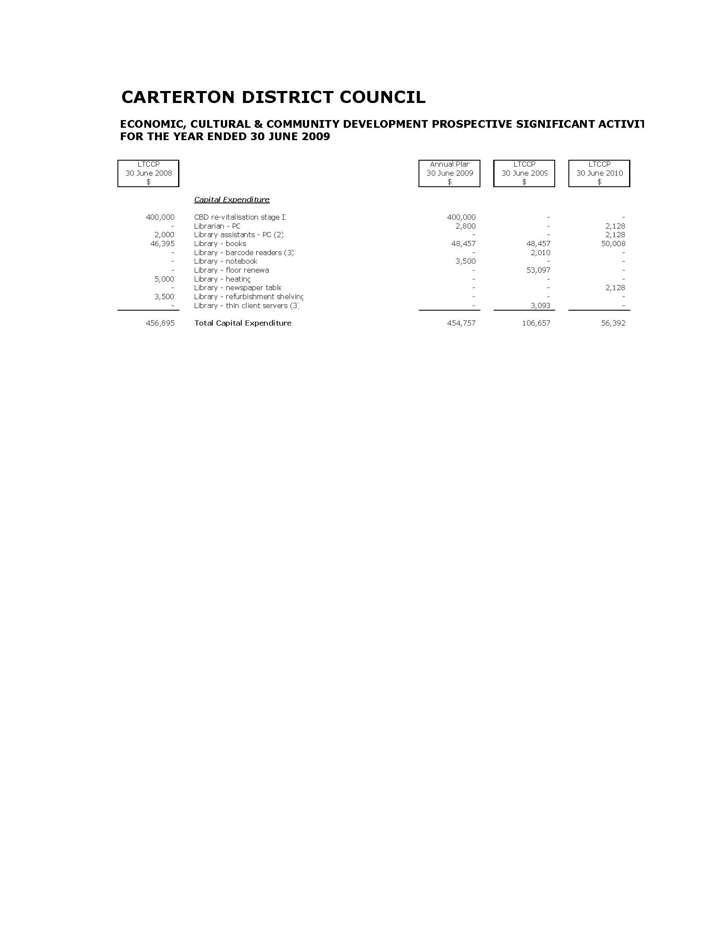
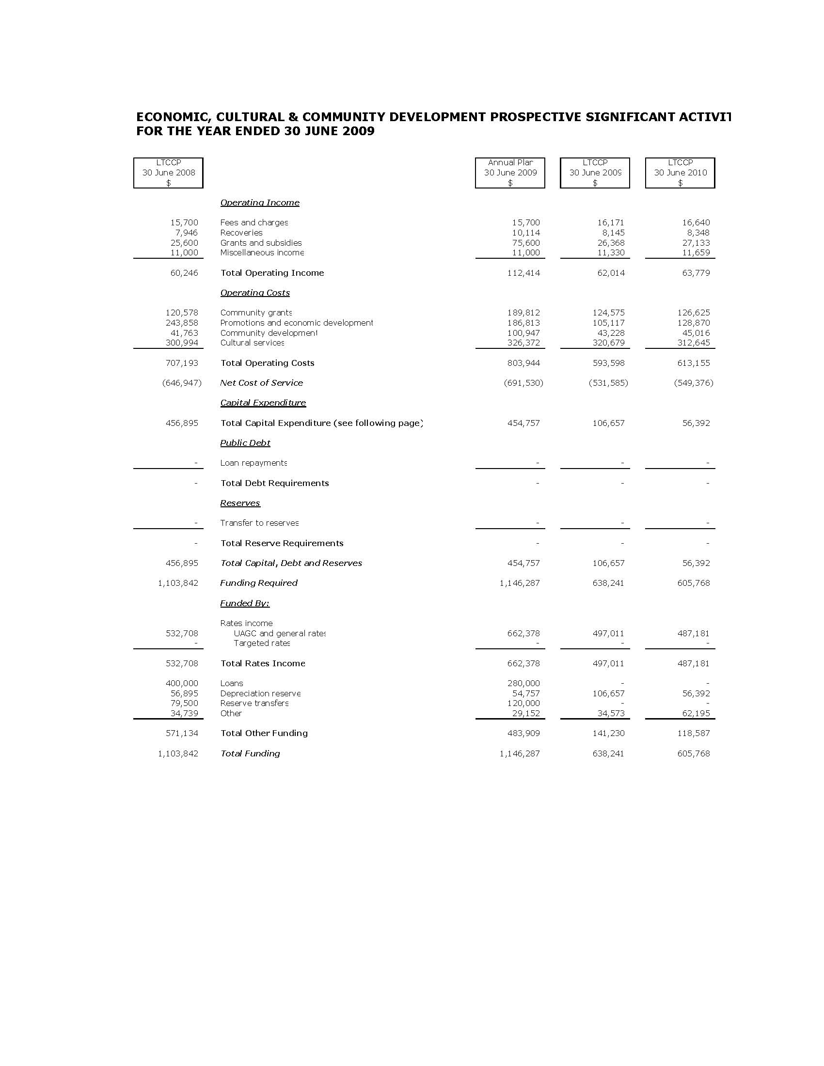
Roads, Streets, & Footpaths

Scope & Nature of Activity

The Council’s role is to provide and operate a safe and efficient roading network that serves the needs of the Carterton district.

This activity includes the following services and programmes:

- Management of Assets – roads, footpaths, street lighting, street and road signs.
- Funding of the Wairarapa Road Safety Council.

Why Council Undertakes this Activity

Council has a legislative requirement to provide and manage the roads within the district.

The roading and footpath network benefits every resident in the district and society in general and are essential for the social, economic and cultural wellbeing of the district and region.

Community Outcomes to which the Activity Contributes

Community Outcomes | How Roads, Streets & Footpaths Contributes
Access to transport and communication systems that best meet the diverse needs of the district. | By providing a well maintained district roading network.
A safe, healthy and educated community. | By supporting community education programmes that promote road safety and community education.

What Role will Council Play in Achieving the Community Outcomes

Advocate | √
Funder | √
Service Provider | √
Monitor | √

How we Manage the Activity

The district’s roading and footpath network are managed under the Roading Asset Management Plan, which sets out the targets for asset condition, performance and levels of service.

Level of Service & Performance Measures

Level of Service | Performance Indicators
Control expenditure to complete all programmed works within allocated budgets. | Expenditure for the roading network is within budget agreed with Council.  Expenditure on footpath renewals is within budgets agreed with Council.
Asset value and capability of the networks are maintained at the current level as agreed by the community. | Networks maintained to a level as specified in the roading maintenance contract as setout in the AMP.
Maintain current standard of district’s roads, including bridges, road signs, street lighting, kerbs and drainage facilities. | 90% compliance with the Maintenance Contract response times.
Provide financial support to organisations who undertake road safety education programmes. | Provide funding to the Wairarapa Road Safety Council as agreed between the Road Safety Council and Council. The Wairarapa Road Safety Council to report on initiatives undertaken by 30 June each year.

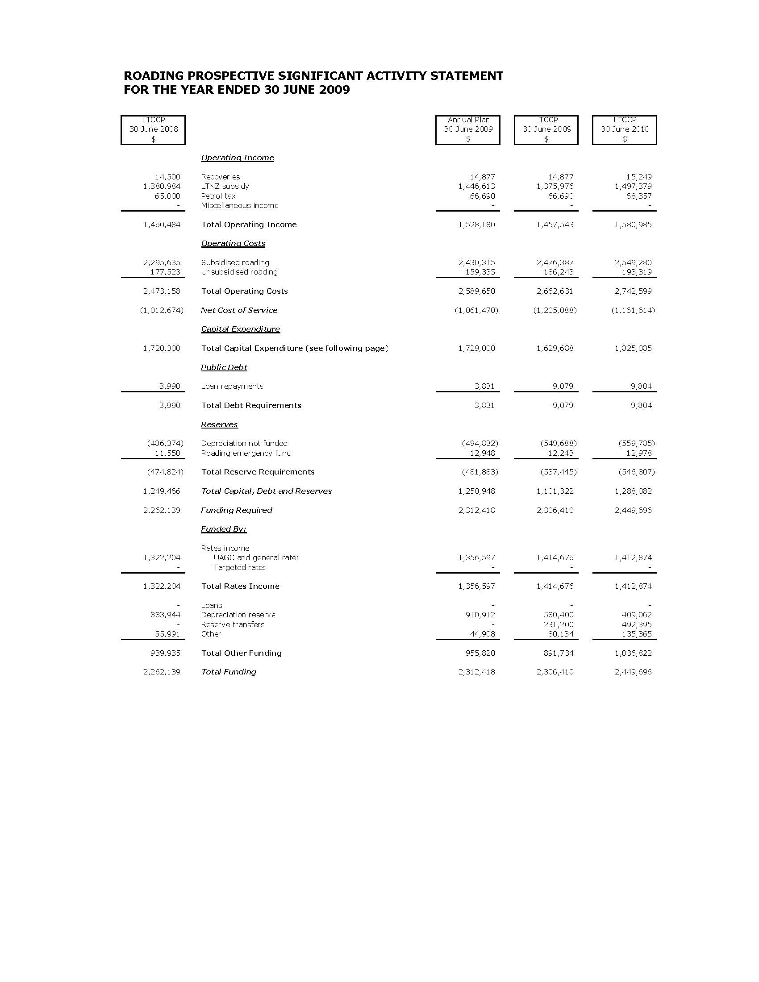

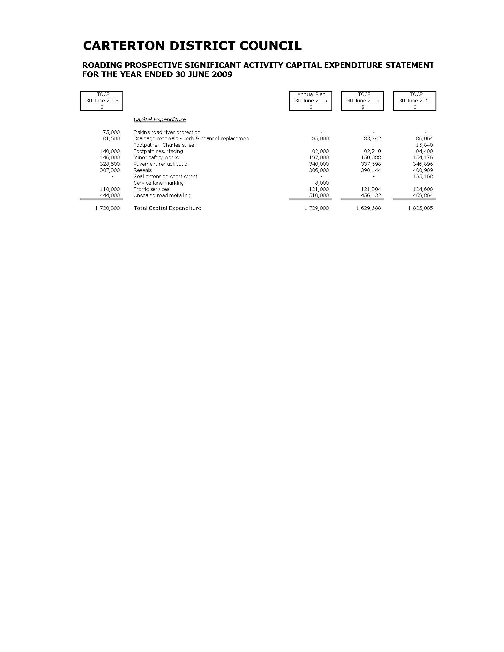
Water

Scope & Nature of Activity

This activity includes the following services:

- Management of the district’s water reticulation and treatment facilities.
- Monitor the quality of the reticulated water supply.
- Promotion and education of water conservation methods.

Why Council Undertakes this Activity

Water is an essential commodity for the health of people living in the community and for business viability.

Council’s role is to ensure that the community has an adequate water supply which is sustainable for future generations and does not adversely affect the environment.

Community Outcomes to which the Activity Contributes

Community Outcomes | How Urban Water Contributes
A buoyant local economy. | By delivering water to Carterton residents in a cost effective manner.
Clean land, water and air for present and future generations. | By ensuring that the water supply activity is managed in a sustainable manner.
A safe, healthy and educated community. | By providing a water treatment system which meets Ministry of Health Standards.

What Role will Council Play in Achieving the Community Outcomes

Advocate | √
Funder | √
Service Provider | √
Monitor | √

How we Manage the Activity

The urban reticulated water network is managed under the Water Asset Management Plan which sets out the targets for asset condition, performance and levels of service.

Levels of Service & Performance Measures

Level of Service | Performance Indicators
Control expenditure to complete all programmed works within allocated budgets. | Expenditure is within approved budgets for programmed works,
Maintain water quality to potable standards. | 100% compliance with bacteriological requirements of the NZ Drinking Water Standards.
Asset value and capability of the networks are maintained at current level as agreed by the community. | Networks maintained to a level as specified in the water asset management plan.
Water supply is operated in accordance with resource consent conditions. | 100% compliance with water resource consent conditions.
Promote community awareness of water conservation practices. | Each household connected to the urban reticulated supply be issued with two conservation reminders per year.

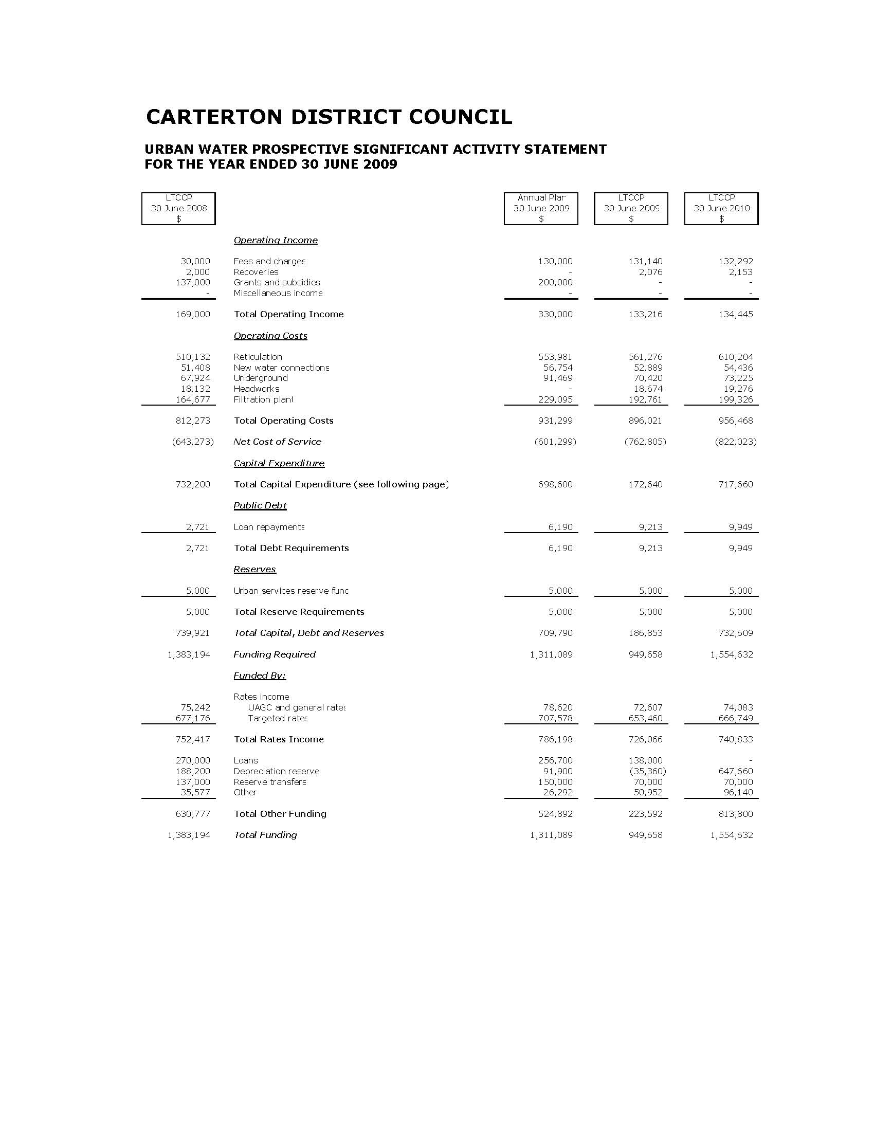

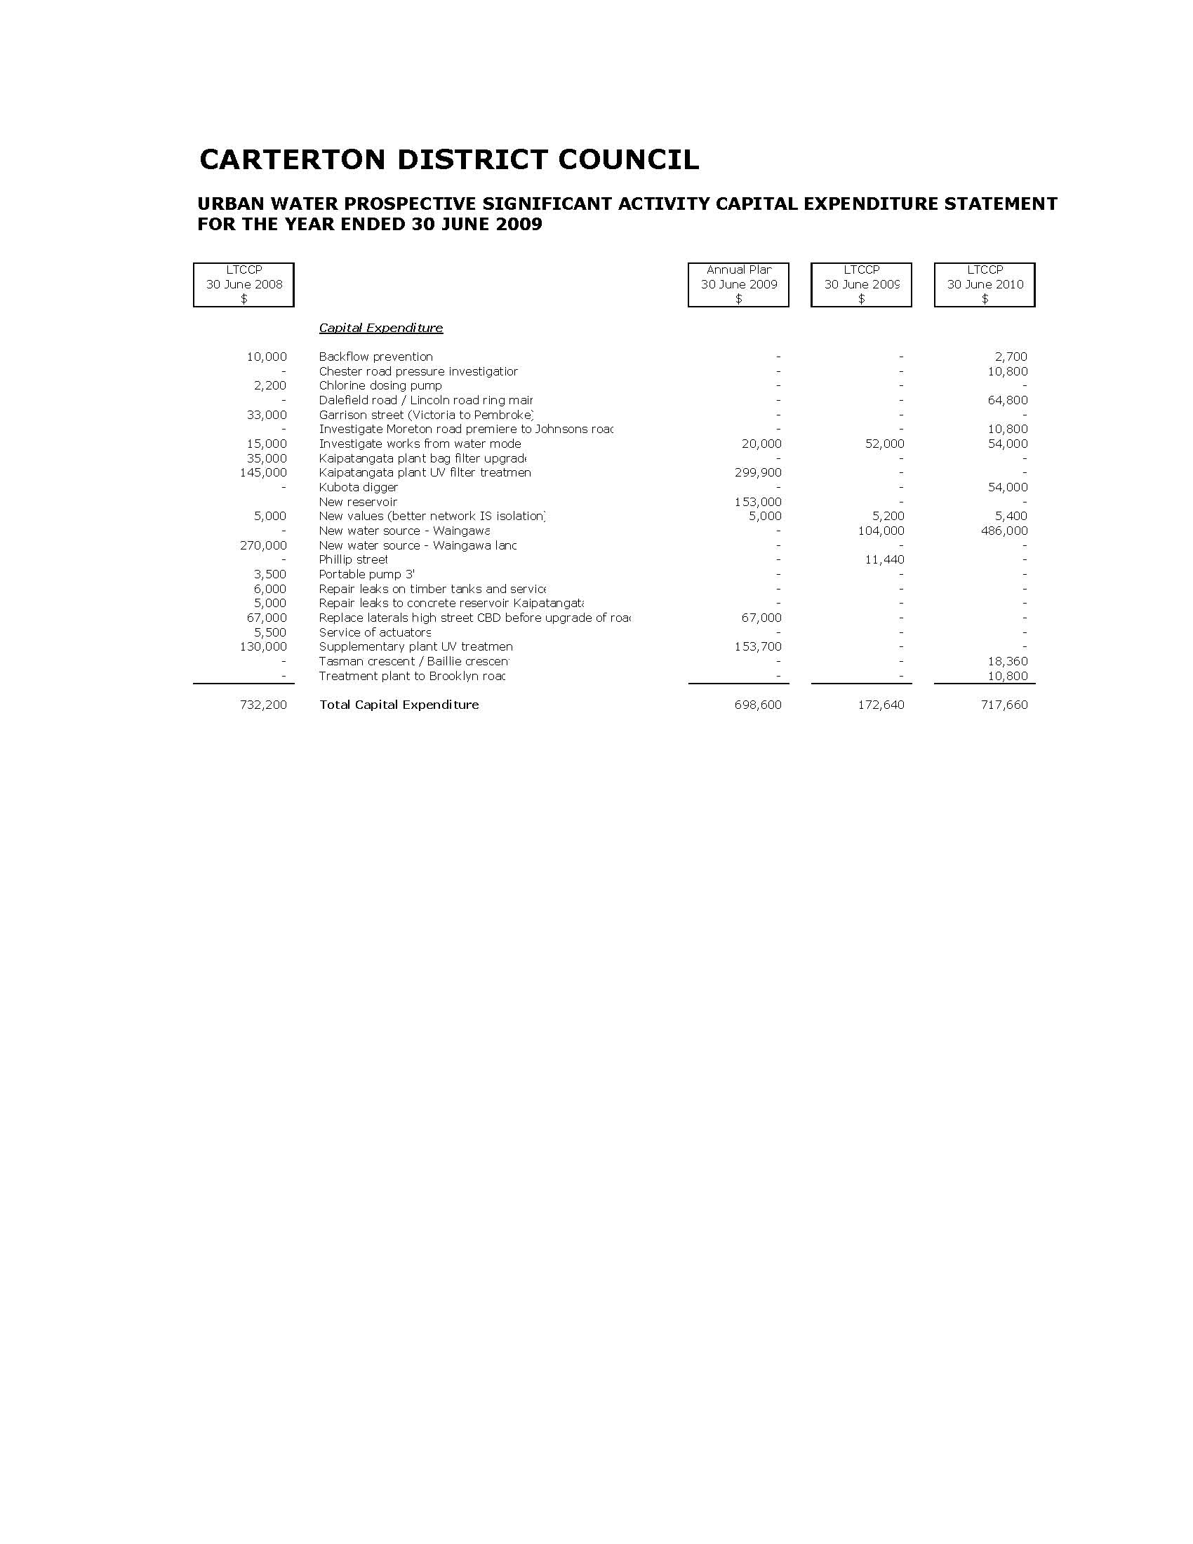

Rural Water Services

Scope & Nature of Activity

This activity includes the following services:

- Management of the Carrington and Taratahi Water Races for stock use, non-potable domestic and industrial use, rural fire fighting and stormwater control,

Why Council Undertakes this Activity

Water is an essential commodity for the health of people living in the community and for business viability.

Council’s role is to ensure that property owners and businesses who have access to the Carrington and Taratahi Water Race system have an adequate supply of non-potable water which is sustainable and does not adversely affect the environment.

Community Outcomes to which the Activity Contributes

Community Outcomes | How Rural Water Services Contributes
A buoyant local economy. | By delivering a managed rural water service to properties with access to the Carrington and Taratahi Water Race system in a cost effective manner.
Clean land, water and air for present and future generations. | By ensuring that the rural water service is managed in a sustainable manner.
A safe, healthy and educated community. | By providing water for non-potable purposes only.

What Role will Council Play in Achieving the Community Outcomes

Funder | √
Service Provider | √

How we Manage the Activity

The Rural Water Race activity is under the oversight of the Water Race Committee which is made up of councillors and community members elected by water race users. The Committee determines policy and sets targets for maintenance to retain the existing level of service.

Levels of Service & Performance Measures

Level of Service | Performance Indicators
Control expenditure to complete all programmed works within allocated budgets. | Expenditure is within approved budgets for programmed works.
The Rural Water Service is operated in accordance with resource consent conditions. | 100% compliance with water resource consent conditions.
The Water Race Committee meets a minimum of three times per year to discuss relevant issues. | Meeting Minutes.
Operate the Rural Water Service systems in a manner which is environmentally sensitive. | No unresolved environmental complaints as at 30 June each year.

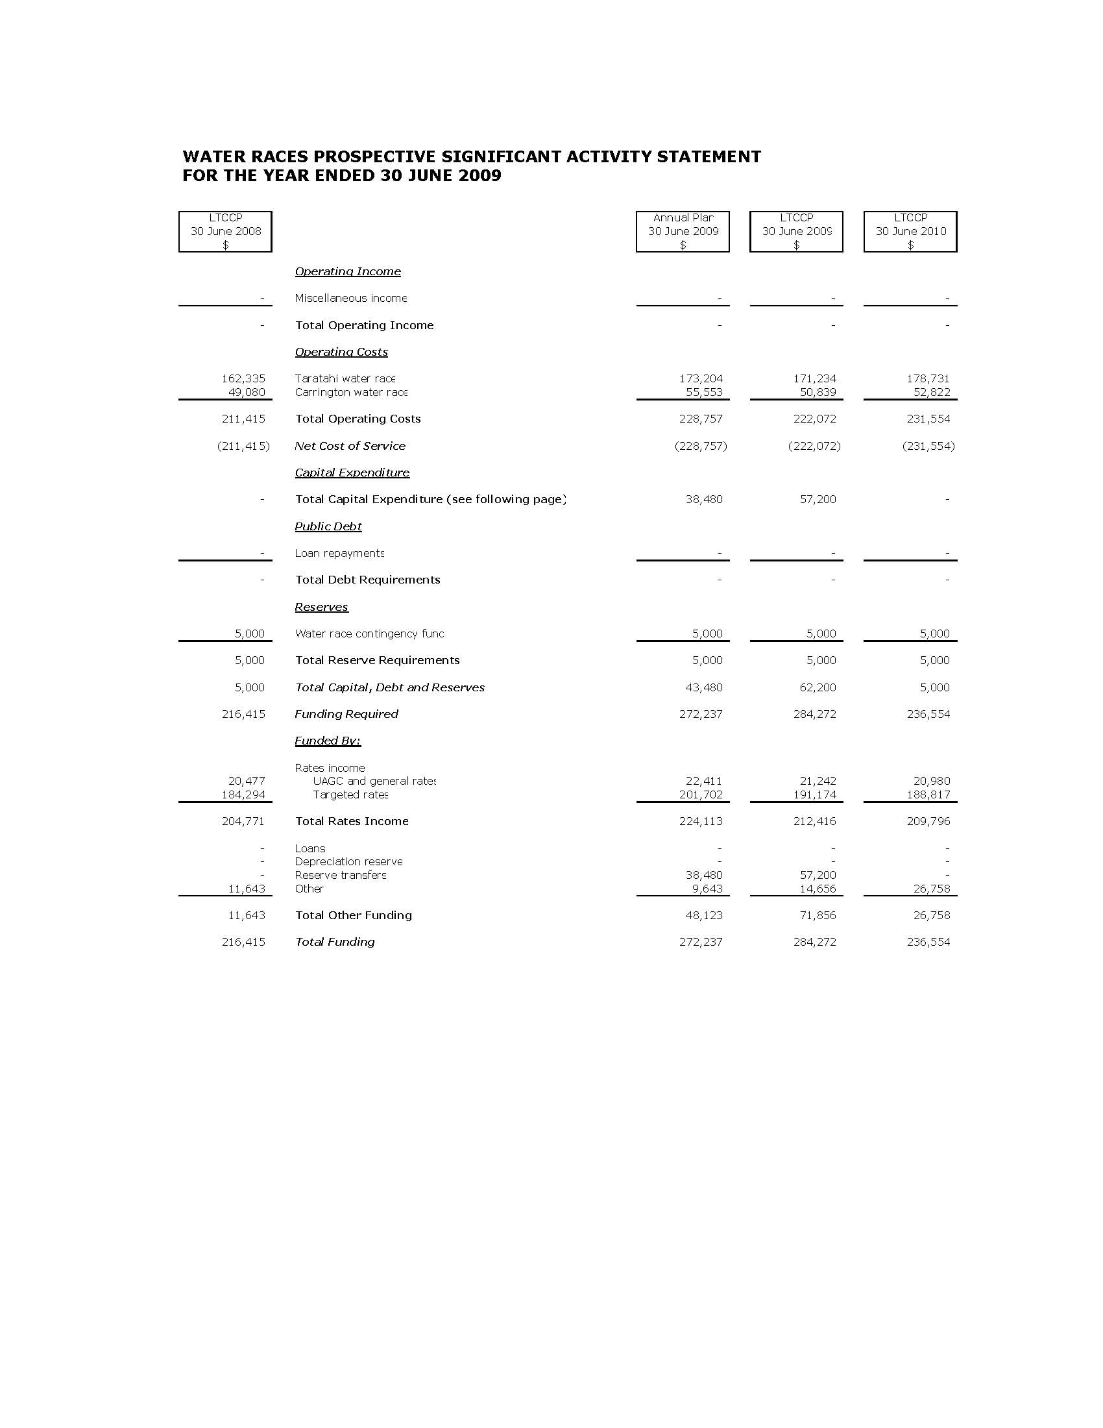

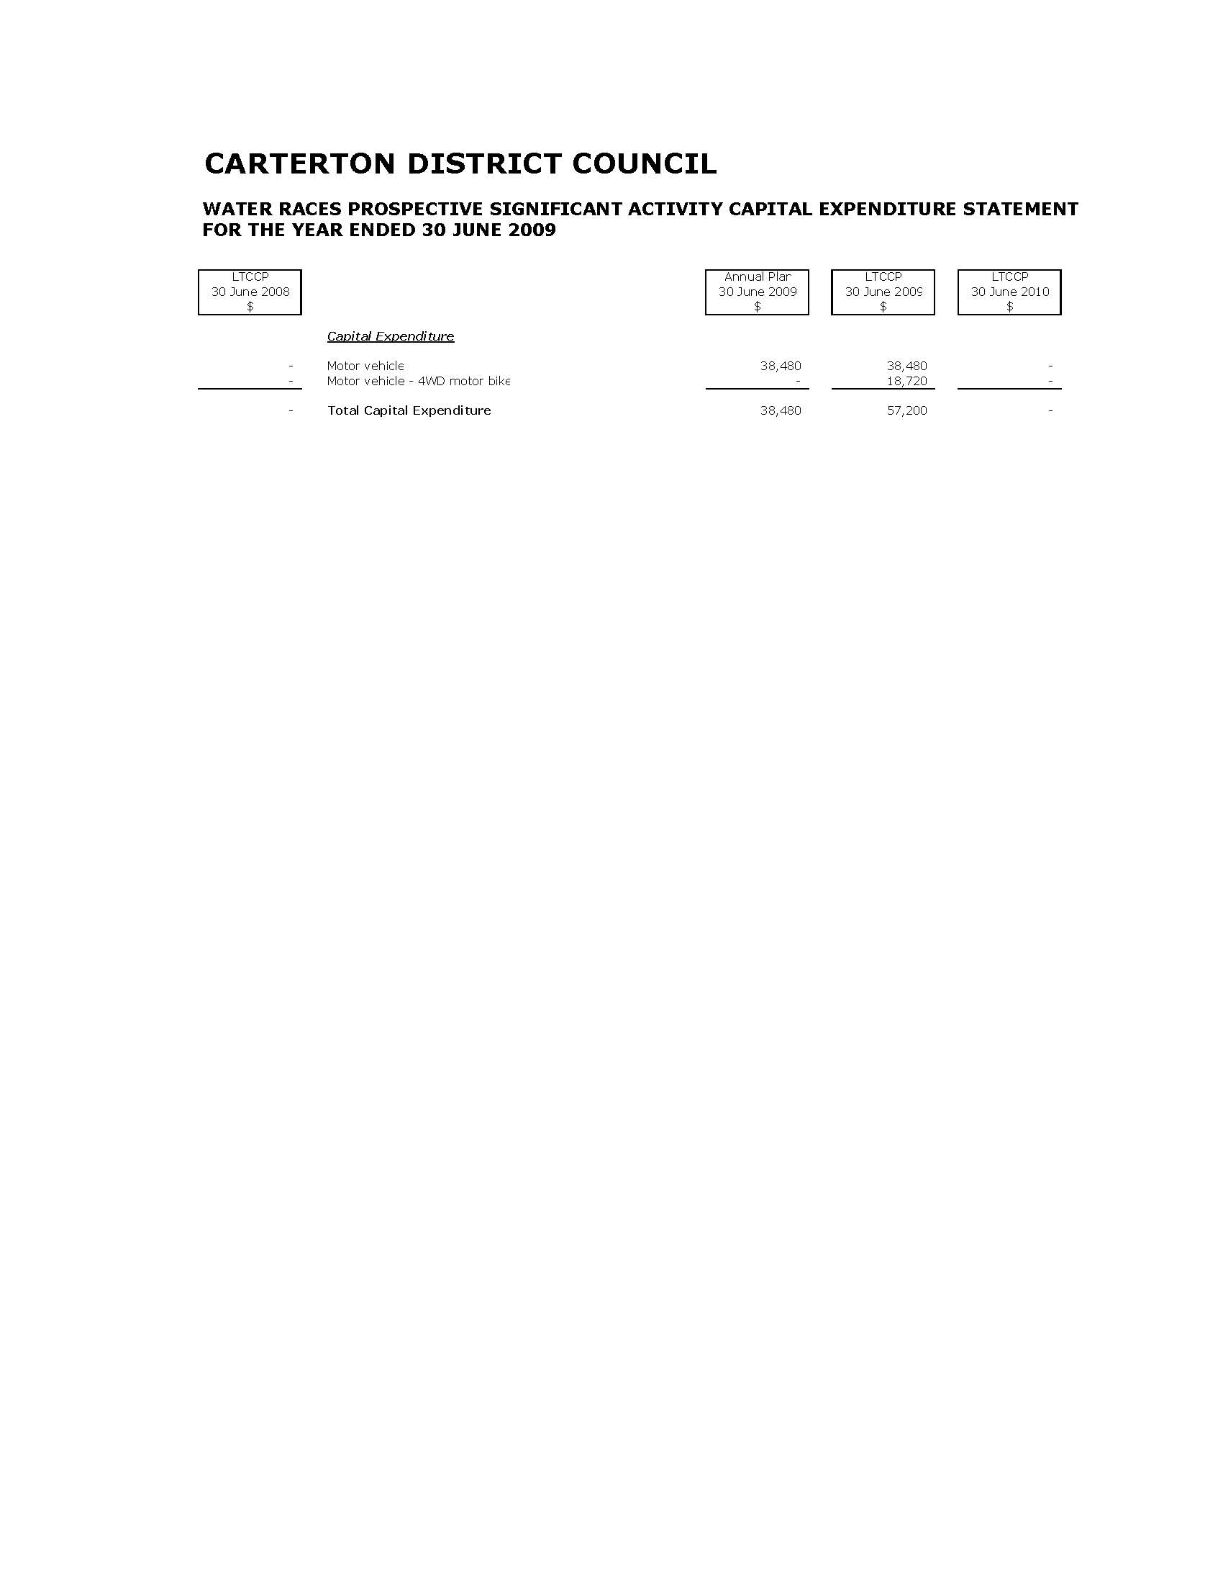
Stormwater

Scope & Nature of Activity

This activity includes the following services:

- Management of the urban stormwater system which includes street kerb collection, piped and open drains.
- Identifying flood prone areas, reviewing known trouble areas and developing cost effective solutions.

Why Council Undertakes this Activity

Council provides the urban stormwater system to ensure that surface flooding in the urban area as a result of high rainfall is contained to waterways and flood prone areas are protected.

Community Outcomes to which the Activity Contributes

Community Outcomes | How Stormwater Contributes
Clean land, water and air for present and future generations. | By ensuring that the stormwater activity is managed in an appropriate manner.
A safe, healthy and educated community. | By undertaking a maintenance programme to minimise potential risks to the health and safety of residents.

What Role will Council Play in Achieving the Community Outcomes

Funder | √
Service Provider | √
Monitor | √

How we Manage the Activity

The urban reticulated stormwater network is managed under the Stormwater Asset Management Plan, which sets out the asset condition, performance and levels of service.

Levels of Service & Performance Measures

Level of Service | Performance Indicator
Control expenditure to complete all programmed works within allocated budgets. | Expenditure is within approved budgets for programmed stormwater works.
Stormwater systems are operated in accordance with resource consents. | 100% compliance with resource consent conditions including compliance monitoring.

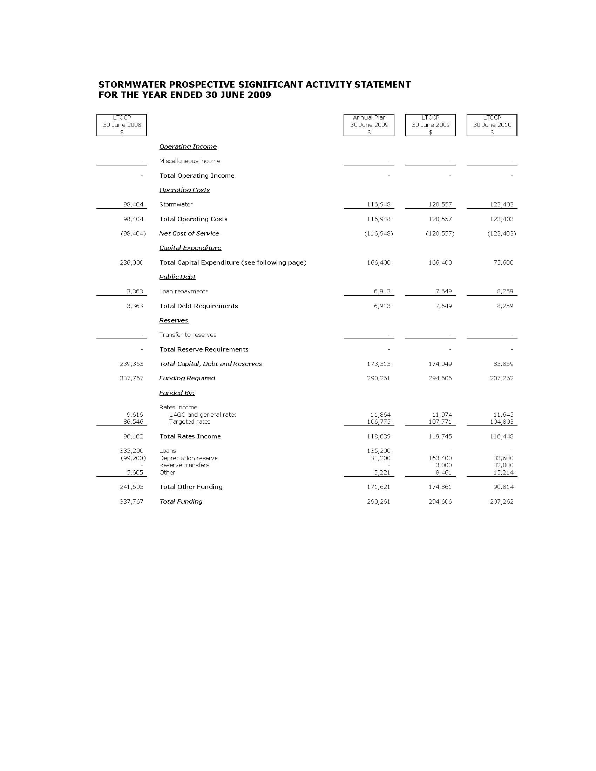

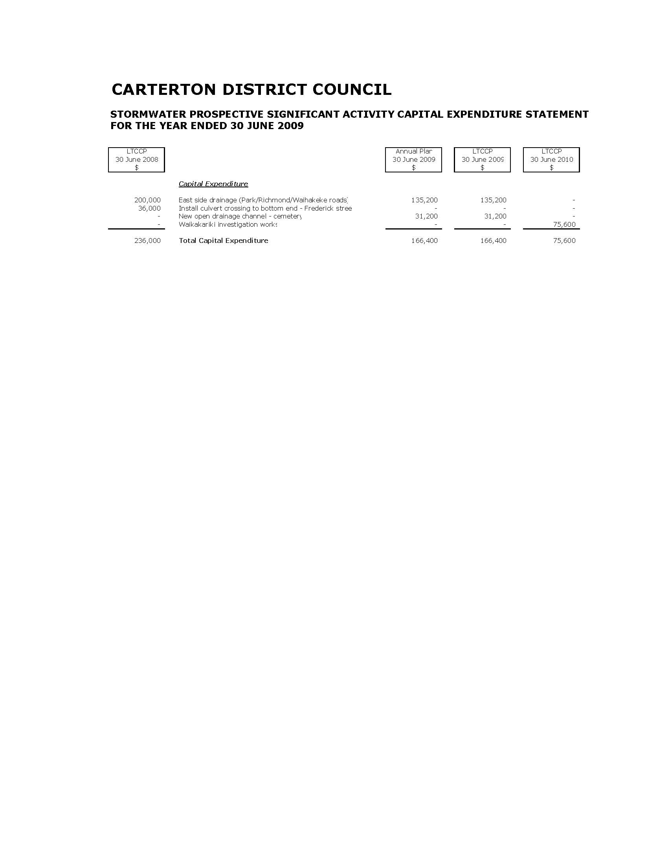
Wastewater

Scope & Nature of Activity

This activity includes the following services:

- Management of the urban reticulated wastewater system, treatment plant and pumping stations.
- Management of the impact of any discharge into the environment.

Why Council Undertakes this Activity

Council provides the urban reticulated wastewater system and treatment facilities to ensure high quality health outcomes for the community and to minimise adverse environmental impact on the environment.

Community Outcomes to which the Activity Relates

Community Outcomes | How Wastewater Contributes
A buoyant local economy. | By delivering the wastewater activity to Carterton residents in a cost effective manner.
Clean land, water and air for present and future generations. | By ensuring that the wastewater activity is managed in a sustainable manner.
A safe, healthy and educated community. | By ensuring that the wastewater activity is managed to minimise any potential risks to the health and safety of Carterton residents.

What Roles will Council Play in Achieving the Community Outcomes

Advocate | √
Funder | √
Service Provider | √
Monitor | √

How we Manage the Activity

The urban reticulated wastewater network is managed under the Wastewater Asset Management Plan, which sets out the targets for asset condition, performance and levels of service.

Levels of Service & Performance Measures

Level of Service | Performance Indicators
Control expenditure to complete all programmed works within allocated budgets. | Expenditure is within approved budgets for programmed wastewater works.
Operate the urban reticulated wastewater system to protect public health. | No unresolved public health risks/issues as at 30 June each year.
Reticulated urban wastewater system is operated in accordance with resource consents. | 100% compliance with resource consent conditions including compliance monitoring.

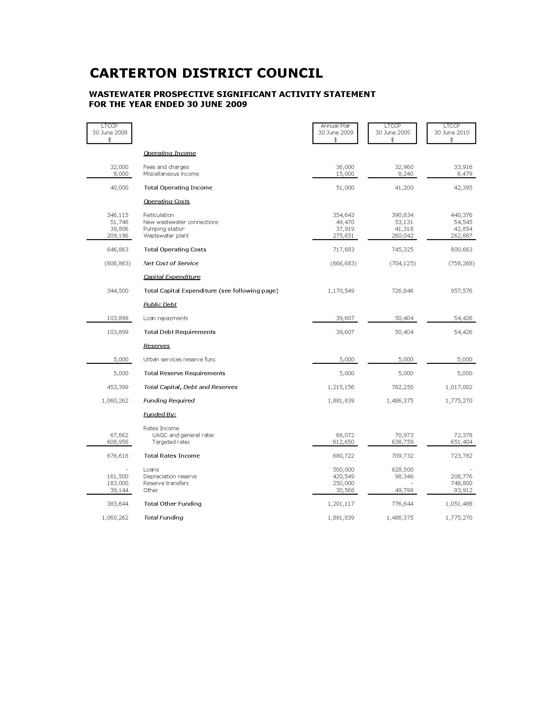

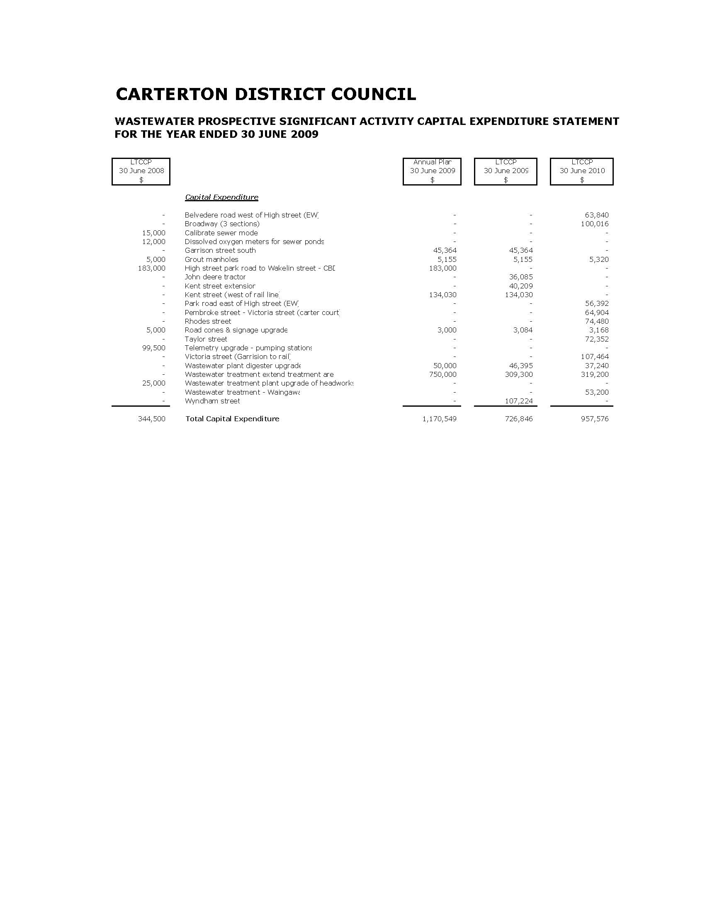
Waste Management

Scope & Nature of Activity

This activity includes the following services:

- Management of the Dalefield Road Transfer Station facilities and associated resource consents.
- Provision of a weekly kerbside refuse & recycling collection and transfer of residual waste to a properly engineered landfill in the Manawatu.
- Daily collection of refuse from street refuse bins.
- Promotion of waste minimisation and recycling.

Why Council Undertakes this Activity

Waste management is essential for the health and quality of the life of the Carterton community. Council is involved to ensure that the quality of the environment is maintained and that the health of the community is not compromised.

Community Outcomes to which the Activity Contributes

Community Outcomes | How Waste Management Contributes
A buoyant local economy. | By delivering the waste management activity to residents in a cost effective manner.
Clean land, water and air for present and future generations. | By ensuring that the waste management activity is managed in a sustainable manner.
A safe, healthy and educated community. | By providing residents with a safe and healthy refuse and recycling collection and Transfer Station

What Role will Council Play in Achieving the Community Outcomes

Advocate | √
Funder | √
Service Provider | √
Monitor | √

How we Manage the Activity

Waste Management Wairarapa, a joint committee of the Carterton, Masterton and South Wairarapa District Councils is responsible for facilitating solutions for the management of the district’s waste. Council has adopted the Solid Waste Management Plan for the Wairarapa as part of its management of solid waste.

Level of Service & Performance Measures

Level of Service | Performance Indicators
Control expenditure to complete all programmed works within allocated budgets. | Expenditure is within approved budgets for programmed waste management services.
The transfer station is operated in accordance with resource consents. | 100% compliance with resource consent conditions including compliance monitoring.
Collection of kerbside refuse and recycling and management of the Transfer Station is carried out in an efficient manner. | 100% compliance with contract requirements.

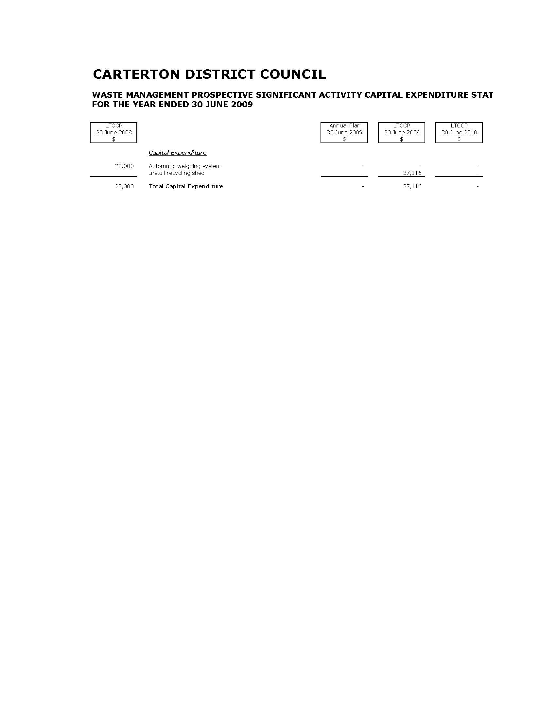
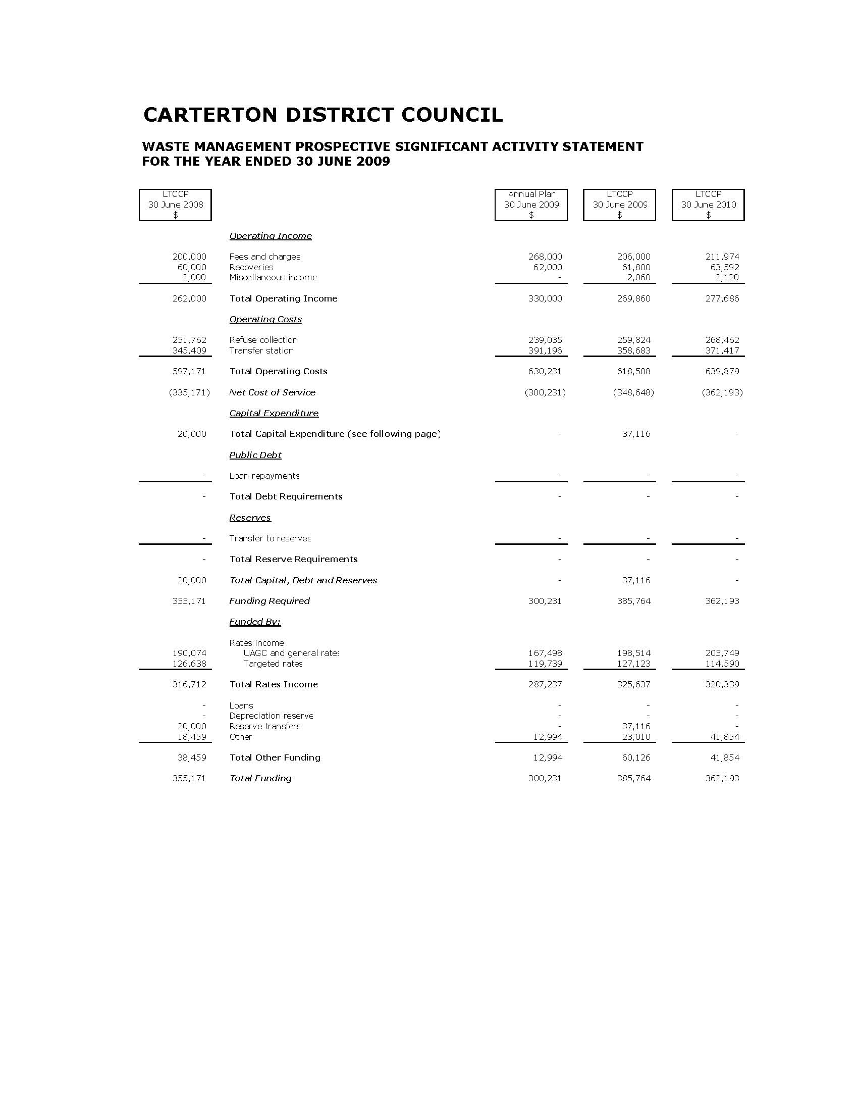
Parks & Reserves

Scope & Nature of Activity

This activity includes the following services:

- Maintenance and ongoing development of Carrington, Howard Booth, South End and Millennium Parks, Memorial Square and their facilities.
- Provision of the Council’s plant nursery.
- Urban street mowing and maintenance of the various civic areas and recreation reserves scattered throughout the urban area.
- Maintenance and ongoing development of the district’s rural reserves.

Why Council Undertakes this Activity

Parks and reserves make an important contribution to the health and lifestyle of the community. They provide areas for relaxation, sporting activities and green attractive open space areas in built up areas. Council contributes to promote the social and environmental wellbeing of the community.

Community Outcomes to which the Activity Contributes

Community Outcomes | How Parks & Reserves Contributes
A buoyant local economy. | Provide pleasant parks and reserves that assist in promoting the district and CBD area.
Clean land, water and air for present and future generations. | Use environmentally friendly parks and reserves maintenance techniques.
A safe, healthy and educated community. | Make available and encourage use of safe play and sporting facilities and provide clean civic amenities.

What Role will Council Play in Achieving the Community Outcomes

Funder | √
Service Provider | √
Facilitator | √

How we Manage the Activity

The Parks & Reserves activity assets are kept in good condition to maintain the existing level of service. New play equipment complies with NZS5828 for playground equipment.

Level of Service & Performance Measures

Level of Service | Performance Indicators
Control expenditure to complete all programmed works within allocated budgets. | Expenditure is within approved budgets for programmed parks and reserves services,
Attractive bedding displays are provided in civic areas. | Flowering bedding displays provided in civic areas twice a year.
Vandalism on Council property is attended to on a timely basis. | High profile and/or offensive graffiti is removed within four hours of Council being made aware of it.  All other graffiti is removed within three working days.
Playground equipment complies with NZS5828. | All new play equipment complies with NZS5828 for playground equipment.

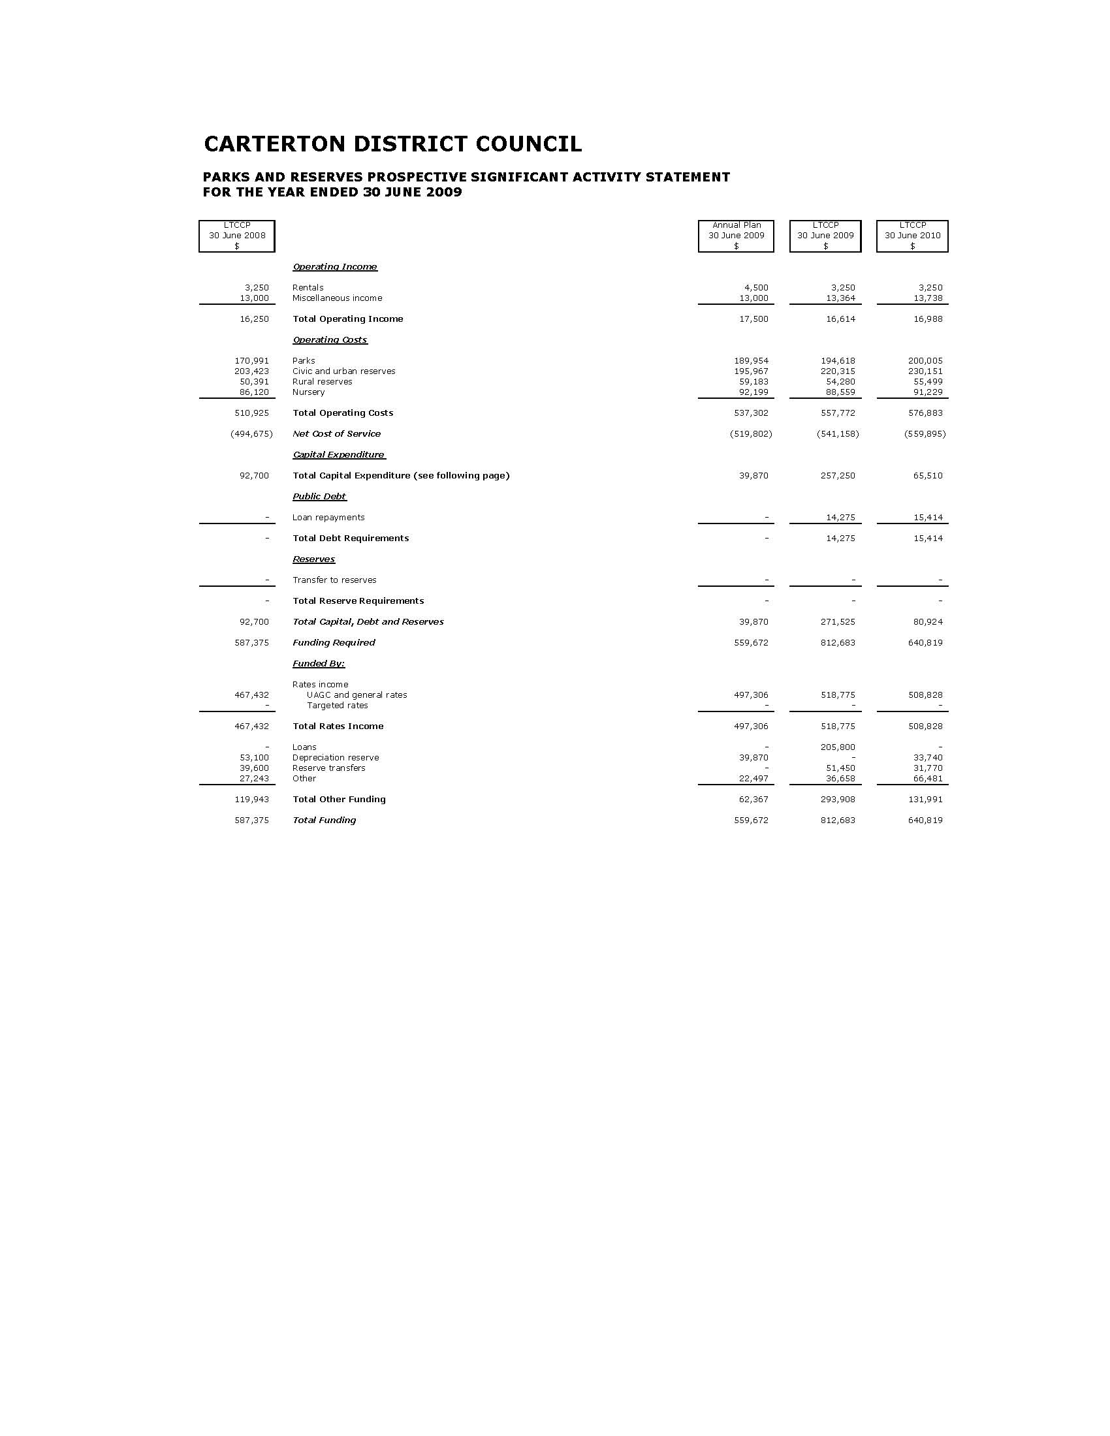
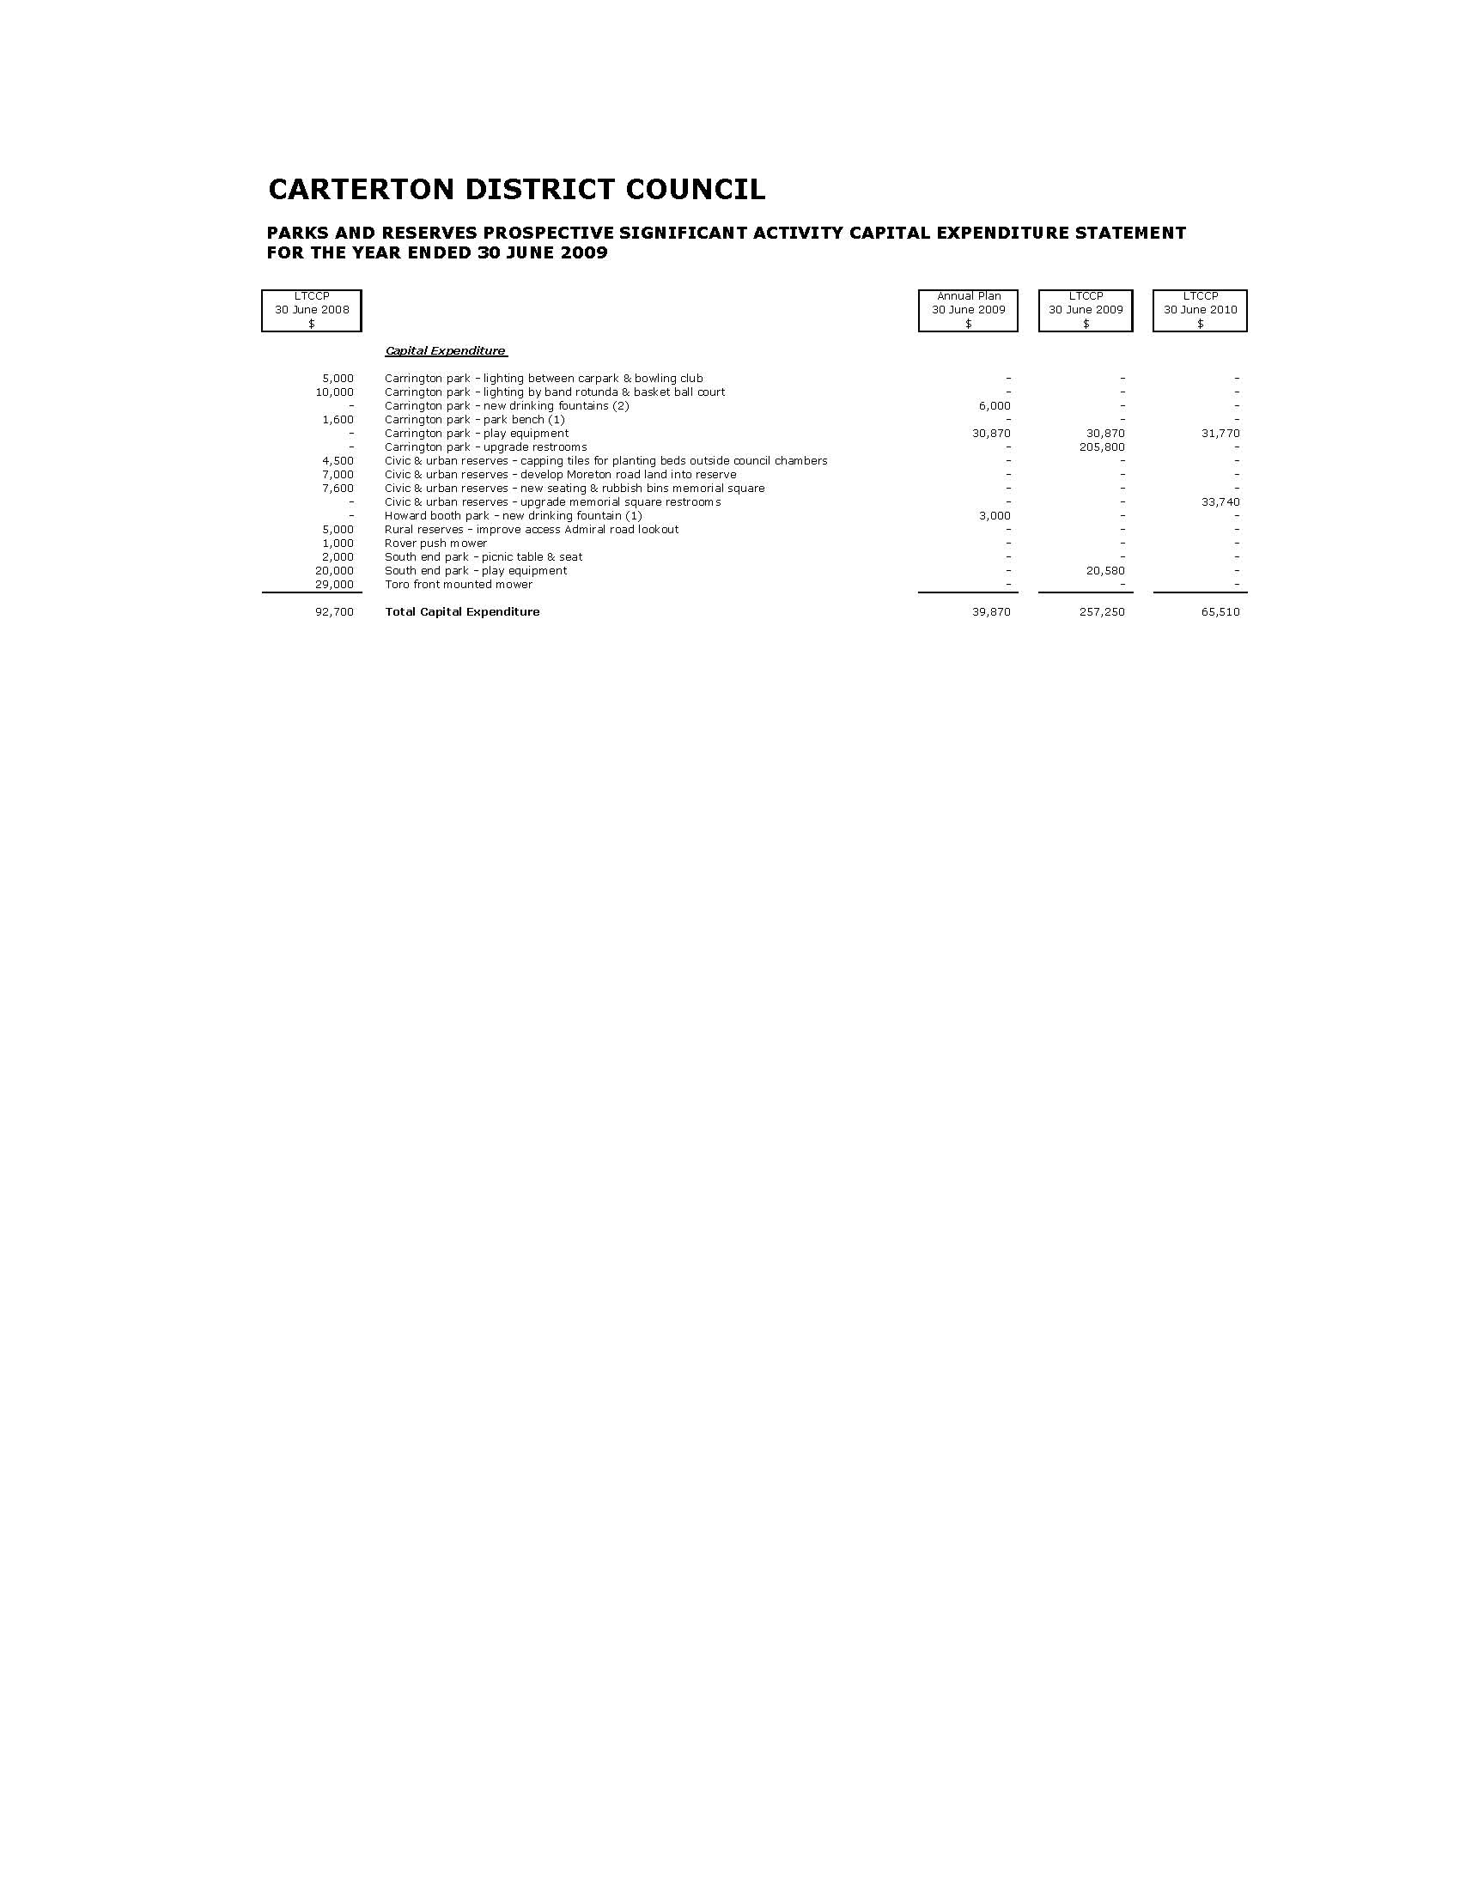
Community Amenities

Scope & Nature of Activity

This activity includes the following services:

- Maintenance and the ongoing development of the Clareville Cemetery.
- Maintenance and the ongoing development of the Outdoor Swimming Complex.
- Maintenance and the ongoing development of the public restrooms.

Why Council Undertakes this Activity

The Community Amenities activity contributes to the health of the district’s community, and is important to the social fabric of the district.

Community Outcomes to which the Activity Contributes

Community Outcomes | How Community Amenities Contributes
A buoyant local economy. | By providing facilities which contribute to the economic wellbeing of the district.
A safe, healthy and educated community. | By providing facilities which contribute to the health and wellbeing of the district’s residents and visitors.

What Role will Council Play in Achieving the Community Outcomes

Funder | √
Service Provider | √
Monitor | √

How we Manage the Activity

The Clareville Cemetery is managed in compliance with relevant legislation, with assets kept in good condition to maintain the existing level of service.

The Outdoor Swimming Pool is managed to comply with relevant legislation, with the assets being kept in good condition to maintain the existing level of service.

The Public Restrooms are managed with the aim of the restrooms being clean and useable during opening hours. Buildings are maintained to a level to maintain the existing level of service.

Level of Service & Performance Measures

Level of Service | Performance Indicators
Control expenditure to complete all programmed works within allocated budgets. | Expenditure is within approved budgets for the programmed community amenities budgets.
Provide safe and well maintained restrooms. | No unresolved complaints at 30 June each year.
Provide safe and well maintained outdoor swimming complex. | No unresolved complaints at 30 June each year.
Council provides a Cemetery which accommodates the burial needs of the district. | No complaints are received relating to burial services.

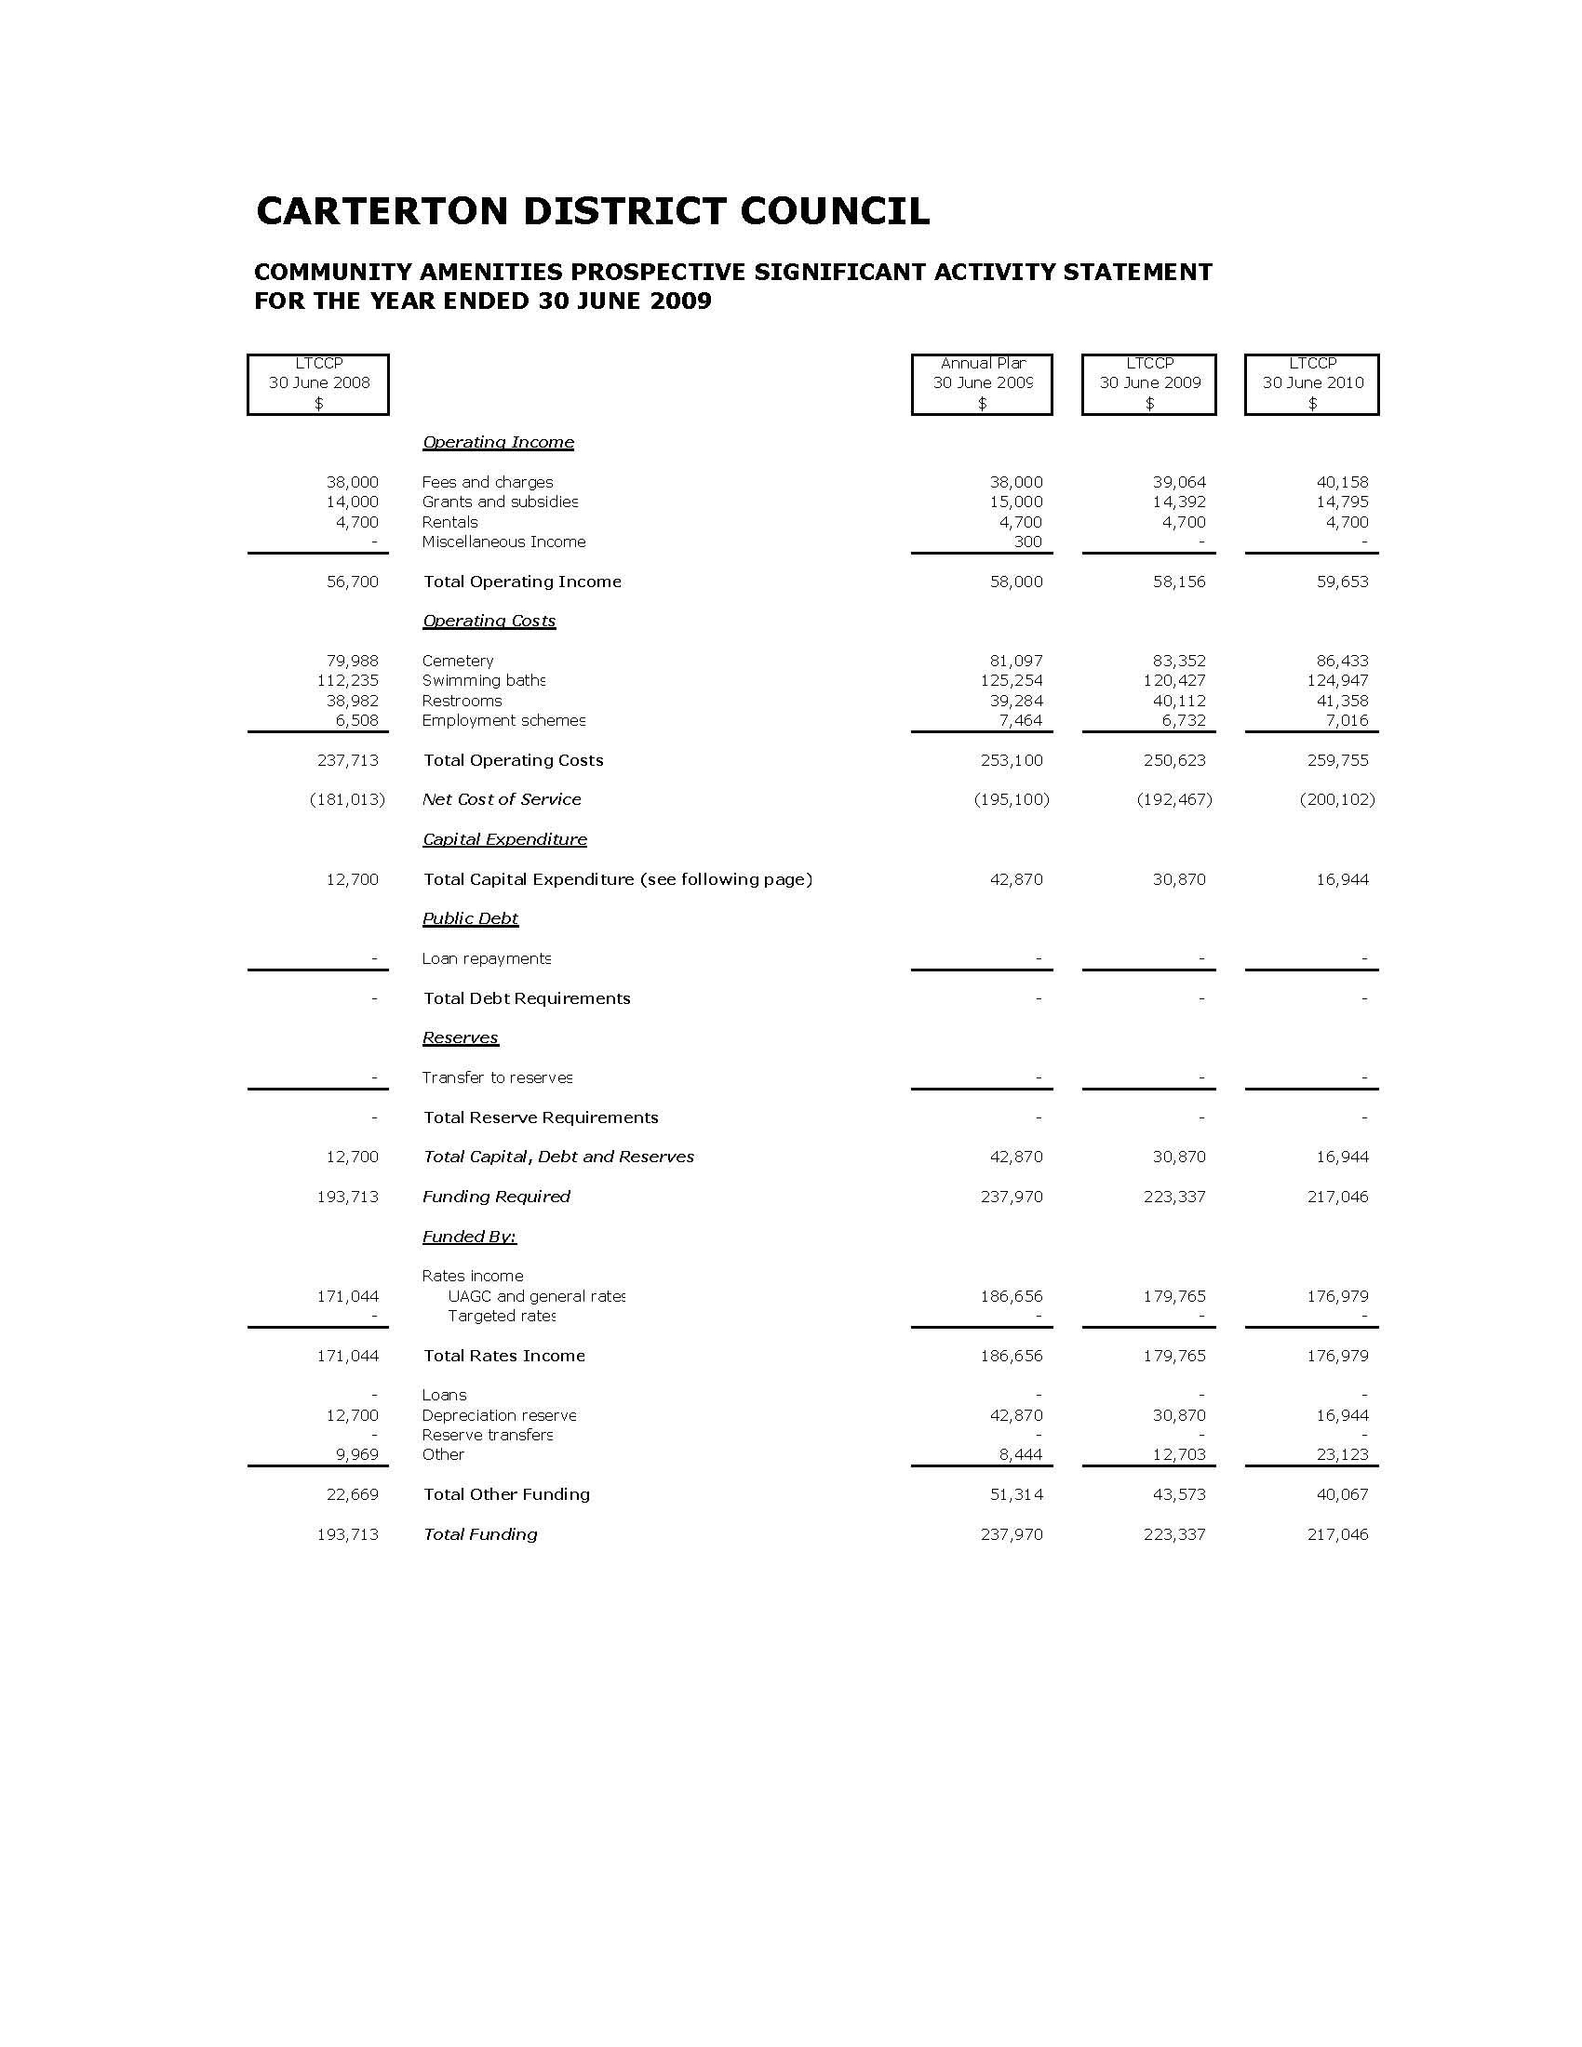
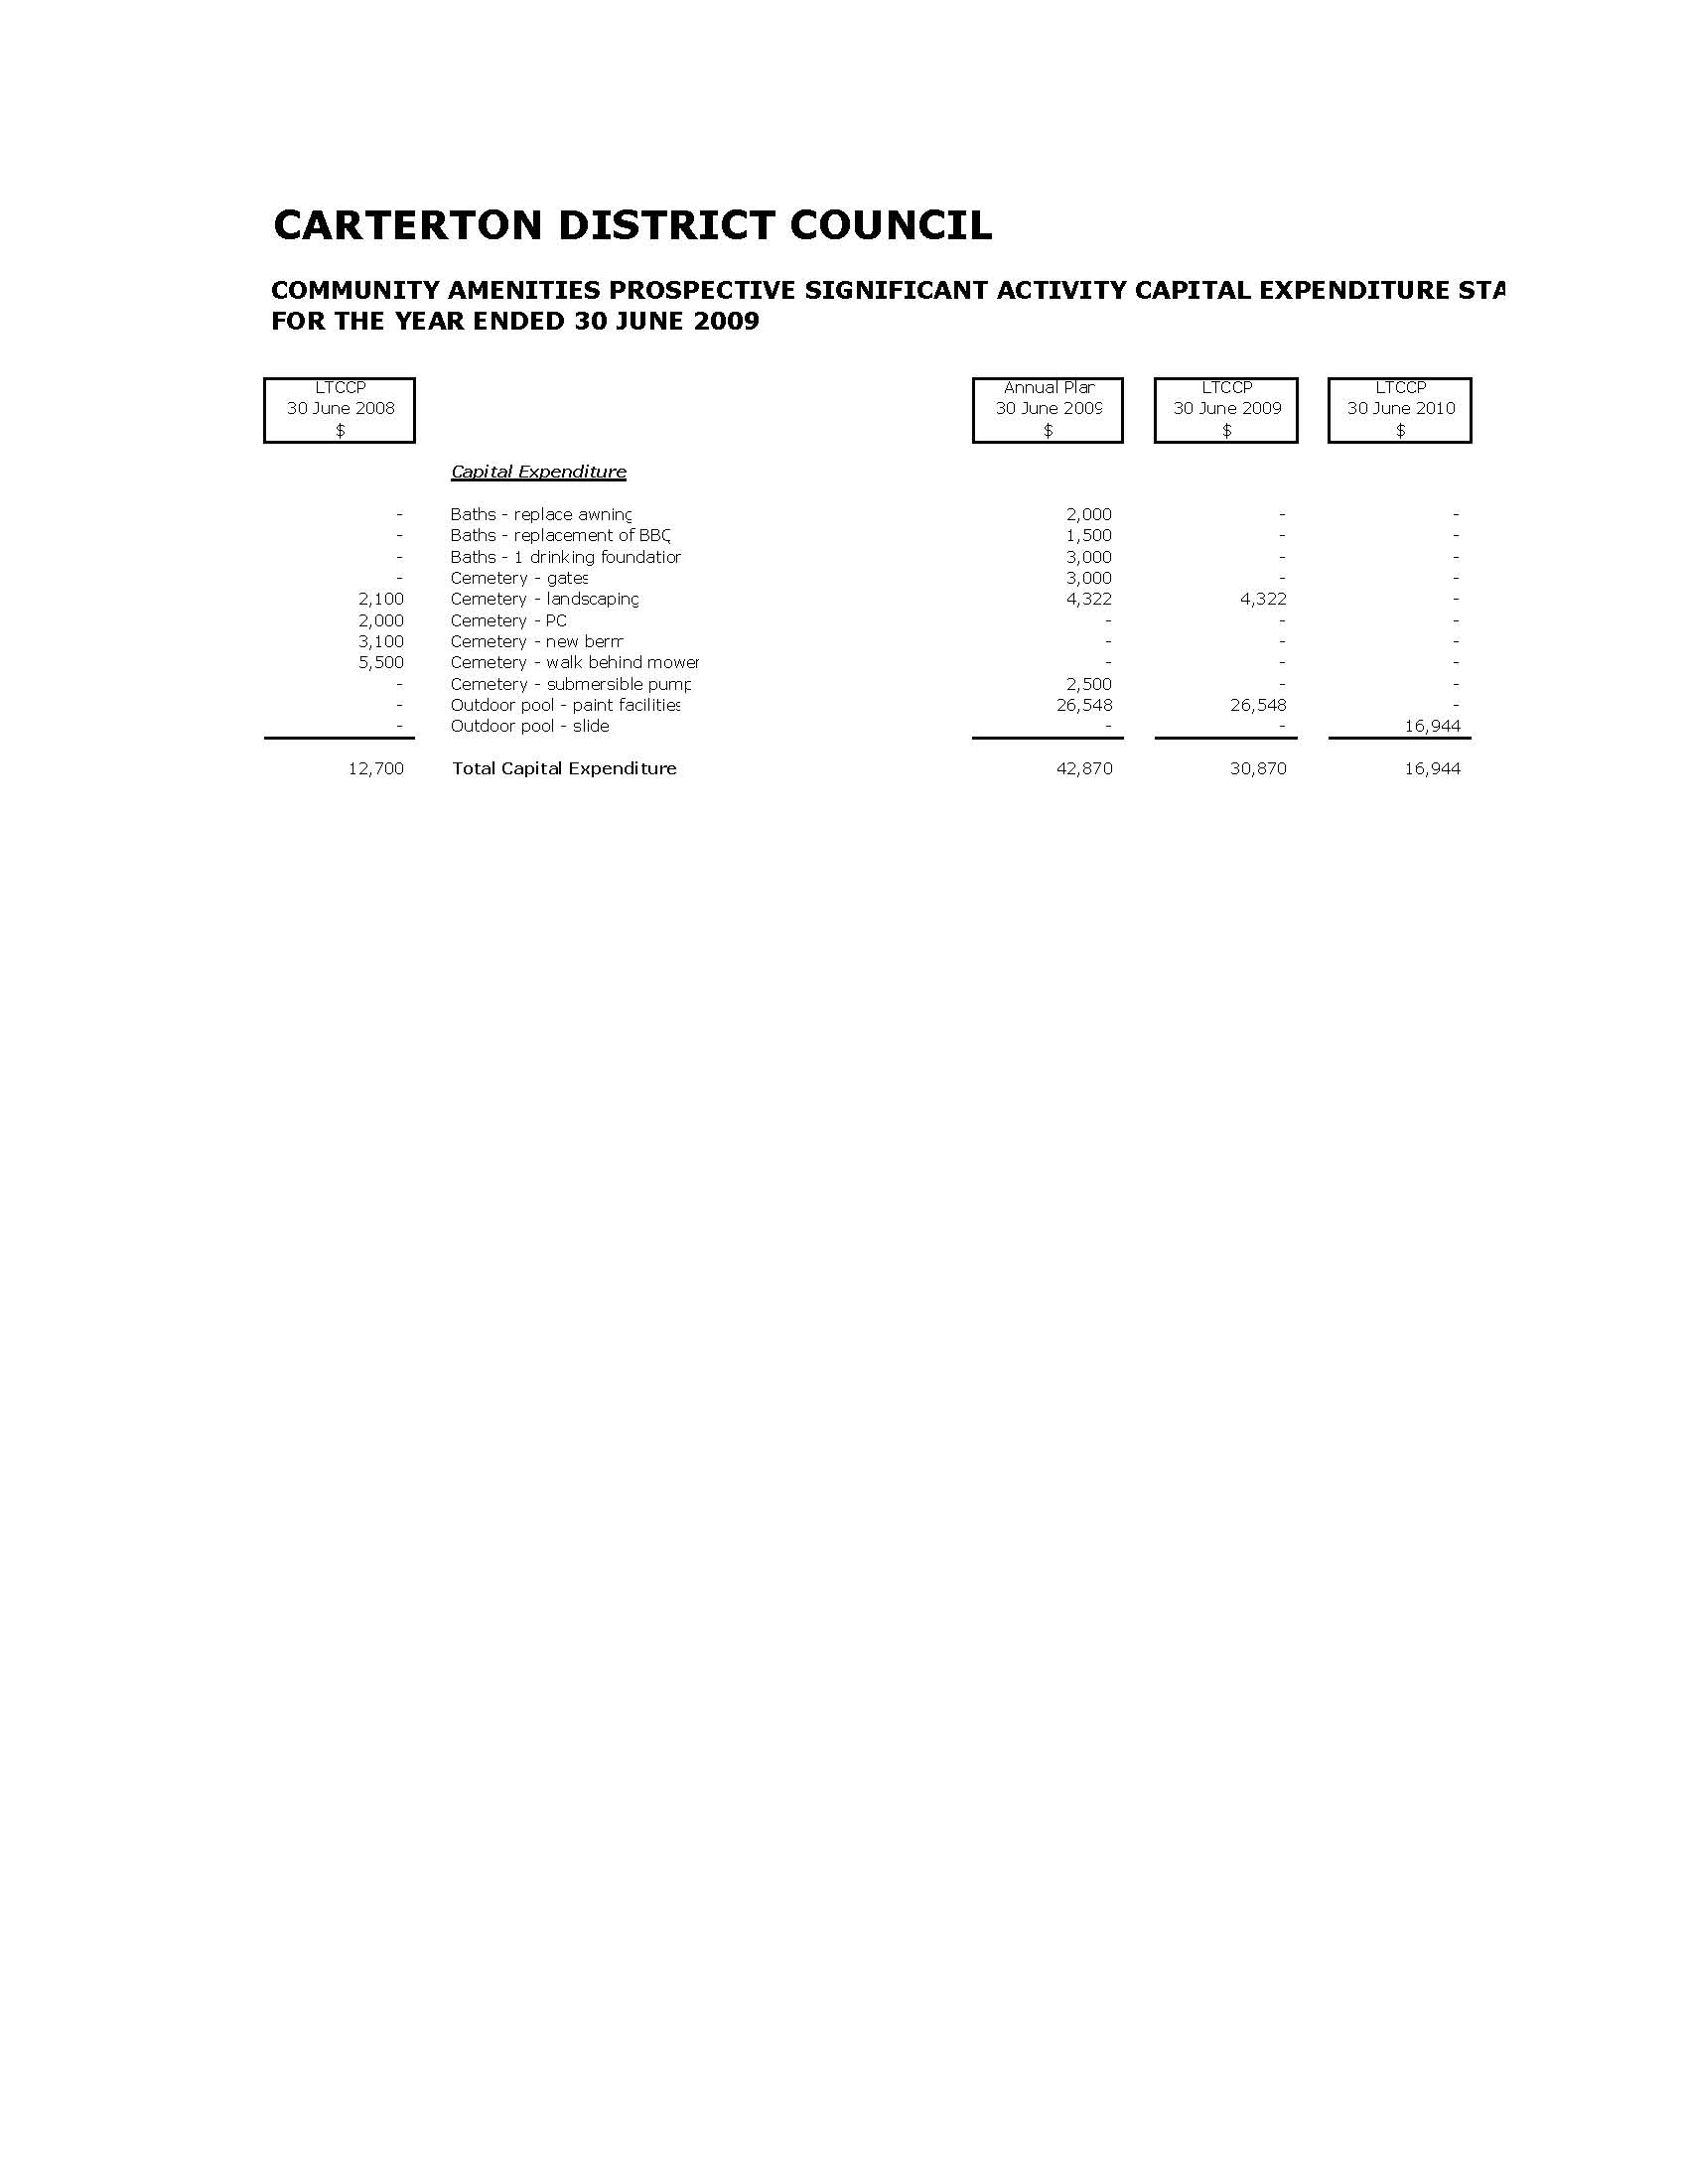
Property

Scope & Nature of Activity

This activity includes the following services:

- Maintenance and ongoing development of the Carterton Holiday Park.
- Maintenance and ongoing development of the Council’s pensioner housing complexes.
- Maintenance of public buildings.
- Maintenance of a number of Council owned properties, some of which are leased.
- Management of the Council’s forestry assets at the Kaipatangata and miscellaneous small roadside blocks located in the Admiral/Clifton Grove area.

Why Council undertakes this Activity

The Property activity contributes to the health of the district’s community, and is important to the economic and social fabric of the district.

Council proposes to regularly review its property needs in terms of the properties it currently owns and occupies. This may result in the upgrade of properties and the sale of surplus assets from time to time.

Community Outcomes to which the Activity Contributes

Community Outcomes | How Property Contributes
A buoyant local economy. | By providing the Carterton Holiday Park which contributes to the economic wellbeing of the district and region.
A safe, healthy and educated community. | By providing pensioner housing complexes for older citizens of Carterton which is affordable, safe and healthy to live in.

What Role will Council Play in Achieving the Community Outcomes

Funder | √
Service Provider | √
Monitor | √

How we Manage the Activity

- Maintain and manage the Carterton Holiday Park to a 4 Star Qual Mark Rating.
- Manage housing for the elderly units to a standard which maintains the existing level of service and complies with the Residential Tenancy Act.
- Manage lease properties and forestry assets to a level which provides the best return for the community.

Level of Service & Performance Measures

Level of Service | Performance Indicators
Control expenditure to complete all programmed works within allocated budgets. | Expenditure is within budgets agreed with Council.
Provide a safe, well maintained living environment for the district’s elderly members. | A 95% occupancy rate is maintained.
Maintain the Holiday park to a standard which meets a Four Star Qual Mark Rating. | Four Star Qual Mark Rating maintained at each annual inspection.

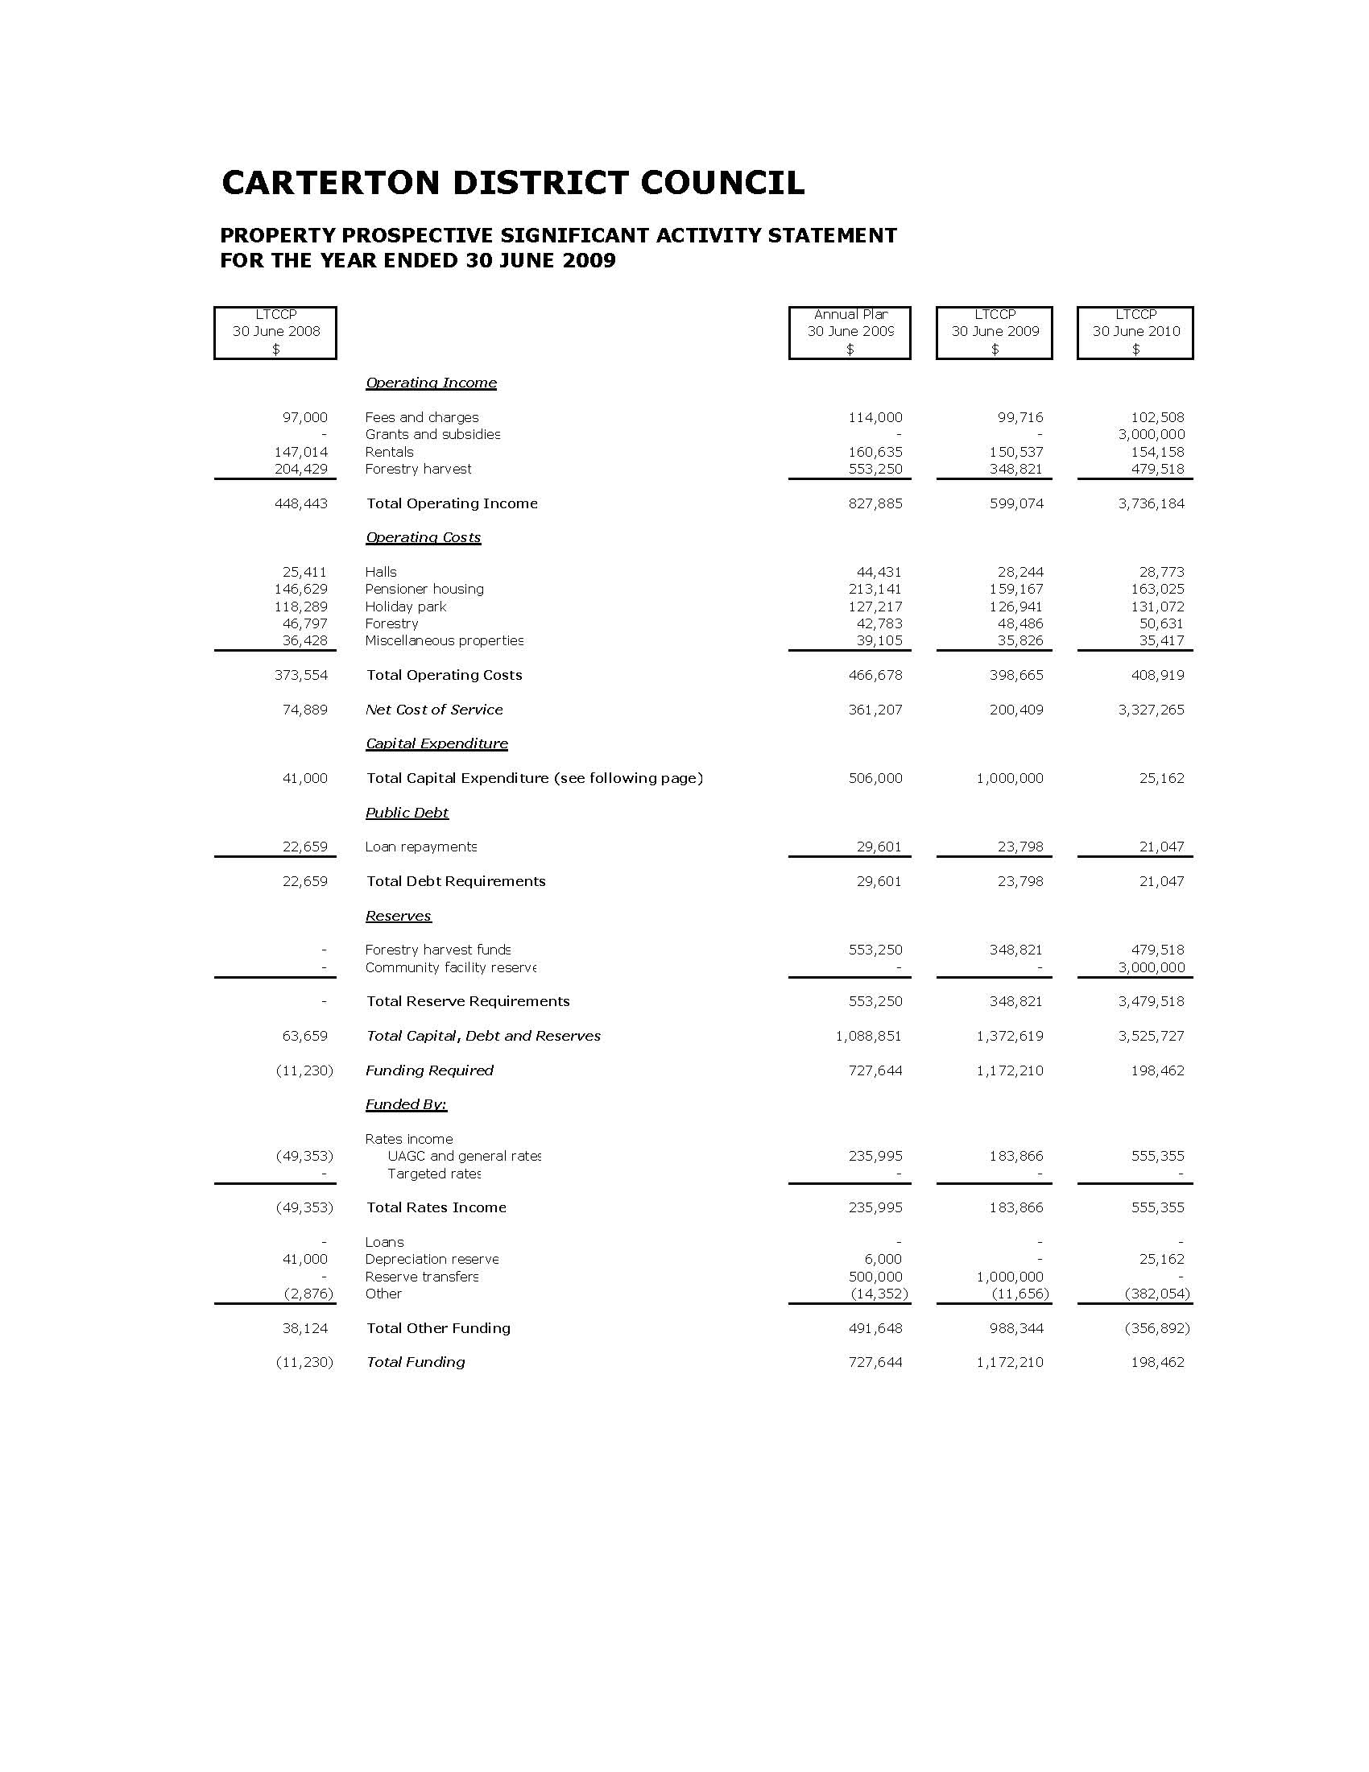
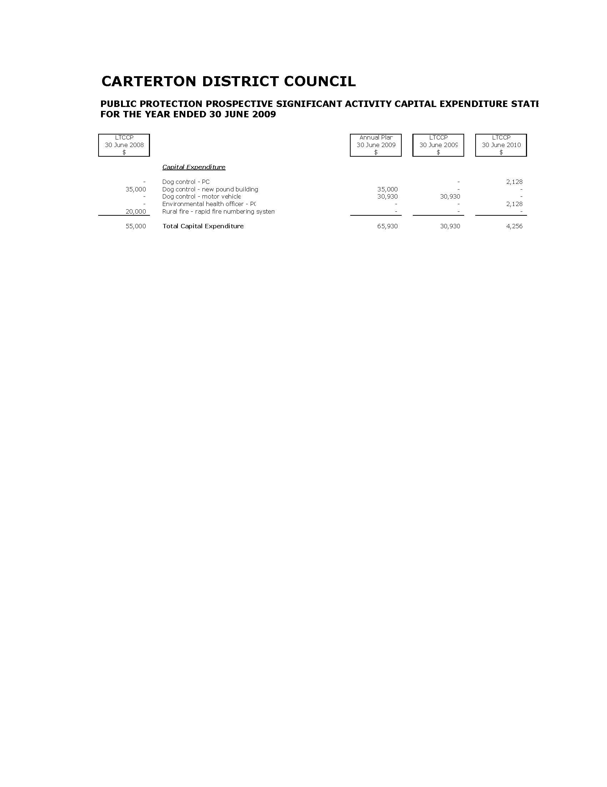
Resource Management & Planning

Scope & Nature of the Activity

This activity includes the following services:

- Administration of the responsibilities imposed on Council under Section 31 of the Resource Management Act 1991. The primary focus being the management of the effects of activities on the environment according to the rules set out in the District Plan.
- Maintenance and development of Council’s Geographic Information System (GIS) which provides a cadastral mapping database which graphically depicts property and road boundaries. The system holds valuable data pertaining to each property in the district, ie. location of sewer and water connections, fault lines, resource consents pertaining to the property, etc.

Why Council Undertakes this Activity

The Resource Management Act places specific statutory functions on territorial authorities to promote the sustainable management of natural and physical resources.

The Resource Management and Planning activity benefits every resident and society in general by promoting sustainable development, whilst encouraging development to occur in a way which benefits the district and region.

Community Outcomes to which the Activity Contributes

Community Outcomes | How Resource Management & Regulatory Contributes
Clean land, water and air for present and future generations. | By ensuring minimal adverse effect on the environment through the promulgation and implementation of appropriate policy and programmes.
A safe, healthy and educated community. | By providing GIS and planning information for both Council requirements and the general public.

What Role will Council Play in Achieving the Community Outcomes

Funder | √
Service Provider | √
Regulator | √
Monitor | √

How we Manage the Activity

The level of service for this activity is governed by the statutory requirements set out in the Resource Management Act 1991 and its amendments.

Level of Service & Performance Measures

Level of Service | Performance Indictors
Control capital and operational expenditure to complete all activities within allocated budgets. | Expenditure is within budget as agreed with Council.
Processing times for LIM’s comply with statutory timeframes. | 100% of Land Information Memorandums processed within ten working days.
Processing of non-notified and notified resource consents to comply with statutory requirements. | 100% of non-notified and notified resource consents processed to comply with statutory requirements.

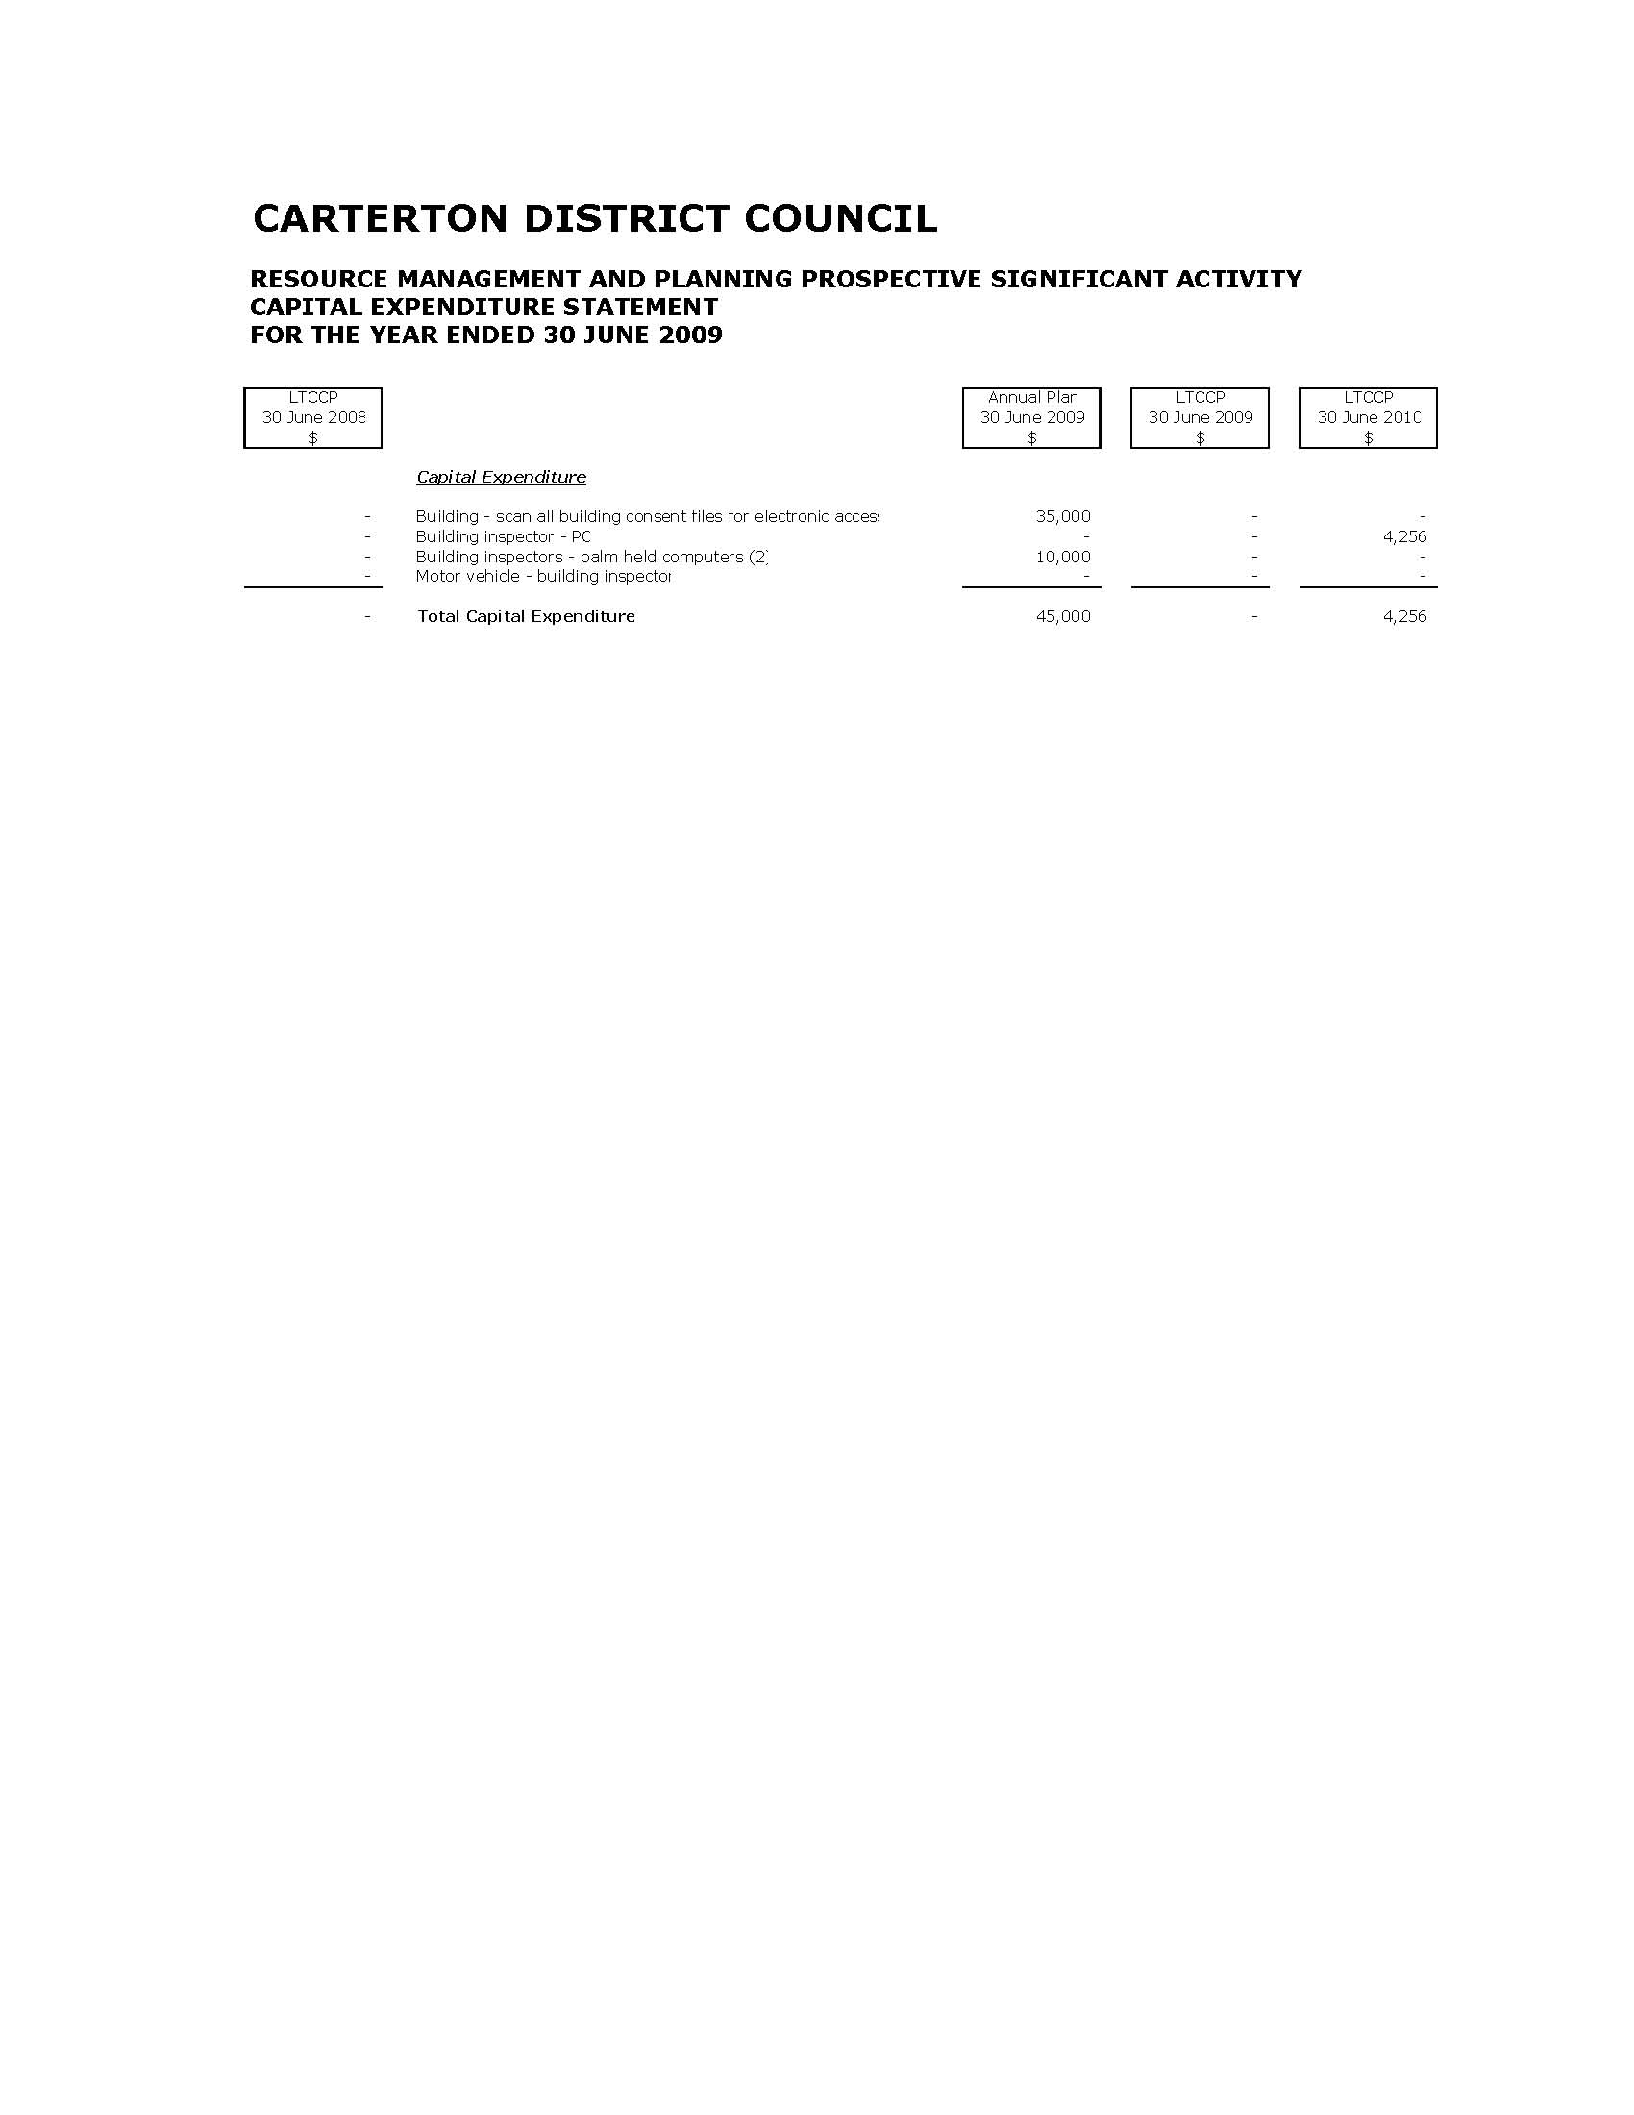
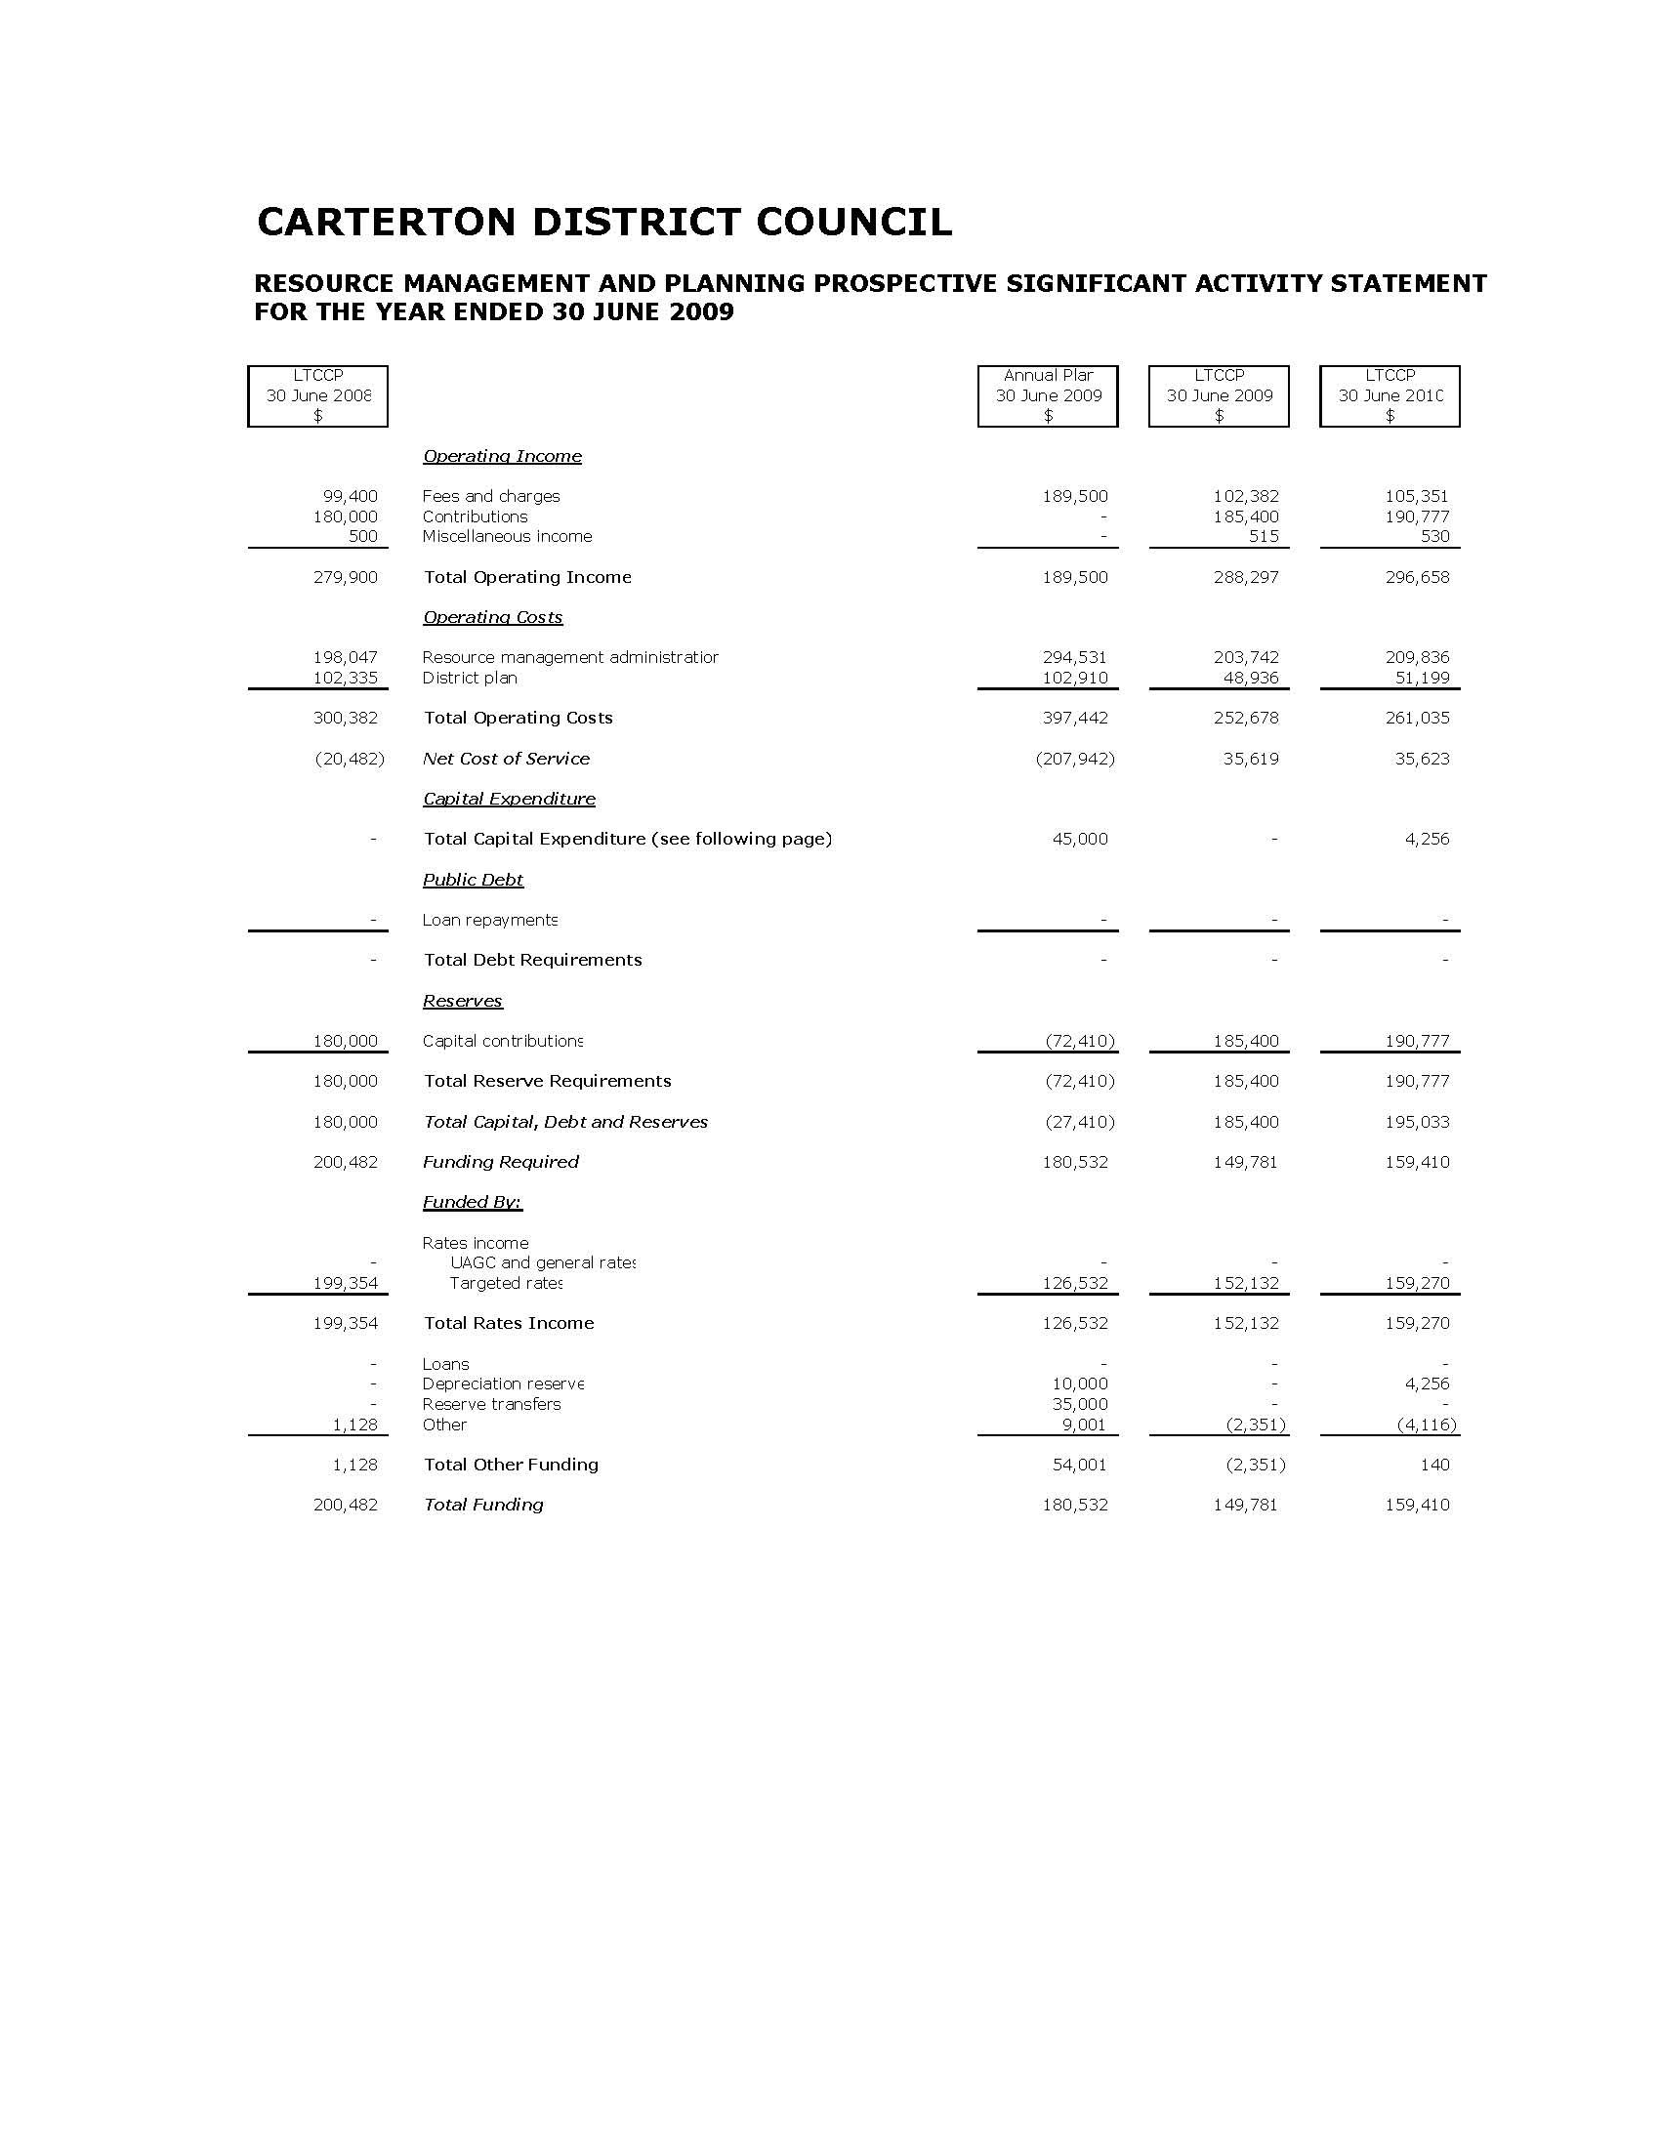
Public Protection

Scope & Nature of Activity

This activity includes the following services:

- Environmental Health
- Liquor Licensing
- Civil Defence/Emergency Management.
- Animal & Dog Control
- Building Control
- Rural Fire Control

Why Council Undertakes this Activity

Council has a legislative requirement to provide and manage the activities included in the Public Protection portfolio.

These activities are important to the health and safety of the district’s community and environment.

Community Outcomes to which the Activity Contributes

Community Outcomes | How Public Protection Contributes
Clean land, water and air for present and future generations. | By providing services to minimise any adverse environmental effects on the district’s natural resources.
A safe, healthy and educated community. | By providing services which assist in the protection of the health and safety of the district’s residents and visitors.

What Role will Council Play in Achieving the Community Outcomes

Funder | √
Service Provider | √
Regulator | √
Monitor | √

How we Manage the Activity

The level of service for this activity is governed by the relevant legislation applicable to the services included in this activity.

Level of Service & Performance Measures

Level of Service | Performance Indicators
Control capital and operations expenditure to complete all activities within allocated budgets. | Expenditure is within budget as agreed with Council.
Processing times for PIM’s and building consents comply with statutory requirements. | 100% of PIM’s and building consents are processed within 20 working days.
Premises (eg. Food and Liquor outlets) are registered or licensed within 30 days of application. | 100% compliance.
Dog complaints are responded to within four hours of notification. | 100% compliance.
Emergencies are responded to in accordance with the Wellington Region Civil Defence Emergency Group Plan. | 100% compliance.
Rural fires are responded to in accordance with the Wairarapa Rural Fire Plan. | 100% compliance

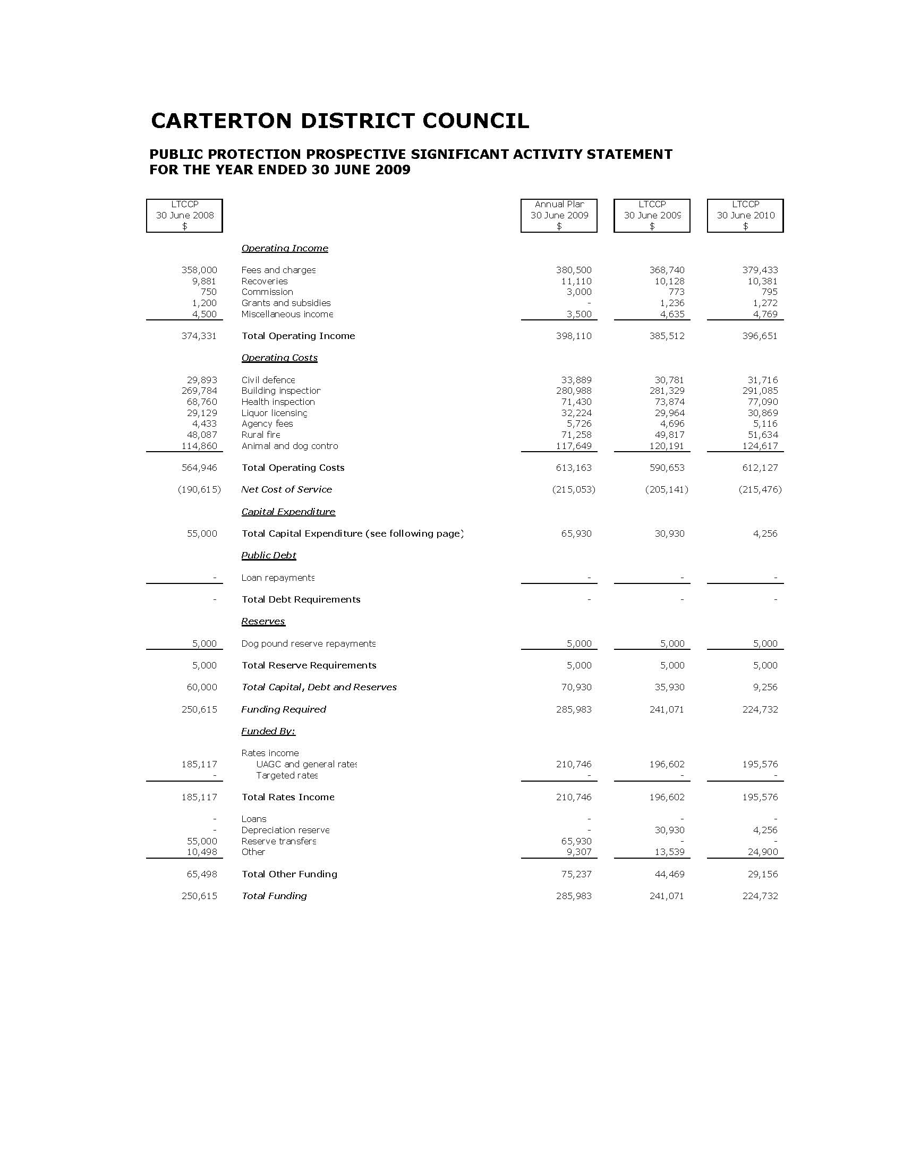
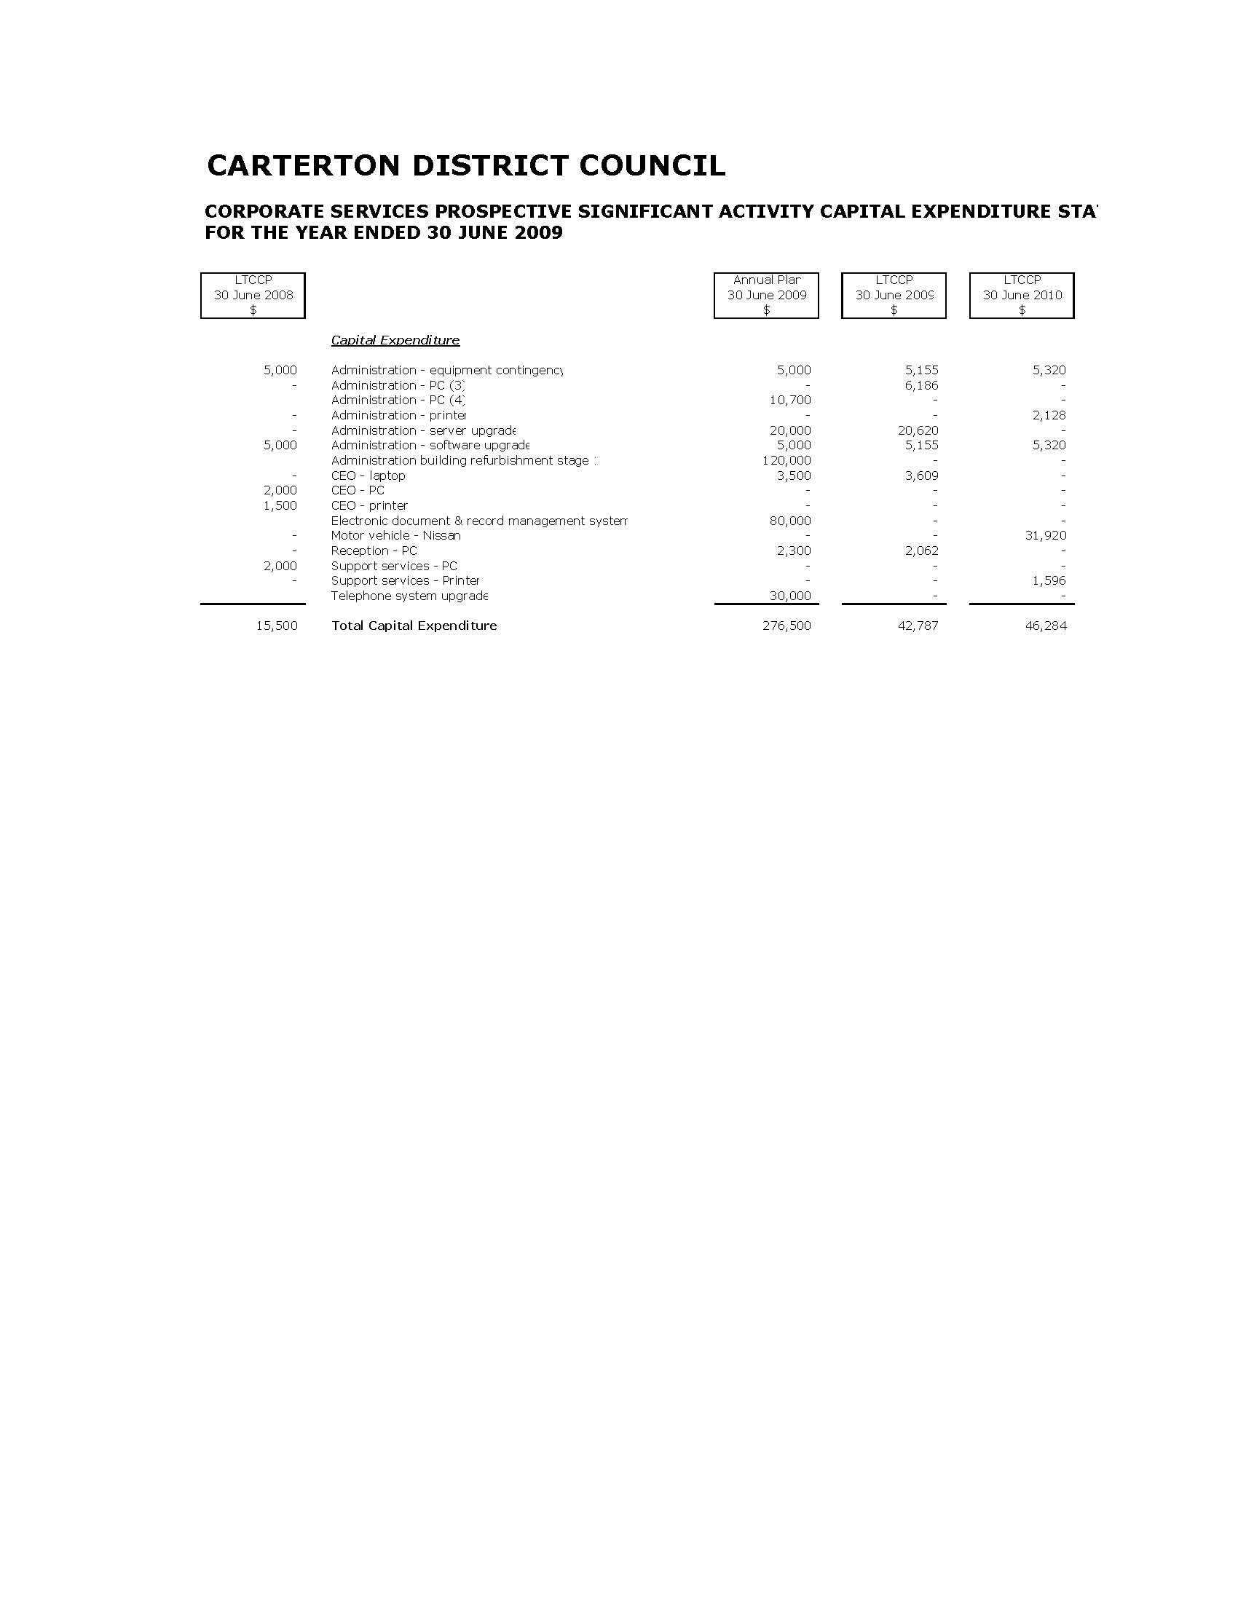
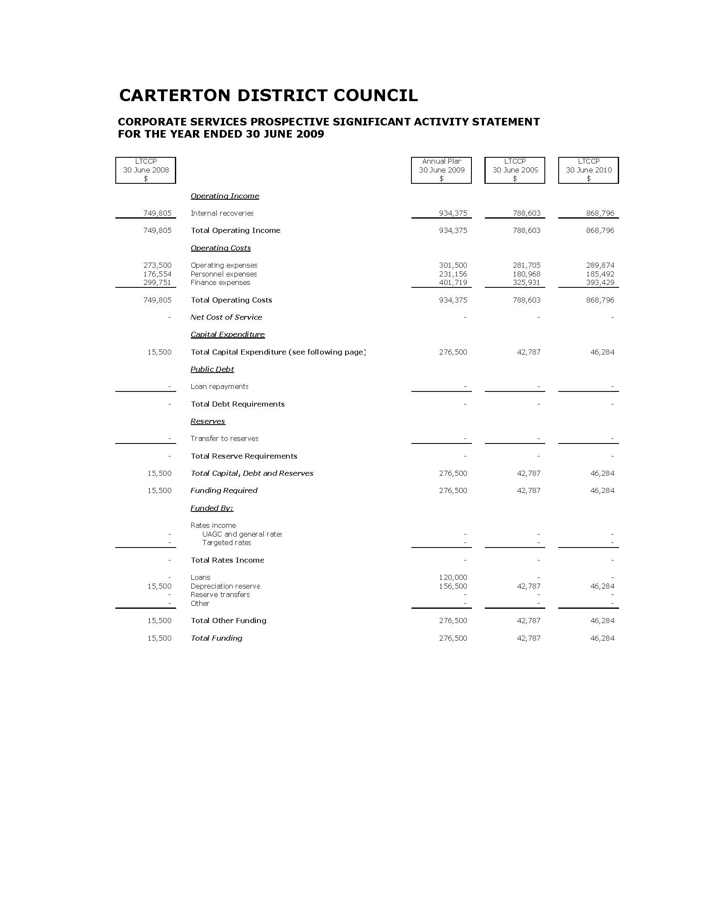

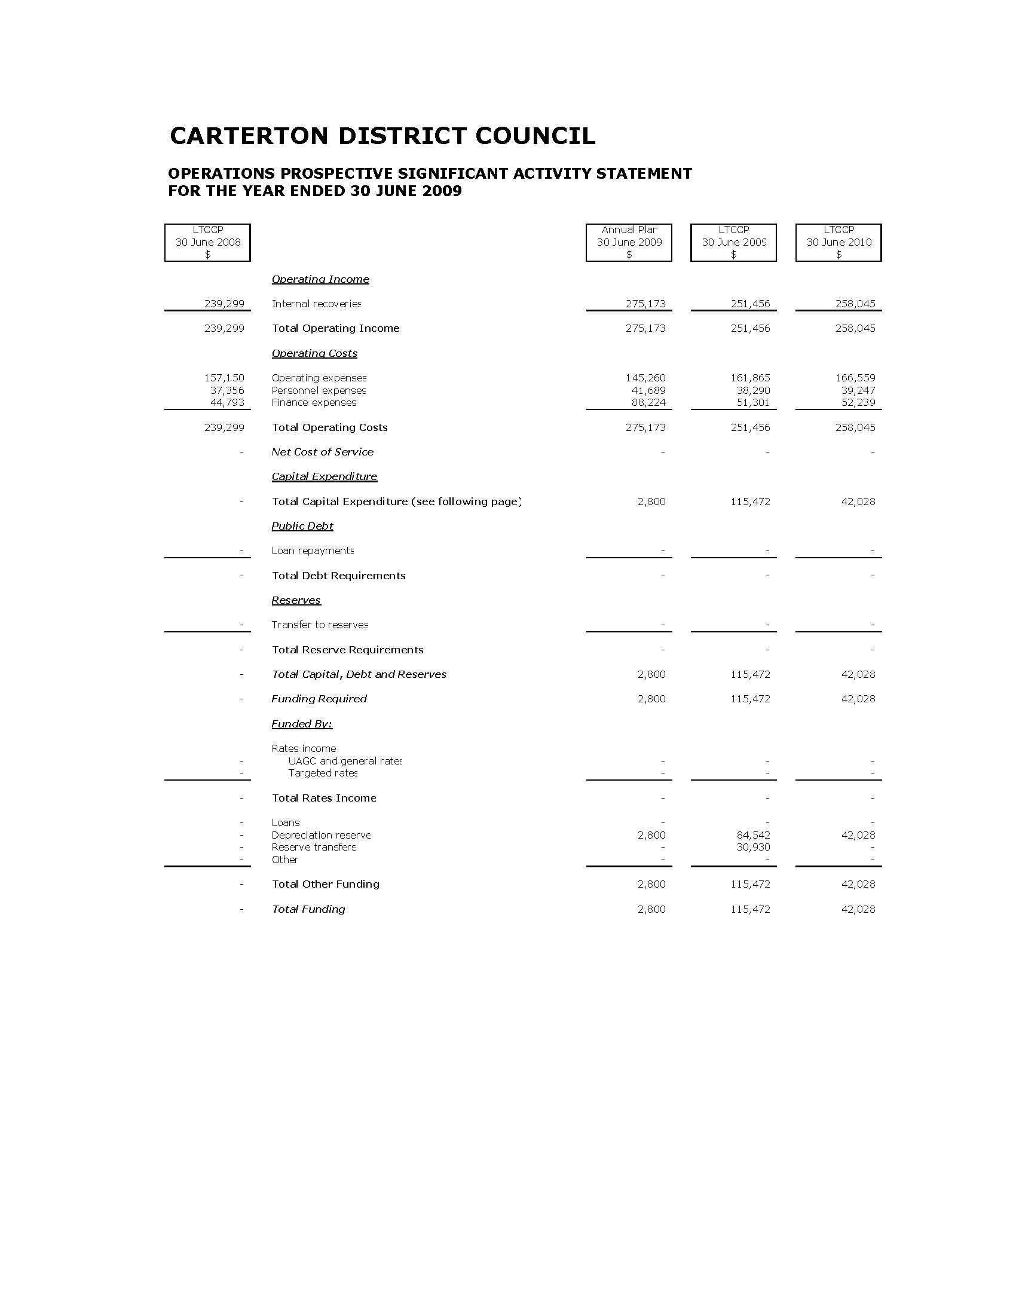
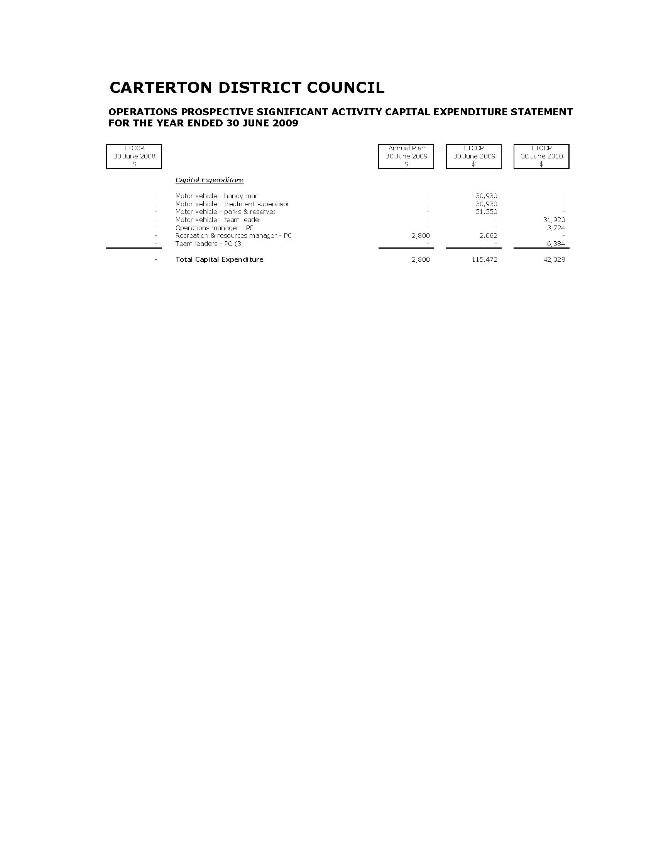

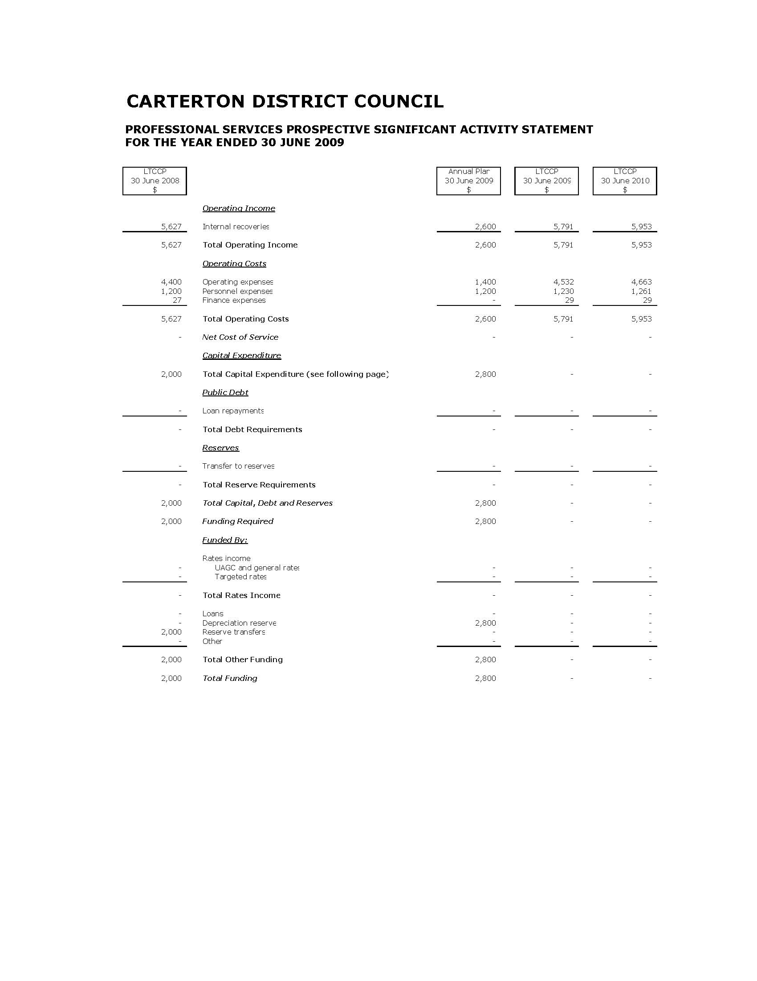
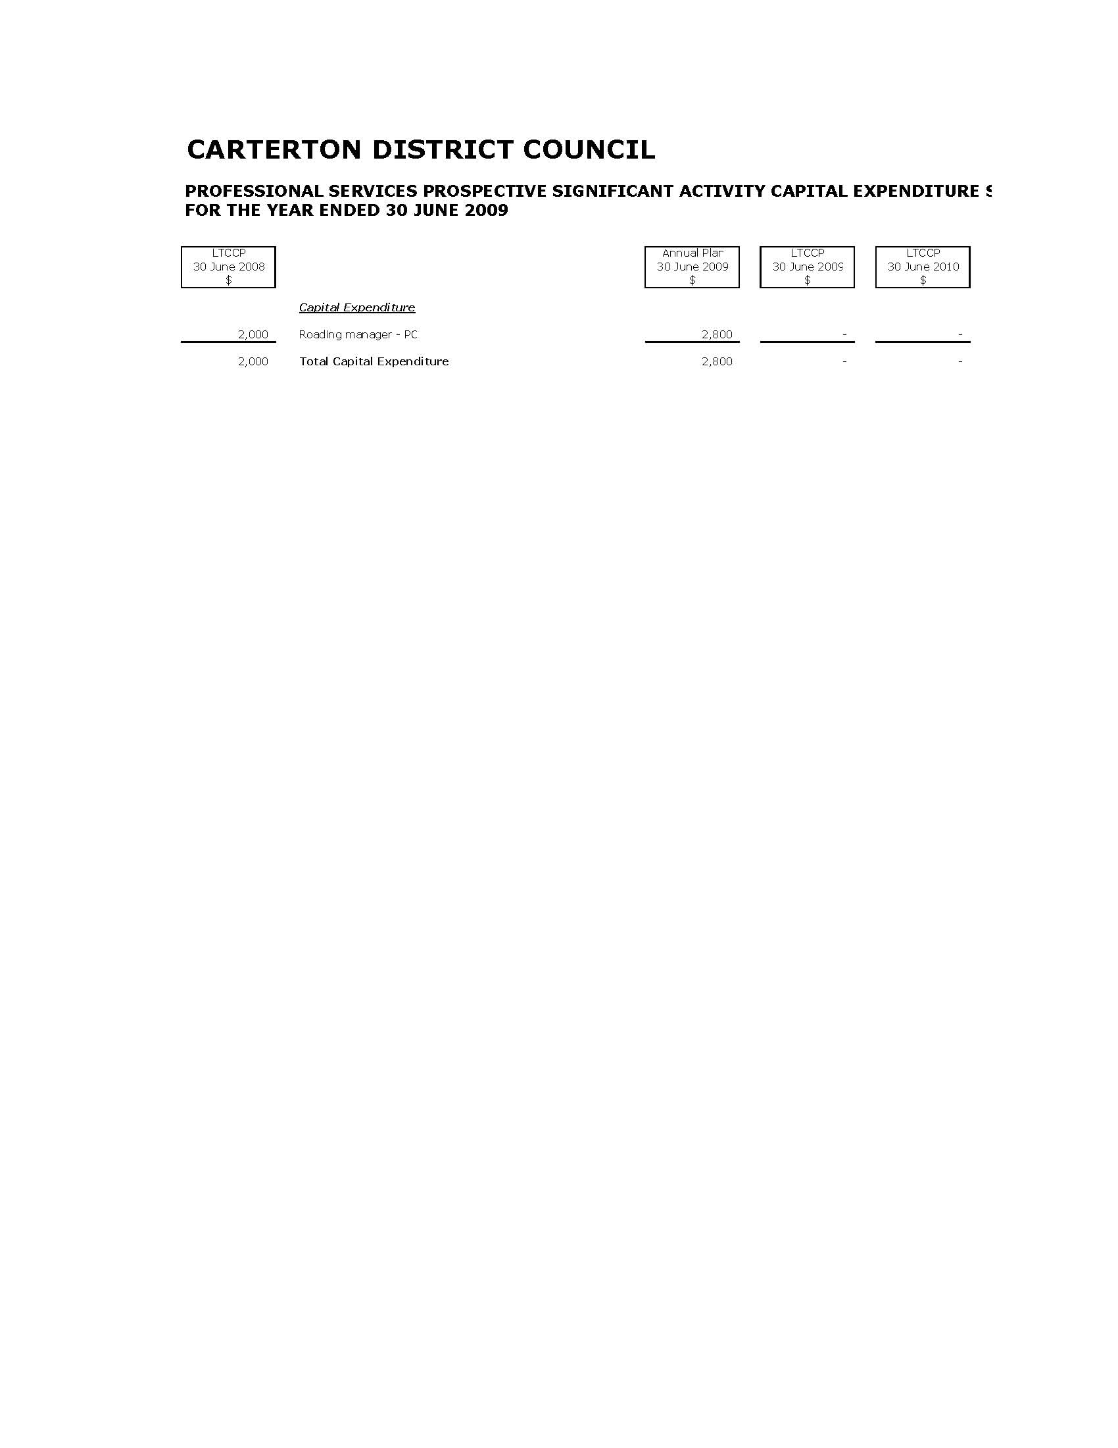

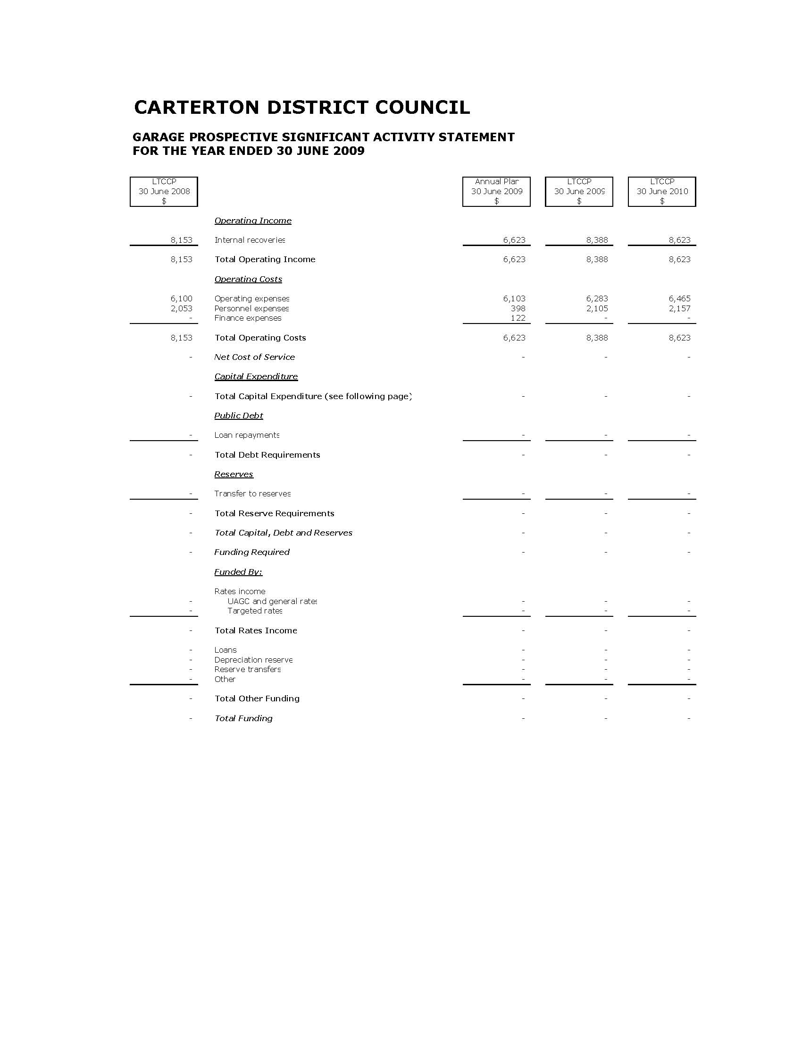
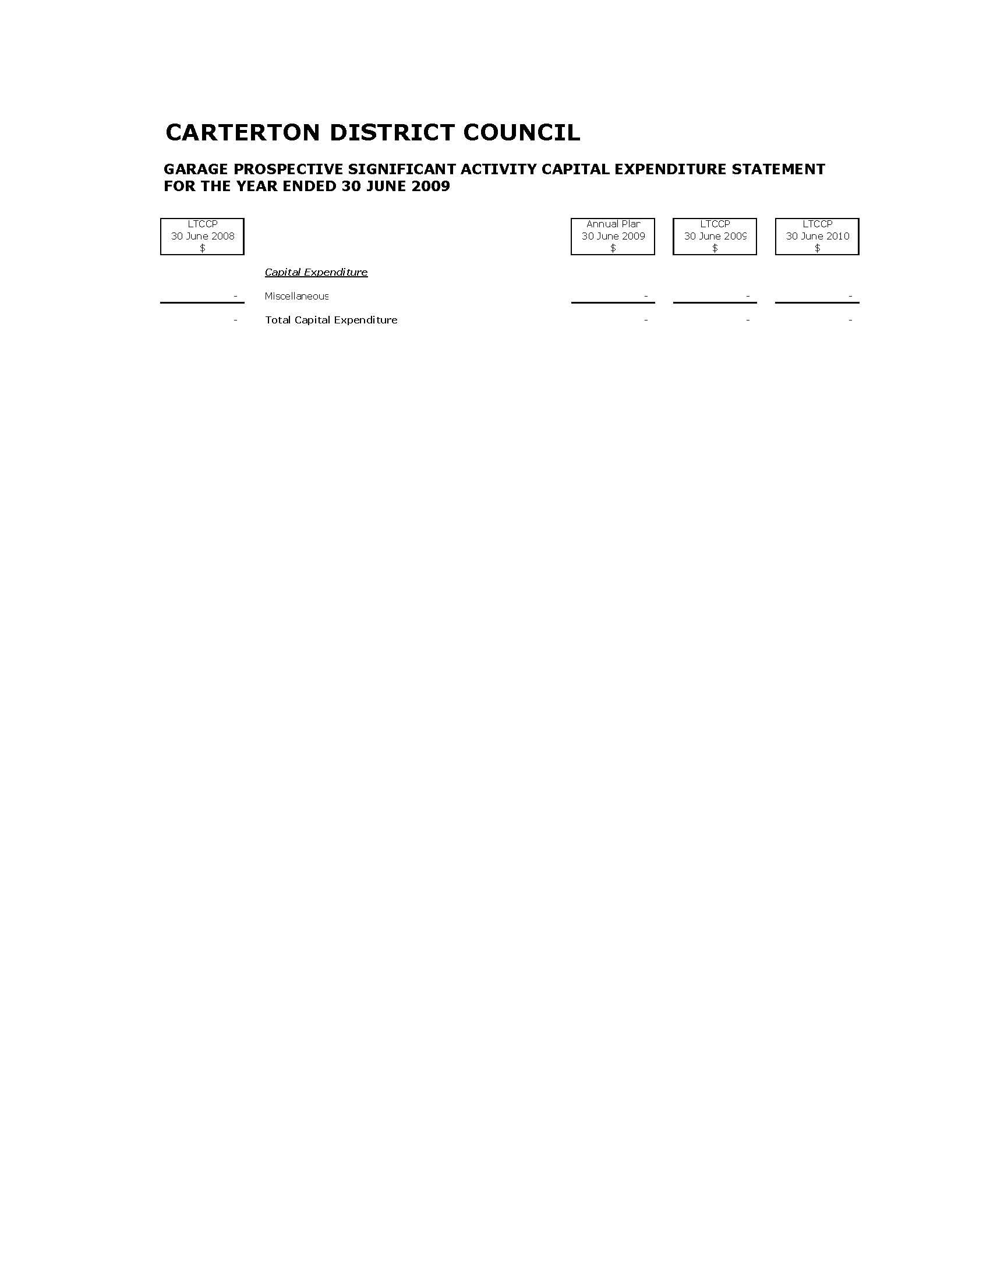

Prospective Financial Statements

Statement of Accounting Policies

Reporting Entity

Carterton District Council is a territorial local body governed by the Local Government Act 2002.

The Carterton District Council is a separate legal entity and does not have any subsidiaries.

The primary objective of the Carterton District Council is to provide goods and services for the community or social benefit rather than making a financial return. Accordingly, the Carterton District Council has designated itself as a public benefit entity for the purposes of New Zealand equivalents to International Financial Reporting Standards (NZ IFRS).

The prospective financial statements of the Carterton District Council are for the year ended 30 June 2009.

The annual plan was authorised for issue by Council on 25 June 2008.

Basis of Preparation

The Annual Plan for the Carterton District Council has been prepared in accordance with the requirements of the Local Government Act 2002, by applying the Council’s assumptions and presenting the financial information in accordance with generally accepted accounting practice in New Zealand. The Council’s responsibilities arise from Section 93 of the Local Government Act 2002.

This financial forecast has been prepared in accordance with NZ GAAP. They comply with NZ IFRS, and other applicable Financial Reporting Standards, as appropriate for public benefit entities.

Statement of Prospective Financial Information

The financial information contained in this document is a forecast for the purposes of FRS 42. It has been prepared on the basis of assumptions as to future events that the Council reasonably expects to occur, associated with the actions it reasonably expects to take, as at the date the forecast was prepared. The purpose for which it has been prepared is to enable the public to participate in the decision making process as to the services to be provided by the Council to the community.

Council does not intend to update the prospective financial statements subsequent to the final presentation of the Annual Plan.

The Annual Plan is in full compliance with Financial Reporting Standard 42 (FRS 42) – Prospective Financial Statements.
The actual results achieved are likely to vary from the information presented. The variation may be material and will be dependent upon circumstances which arise during the forecast period.

Accounting Policies

The accounting policies set out below have been applied consistently in the presented financial forecast.

The financial forecast has been prepared on a historical cost basis, modified by the revaluation of land and buildings, certain infrastructure assets, investment property and financial instruments. The estimates and associated assumptions are based on historical experience and various other factors that are believed to be reasonable under the circumstances, the results of which form the basis of making the judgments about carrying values of assets and liabilities that are not readily apparent from other sources.

The financial estimates are presented in New Zealand dollars and all values are rounded to the nearest dollar. The functional currency of the Carterton District Council is New Zealand dollars.

Standards and Interpretations Issued and not yet Adopted

There are no standards, interpretations and amendments that have been issued, but are not yet effective, that Carterton District Council has not yet applied.

Revenue

Revenue is estimated at the fair value of consideration received.

Rates revenue

Rates are set annually by a resolution from Council and relate to a financial year. All ratepayers are invoiced within the financial year to which the rates have been set. Rates revenue is recognised when payable.

Other revenue

Water billing revenue is recognised on an accrual basis. Unbilled usage, as a result of unread meters at year end, is accrued on an average usage basis.

Carterton District Council receives government grants from Land Transport New Zealand, which subsidises part of Carterton District Council’s costs in maintaining the local roading infrastructure. The subsidies are recognised as revenue upon entitlement as conditions pertaining to eligible expenditure have been fulfilled.

Revenue from the rendering of services is recognised by reference to the stage of completion of the transaction at balance date, based on the actual service provided as a percentage of the total services to be provided.

Where a physical asset is acquired for nil or nominal consideration the fair value of the asset received is recognised as revenue. Assets vested in the Carterton District Council are recognised as revenue when control over the asset is obtained.

Where revenue is derived by acting as an agent for another party, the revenue that is recognised is the commission or fee on the transaction.

Interest income is recognised using the effective interest method.

Dividends are recognised when the right to receive payment has been established. Dividends are recorded net of imputation credits.

Development contributions

Development contributions and financial contributions are recognised as revenue when the council provides, or is able to provide, the service that gave rise to the charging of the contribution. Otherwise development contributions and financial contributions are recognised as liabilities until such time as the council provides or is able to provide, the service.

Borrowing Costs

Borrowing costs are recognised as an expense in the period in which they are incurred.

Grant Expenditure

Non-discretionary grants are those grants that are awarded if the grant application meets the specified criteria and are recognised as expenditure when an application that meets the specified criteria for the grant has been received.

Discretionary grants are those grants where Carterton District Council has no obligation to award on receipt of the grant application and are recognised as expenditure when a successful applicant has been notified of the Carterton District Council’s decision.

Income Tax

The Carterton District Council has no income liable for income tax.

Leases

Finance leases

A finance lease is a lease that transfers to the lessee substantially all the risks and rewards incidental to ownership of an asset, whether or not title is eventually transferred.

At the commencement of the lease term, the Carterton District Council recognises finance leases as assets and liabilities in the statement of financial position at the lower of the fair value of the leased item or the present value of the minimum lease payments.

The amount recognised as an asset is depreciated over its useful life. If there is no certainty as to whether the Carterton District Council will obtain ownership at the end of the lease term, the asset is fully depreciated over the shorter of the lease term and its useful life.

Operating leases

An operating lease is a lease that does not transfer substantially all the risks and rewards incidental to ownership of an asset. Lease payments under an operating lease are recognised as an expense on a straight-line basis over the lease term.

Cash and Cash Equivalents

Cash and cash equivalents includes cash in hand, deposits held at call with banks, other short-term highly liquid investments with original maturities of three months or less, and bank overdrafts.

Bank overdrafts are shown within borrowings in current liabilities in the statement of financial position.

Trade and Other Receivables

Trade and other receivables are initially estimated at fair value and subsequently estimated at amortised cost using the effective interest method, less any provision for impairment.

Loans, including loans to community organisations made by the Carterton District Council at nil, or below market interest rates are initially recognised at the present value of their expected future cash flows, discounted at the current market rate of return for a similar asset/investment. They are subsequently estimated at amortised cost using the effective interest method. The difference between the face value and present value of the expected future cash flows of the loan is recognised in the statement of financial performance as a grant.

A provision for impairment of receivables is established when there is objective evidence that the Carterton District Council will not be able to collect all amounts due according to the original terms of receivables. The amount of the provision is the difference between the asset’s carrying amount and the present value of estimated future cash flows, discounted using the effective interest method.

Inventories

Inventories (such as spare parts and other items) held for distribution or consumption in the provision of services that are not supplied on a commercial basis are estimated at the lower of cost and current replacement cost. The valuation includes allowance for slow moving and obsolete items.

The write down from cost to current replacement cost is recognised in the statement of financial performance.

Financial Assets

Carterton District Council classifies its financial assets into the following four categories: financial assets at fair value through profit and loss, held-to-maturity investments, loans and receivables and financial assets at fair value through equity. The classification depends on the purpose for which the investments were acquired. Management determines the classification of its investments at initial recognition and re-evaluates this designation at every reporting date.

Financial assets and liabilities are initially estimated at fair value plus transaction costs unless they are carried at fair value through profit or loss in which case the transaction costs are recognised in the statement of financial performance.

Purchases and sales of investments are recognised on trade-date, the date on which the Carterton District Council commits to purchase or sell the asset. Financial assets are derecognised when the rights to receive cash flows from the financial assets have expired or have been transferred and the Carterton District Council has transferred substantially all the risks and rewards of ownership.

The fair value of financial instruments traded in active markets is based on quoted market prices at the balance sheet date. The quoted market price used is the current bid price.

The fair value of financial instruments that are not traded in an active market is determined using valuation techniques. The Carterton District Council uses a variety of methods and makes assumptions that are based on market conditions existing at each balance date. Quoted market prices or dealer quotes for similar instruments are used for long-term debt instruments held. Other techniques, such as estimated discounted cash flows, are used to determine fair value for the remaining financial instruments.

The four categories of financial assets are:

- Financial assets at fair value through profit or loss

This category has two sub-categories: financial assets held for trading, and those designated at fair value through profit or loss at inception. A financial asset is classified in this category if acquired principally for the purpose of selling in the short term or if so designated by management. Assets in this category are classified as current assets if they are either held for trading or are expected to be realised within 12 months of the balance sheet date.

After initial recognition they are estimated at their fair values. Gains or losses on re-estimation are recognised in the statement of financial performance.

Currently, the Carterton District Council does not hold any financial assets in this category.

- Loans and receivables

These are non-derivative financial assets with fixed or determinable payments that are not quoted in an active market.

After initial recognition they are measured at amortised cost using the effective interest method. Gains and losses when the asset is impaired or derecognised are recognised in the statement of financial performance. Loans and receivables are classified as “prepayments and receivables” in the statement of financial position.
- Held to maturity investments

Held to maturity investments are assets with fixed or determinable payments and fixed maturities that Carterton District Council has the positive intention and ability to hold to maturity.

After initial recognition they are estimated at amortised cost using the effective interest method. Gains and losses when the asset is impaired or derecognised are recognised in the statement of financial performance.

Investments in this category include: local authority and government stock and bank term deposits.

- Financial assets at fair value through equity

Financial assets at fair value through equity are those that are designated as fair value through equity or are not classified in any of the other categories above.

This category encompasses:

- Investments that the Carterton District Council intends to hold long-term but which may be realised before maturity; and
- Shareholdings that the Carterton District Council holds for strategic purposes.

After initial recognition these investments are estimated at their fair value.

Gains and losses are recognised directly in equity except for impairment losses, which are recognised in the statement of financial performance. In the event of impairment, any cumulative losses previously recognised in equity will be removed from equity and recognised in the statement of financial performance even though the asset has not been derecognised.

On derecognisation the cumulative gain or loss previously recognised in equity is recognised in the statement of financial performance.

Impairment of Financial Assets

At each balance sheet date Carterton District Council assesses whether there is any objective evidence that a financial asset or group of financial assets is impaired. Any impairment losses are recognised in the statement of financial performance.

Non-Current Assets Held for Sale

Non-current assets held for sale are classified as held for sale if their carrying amount will be recovered principally through a sale transaction, not through continuing use. Non-current assets held for sale are estimated at the lower of their carrying amount and fair value less costs to sell.

Any impairment losses for write-downs of non-current assets held for sale are recognised in the statement of financial performance.

Any increases in fair value (less costs to sell) are recognised up to the level of any impairment losses that have previously been recognised.

Non-current assets (including those that are part of a disposal group) are not depreciated or amortised while they are classified as held for sale. Interest and other expenses attributable to the liabilities of a disposal group classified as held for sale continue to be recognised.

Property, Plant and Equipment

Property, plant and equipment consists of:

Operational assets

These include land, buildings, landfill post closure, library books, plant and equipment, and motor vehicles.

Restricted assets

Restricted assets are parks and reserves owned by the Carterton District Council which provide a benefit or service to the community and cannot be disposed of because of legal or other restrictions.

Infrastructure assets

Infrastructure assets are the fixed utility systems owned by the Carterton District Council. Each asset class includes all items that are required for the network to function, for example, sewer reticulation includes reticulation piping and sewer pump stations.

Heritage assets

Heritage assets are assets owned by the Carterton District Council which are of cultural or historical significance to the community and cannot be replaced due to the nature of the assets. Buildings recorded under the Historical places Act 1993 have been recorded as heritage assets.

Property, plant and equipment is shown at cost or valuation, less accumulated depreciation and impairment losses.

Additions

The cost of an item of property, plant and equipment is recognised as an asset if, and only if, it is probable that future economic benefits or service potential associated with the item will flow to the Carterton District Council and the cost of the item can be measured reliably.

In most instances, an item of property, plant and equipment is recognised at cost. Where an asset is acquired at no cost, or for nominal cost, it is recognised at fair value as at the date of acquisition.

Disposals

Gains and losses on disposals are determined by comparing the proceeds with the carrying amount of the asset. Gains and losses on disposals are included in the statement of financial performance. When revalued assets are sold, the amounts included in asset revaluation reserves in respect of those assets are transferred to retained earnings.

Subsequent costs

Costs incurred subsequent to initial acquisition are capitalised only when it is probable that future economic benefits or service potential associated with the item will flow to the Carterton District Council and the cost of the item can be measured reliably.

Depreciation

Depreciation is provided on a straight-line basis on all property, plant and equipment other than land, at rates which will write off the cost (or valuation) of the assets to their estimated residual values over their useful lives. The estimated useful economic lives of major classes of assets have been estimated as follows:
- Motor vehicles | 5 years
- Plant and equipment | 10 to 15 years
- Roads, bridges & footpaths* | 2 to 123 years
- Water systems* | 2 to 100 years
- Stormwater systems* | 39 to 79 years
- Sewerage systems* | 2 to 97 years
- Buildings | 5 to 63 years
- Library collections | 7 years
- Office equipment | 5 to 10 years
- Fixtures and fittings | 10 years
- Heritage assets | 18 to 70 years

In relation to infrastructural assets marked * (above), depreciation has been calculated at a componentry level based on the estimated remaining useful lives as assessed by Council’s engineers and independent registered valuers. A summary of these lives is detailed above.

The residual value and useful life of an asset is reviewed, and adjusted if applicable, at each financial year-end.

Revaluation

Those asset classes that are revalued are valued on a three yearly cycle on the basis described below. All other asset classes are carried at depreciated historical cost. The carrying values of revalued items are reviewed at each balance date to ensure that those values are not materially different to fair value.

Operational land and buildings

At fair value as determined from market-based evidence by an independent valuer. The most recent valuation was performed by Kerry Stewart (Val Prof Urb, PG Dip Env Audit, MBA, FNZIV, FPINZ), Angela Croad (BBS, (VPM), MPINZ) and Max Meyers (MBA. M.Prop.Studs, ANZIV, SPINZ) of Quotable Value New Zealand, and the valuation is effective as at 30 June 2007. The landfill liner and water races have not been revalued for the 2007 year and are currently valued using the deemed cost option under NZ IFRS 1. Heritage assets are included in this category and are revalued to fair value annually. Additions are recorded at cost.

Restricted land and buildings

At fair value as determined from market-based evidence by an independent valuer. The most recent valuation was performed by Kerry Stewart (Val Prof Urb, PG Dip Env Audit, MBA, FNZIV, FPINZ) of Quotable Value New Zealand, and the valuation is effective as at 30 June 2007. Additions are recorded at cost.

Infrastructure asset classes – Roads, bridges & footpaths, water systems, sewerage systems and stormwater systems

At fair value determined on a depreciated replacement cost basis by an independent valuer. At balance date the Carterton District Council assesses the carrying values of its infrastructure assets to ensure that they do not differ materially from the assets’ fair values. If there is a material difference, than the off-cycle asset classes are revalued. The most recent valuation was performed by John Vessey (BE (Civil), BA (Economics), Reg Eng (MIPENZ)) of Opus International Consultants, and the valuation is effective as at 1 July 2005. All infrastructure asset classes carried at valuation were valued. Additions are recorded at cost.

Land under roads

Land under roads, was valued based on fair value of adjacent land determined by John Vessey (BE (Civil), BA (Economics), Reg Eng (MIPENZ)) of Opus International Consultants, effective 30 June 2002. Under NZ IFRS, the Carterton District Council has elected to use the fair value of land under roads as at 30 June 2002 as deemed cost. Land under roads is no longer revalued.

Vested assets

At the actual costs or the current cost of providing identical services.

Library collections

At depreciated replacement cost in accordance with the guidelines released by the New Zealand Library Association and the National Library of New Zealand in May 2002. Library valuations are performed by Richard Hollier of Maunsell Limited, and the valuation is effective as at 30 June 2006.

Accounting for Revaluations

Carterton District Council accounts for revaluations of property, plant and equipment on a class of asset basis.

The results of revaluing are credited or debited to an asset revaluation reserve for that class of asset. Where this results in a debit balance in the asset revaluation reserve, this balance is expensed in the statement of financial performance. Any subsequent increase on revaluation that off-sets a previous decrease in value recognised in the statement of financial performance will be recognised first in the statement of financial performance up to the amount previously expensed, and then credited to the revaluation reserve for that class of asset.

Intangible Assets

Software acquisition

Acquired computer software licences are capitalised on the basis of the costs incurred to acquire and bring to use the specific software. Costs associated with maintaining computer software are recognised as an expense when incurred. Costs that are directly associated with the development of software for internal use by Carterton District Council, are recognized as an intangible asset. Direct costs include the software development employee costs and an appropriate portion of relevant overheads.

Easements

Easements are recognised at cost, being the costs directly attributable in bringing the asset to its intended use. Easements have an indefinite life and are not amortised, but are instead tested for impairment annually.

Amortisation

The carrying value of an intangible asset with a finite life is amortised on a straight-line basis over its useful life. Amortisation begins when an asset is available for use and ceases at the date that the asset is derecognised. The amortisation charge for each period is recognized in statement of financial performance.

The useful lives and associated amortisation rates of major classes of intangible assets have been estimated as follows:

Computer software 10 years 10%

Forestry Assets

Forestry assets are independently revalued annually at fair value less estimated point of sale costs. Fair value is determined based on the present value of expected net cash flows discounted at a current market determined pre-tax rate.

Gains or losses arising on initial recognition of biological assets at fair value less estimated point of sale costs and from a change in fair value less estimated point of sale costs are recognised in the statement of financial performance.

The costs to maintain the forestry assets are included in the statement of financial performance.

Investment Property

Properties leased to third parties under operating leases are classified as investment property unless the property is held to meet service delivery objectives, rather than to earn rentals or for capital appreciation.

Investment property is measured initially at cost, including transaction costs.

After initial recognition, the Carterton District Council measures all investment property at fair value as determined annually by an independent valuer.

Gains and losses arising from a change in the fair value of investment property are recognised in the statement of financial performance.

Impairment of Non-Financial Assets

Non-financial assets that have an indefinite useful life are not subject to amortisation and are tested annually for impairment. Assets that have a finite useful life are reviewed for impairment whenever events and changes in circumstances indicate that the carrying amount may not be recoverable. An impairment loss is recognised for the amount by which the asset’s carrying amount exceeds its recoverable amount. The recoverable amount is the higher of an asset’s fair value less costs to sell and value in use.

Value in use is depreciated replacement cost for an asset where the future economic benefits or service potential of the asset are not primarily dependent on the assets ability to generate net cash flows and where the entity would, if deprived of the asset, replace its remaining future economic benefits or service potential.

The value in use for cash-generating assets is the present value of expected future cash flows.

If an asset’s carrying amount exceeds its recoverable amount the asset is impaired and the carrying amount is written down to the recoverable amount. For revalued assets the impairment loss is recognised against the revaluation reserve for that class of asset. Where that results in a debit balance in the revaluation reserve, the balance is recognised in the statement of financial performance.

For assets not carried at a revalued amount, the total impairment loss is recognised in the statement of financial performance.
The reversal of an impairment loss on a revalued asset is credited to the revaluation reserve. However, to the extent that an impairment loss for that class of asset was previously recognised in the statement of financial performance, a reversal of the impairment loss is also recognised in the statement of financial performance.

For assets not carried at a revalued amount, the reversal of an impairment loss is recognised in the statement of financial performance.

Employee Benefits

Short-term benefits

Employee benefits that the Carterton District Council expects to be settled within twelve months of balance date are estimated at nominal values based on accrued entitlements at current rates of pay.

These include salaries and wages accrued up to balance date, annual leave earned to, but not yet taken at balance date, long service leave entitlements expected to be settled within twelve months, and sick leave.

The Carterton District Council recognises a liability for sick leave to the extent that absences in the coming year are expected to be greater than the sick leave entitlements earning in the coming year. The amount is calculated based on the unused sick leave entitlement that can be carried forward at balance date, to the extent that the Carterton District Council anticipates it will be used by staff to cover those future absences.

The Carterton District Council recognises a liability and an expense for bonuses where contractually obliged or where there is a past practice that has created a constructive obligation.

Long-term benefits

Long service leave

Entitlements that are payable beyond twelve months, such as long service leave, have been calculated on an actuarial basis. The calculations are based on:

- Likely future entitlements accruing to staff, based on years of service, years to entitlement, the likelihood that staff will reach the point of entitlement and contractual entitlements information; and

- The present value of the estimated future cash flows. A discount rate of 7.03%, and an inflation factor of 3.00% were used. The discount rate is based on the weighted average of Government interest rates for stock with terms to maturity similar to those of the relevant liabilities. The inflation factor is based on the expected long-term increase in remuneration for employees.

Superannuation schemes

Obligations for contributions to defined contribution superannuation schemes are recognised as an expense in the statement of financial performance as incurred.

Provisions

The Carterton District Council recognises a provision for future expenditure of uncertain amount or timing when there is a present obligation (either legal or constructive) as a result of a past event, it is probable that expenditures will be required to settle the obligation and a reliable estimate can be made of the amount of the obligation. Provisions are not recognised for future operating losses.

Provisions are measured at the present value of the expenditures expected to be required to settle the obligation using a pre-tax discount rate that reflects current market assessments of the time value of money and the risks specific to the obligation. The increase in the provision due to the passage of time is recognised as an interest expense.

Borrowings

Borrowings are initially recognised at their fair value. After initial recognition, all borrowings are estimated at amortised cost using the effective interest method.

Equity

Equity is the community’s interest in the Carterton District Council and is estimated as the difference between total assets and total liabilities. Equity is disaggregated and classified into a number of reserves.

The components of equity are:

- Public equity – accumulated funds
- Restricted reserves
- Other reserves – trust funds
- Asset revaluation reserves

Restricted and Council Created Reserves

Restricted reserves are a component of equity generally representing a particular use to which various parts of equity have been assigned. Reserves may be legally restricted or created by the Carterton District Council.

Restricted reserves are those subject to specific conditions accepted as binding by the Carterton District Council and which may not be revised by the Carterton District Council without reference to the Courts or a third party. Transfers from these reserves may be made only for certain specified purposes or when certain specified conditions are met.

Also included in restricted reserves are reserves restricted by Council decision. The Council may alter them without references to any third party or the Courts. Transfers to and from these reserves are at the discretion of the Council.

The Carterton District Council’s objectives, policies and processes for managing capital are described in the Council’s policies.

Goods and Services Tax (GST)

All items in the financial forecast are stated exclusive of GST, except for receivables and payables, which are stated on a GST inclusive basis. Where GST is not recoverable as input tax then it is recognised as part of the related asset or expense.

The net amount of GST recoverable from, or payable to, the Inland Revenue Department (IRD) is included as part of receivables or payables in the statement of financial position.

The net GST paid to, or received from the IRD, including the GST relating to investing and financing activities, is classified as an operating cash flow in the statement of cash flows.

Commitments and contingencies are disclosed exclusive of GST.

Cost Allocation

The Carterton District Council has derived the cost of service for each significant activity of the Council using the cost allocation system outlined below.

Direct costs are those costs directly attributable to a significant activity. Indirect costs are those costs, which cannot be identified in an economically feasible manner, with a significant activity.

Direct costs are charged directly to significant activities. Indirect costs are charged to significant activities using appropriate cost drivers such as actual usage, staff numbers and floor area.

Critical Accounting Estimates and Assumptions

In preparing the annual plan, the Carterton District Council has made estimates and assumptions concerning the future. These estimates and assumptions may differ from the subsequent actual results. Estimates and judgments are continually evaluated and are based on historical experience and other factors, including expectations or future events that are believed to be reasonable under the circumstances. The estimates and assumptions that have a significant risk of causing a material adjustment to the carrying amounts of assets and liabilities within the next financial year are discussed below:

Landfill aftercare provision

A provision has been included in the financial forecast for the exposure of the Carterton District Council in relation to the estimates and uncertainties surrounding the landfill aftercare provision.

Infrastructural assets

There are a number of assumptions and estimates used when performing DRC valuations over infrastructural assets. These include:

- The physical deterioration and condition of an asset, for example the Council could be carrying an asset at an amount that does not reflect its actual condition. This is particularly so for those assets, which are not visible, for example stormwater, wastewater and water supply pipes that are underground. This risk is minimized by Council performing a combination of physical inspections and condition modeling assessments of underground assets;
- Estimating any obsolescence or surplus capacity of an asset;
- Estimates are made when determining the remaining useful lives over which the asset will be depreciated. These estimates can be impacted by the local conditions, for example weather patterns and traffic growth. If useful lives do not reflect the actual consumption of the benefits of the asset, then the Carterton District Council could be over and under estimating the annual depreciation charge recognised as an expense in the statement of financial performance. To minimise this risk, Carterton District Council’s infrastructural asset useful lives have been determined with reference to the NZ Infrastructural Asset Valuation and Depreciation Guidelines published by the National Asset Management Steering Group, and have been adjusted for local conditions based on past experience. Asset inspections, deterioration and condition modeling are also carried out regularly as part of the Carterton District Council’s asset management planning activities, which gives the Carterton District Council further assurance over its useful life estimates.

Experienced independent valuers perform the Council’s infrastructural asset revaluations.

Critical Judgments in Applying the Carterton District Council’s Accounting Policies

Management has exercised the following critical judgments in applying the Carterton District Council’s accounting policies for the 2009 financial year:

Classification of property

Carterton District Council owns a number of properties, which are maintained primarily to provide housing to pensioners. The receipt of market-based rental from these properties is incidental to holding these properties. These properties are held for service delivery objectives as part of the Carterton District Council’s social housing policy. These properties are accounted for as property, plant and equipment.

Statement of Cash Flows

Cash means cash balances on hand, held in bank accounts, demand deposits and other highly liquid investments in which Council invests as part of its day-to-day cash management.

Operating activities include cash received from all income sources and cash payments made for the supply of goods and services. Agency transactions (the collection of Regional Council rates) are recognised as receipts and payments in the Statement of Cash Flows because they flow through the Council’s main bank account.

Investing activities are those activities relating to the acquisition and disposal of non-current assets.

Financing activities comprise the change in equity and debt structure of the Council.

Cost of Service Statements

The prospective significant activity statements report the net cost of services for significant activities of the Council, and are represented by the costs of providing the service less all revenue that can be allocated to these activities.
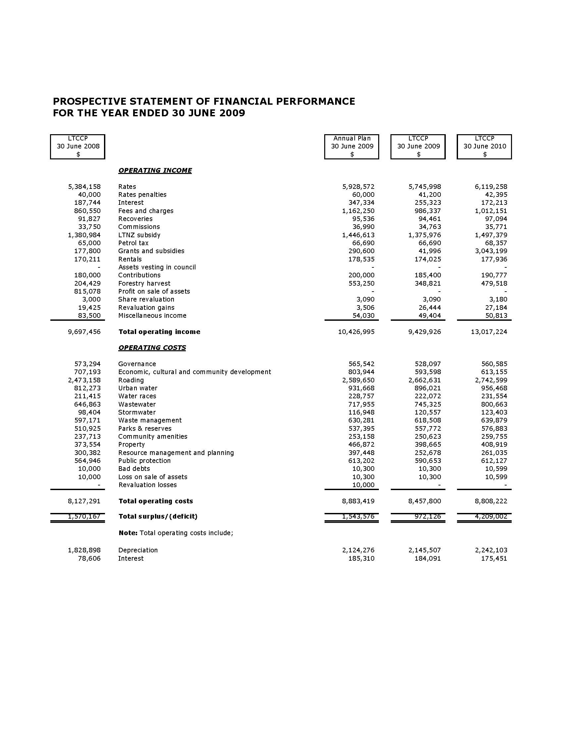
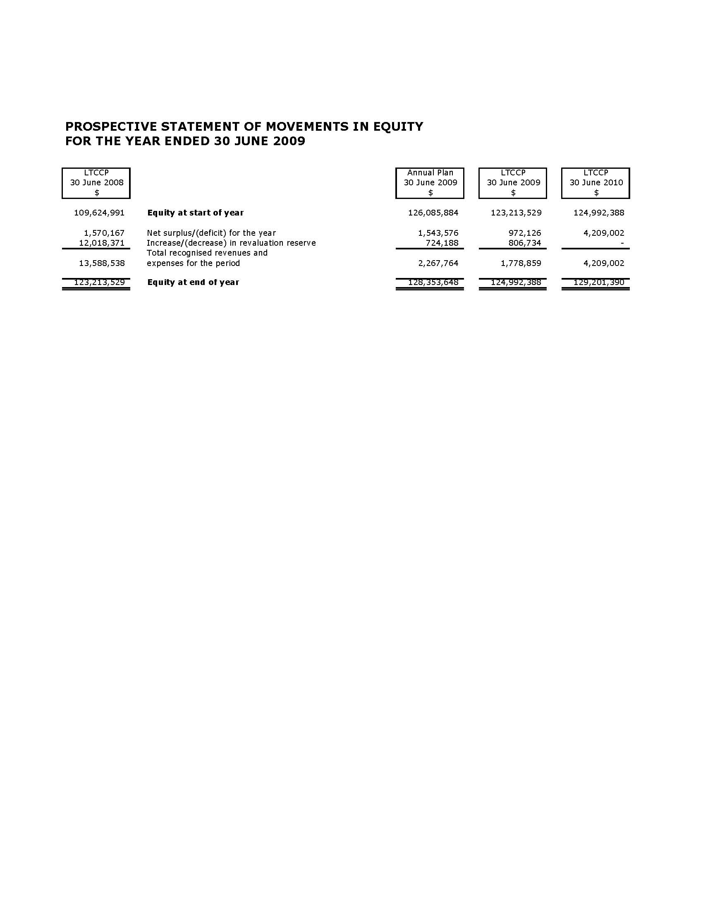

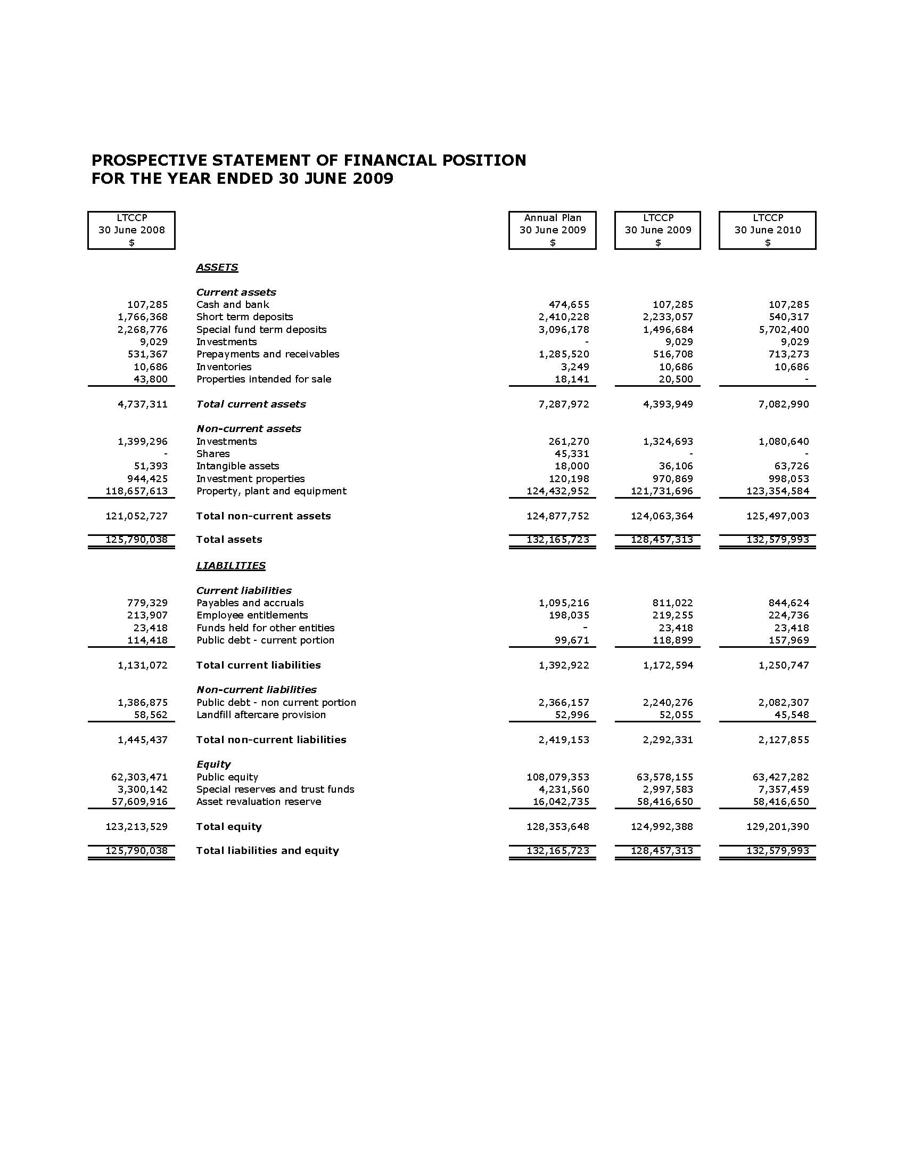
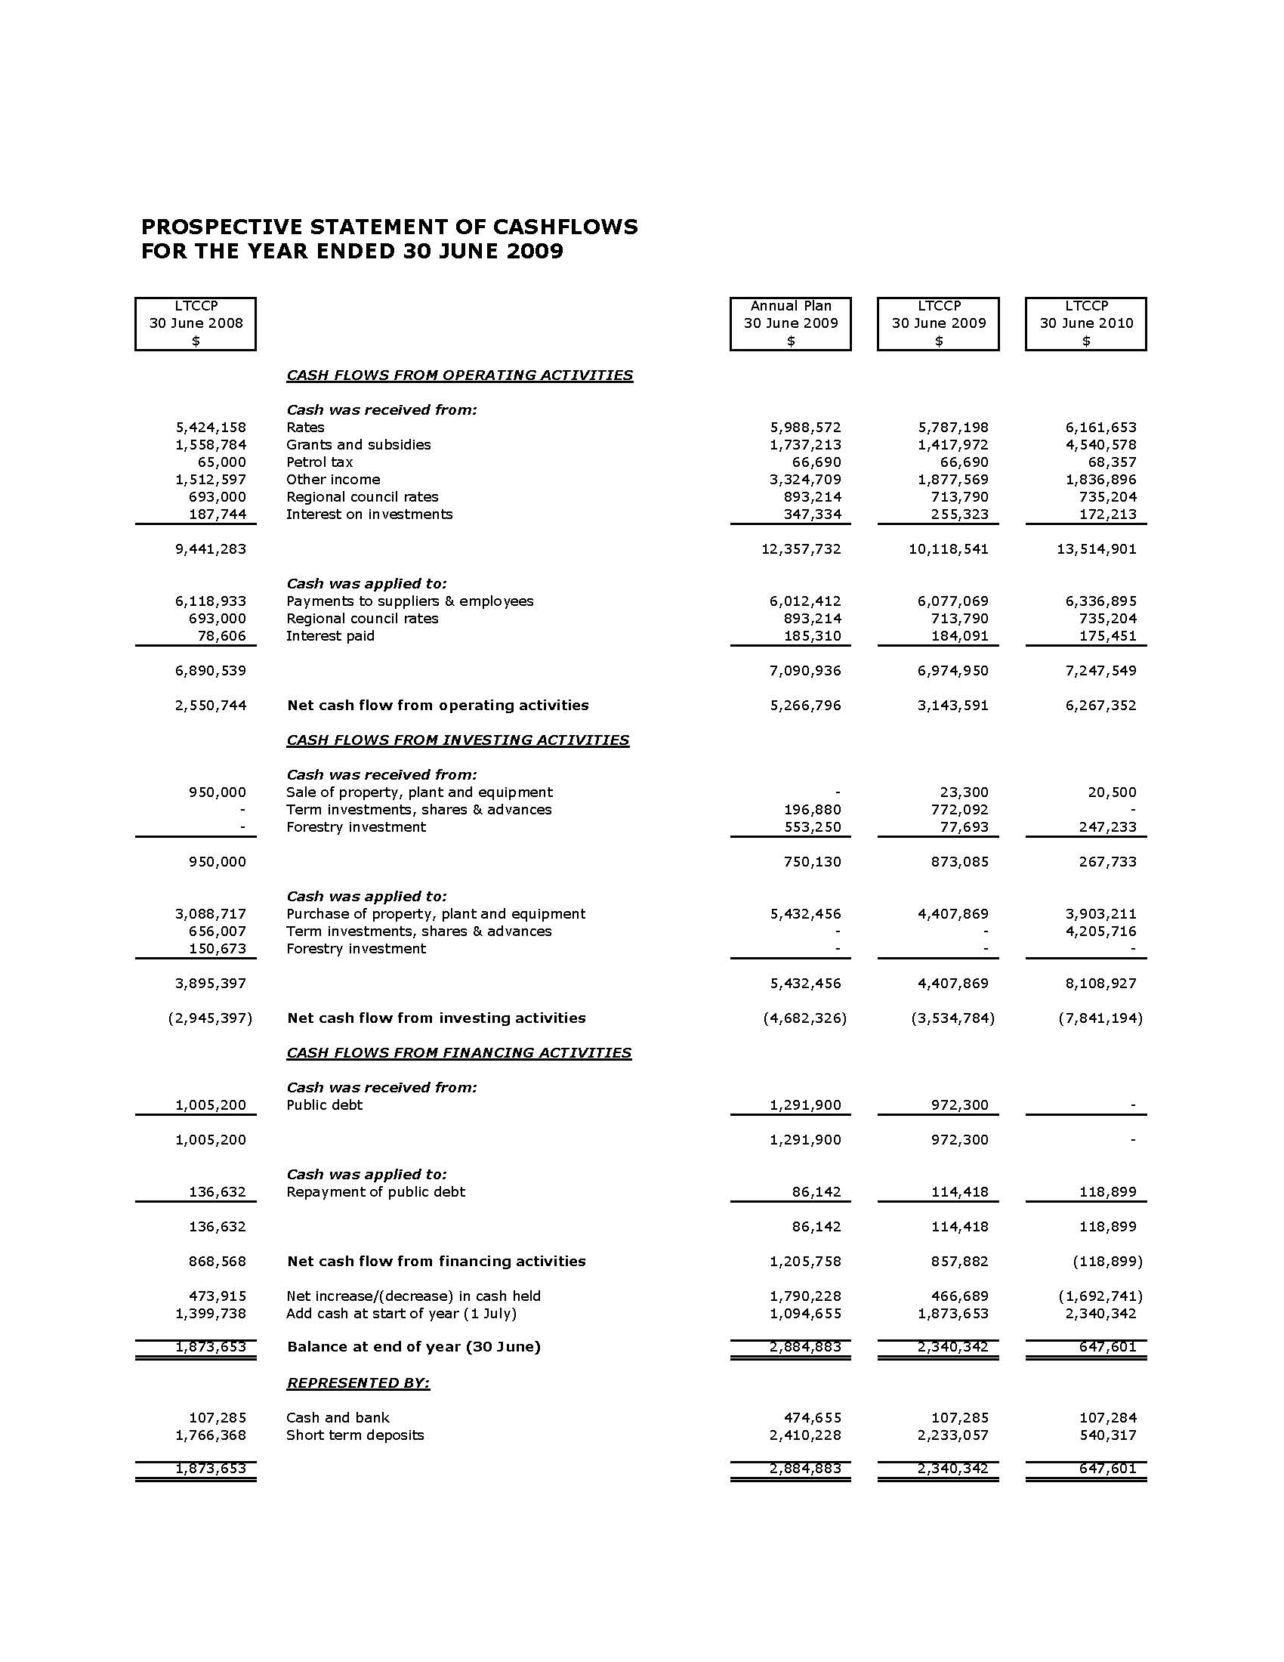

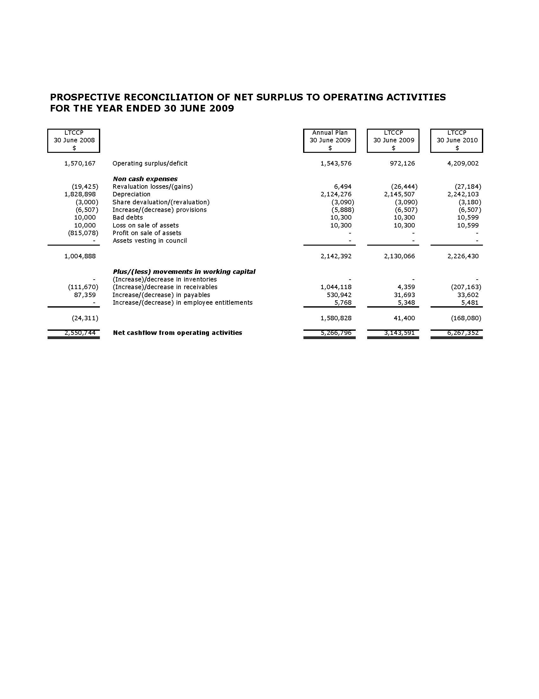

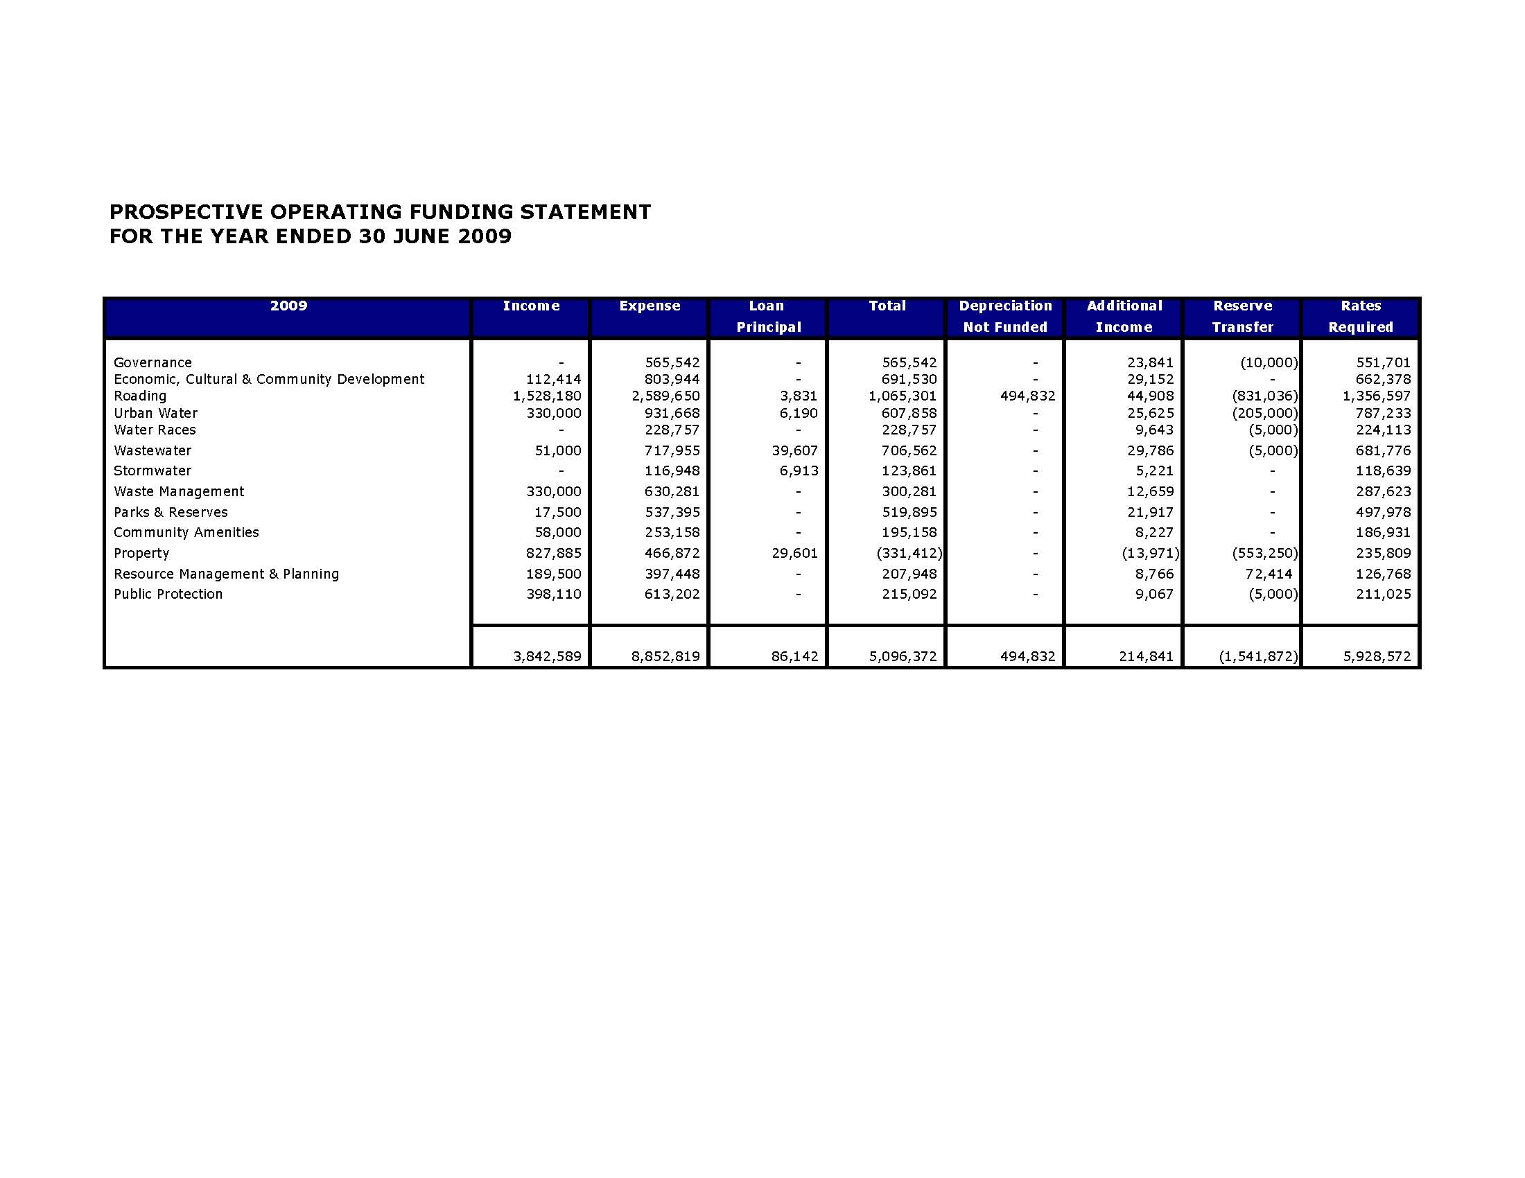
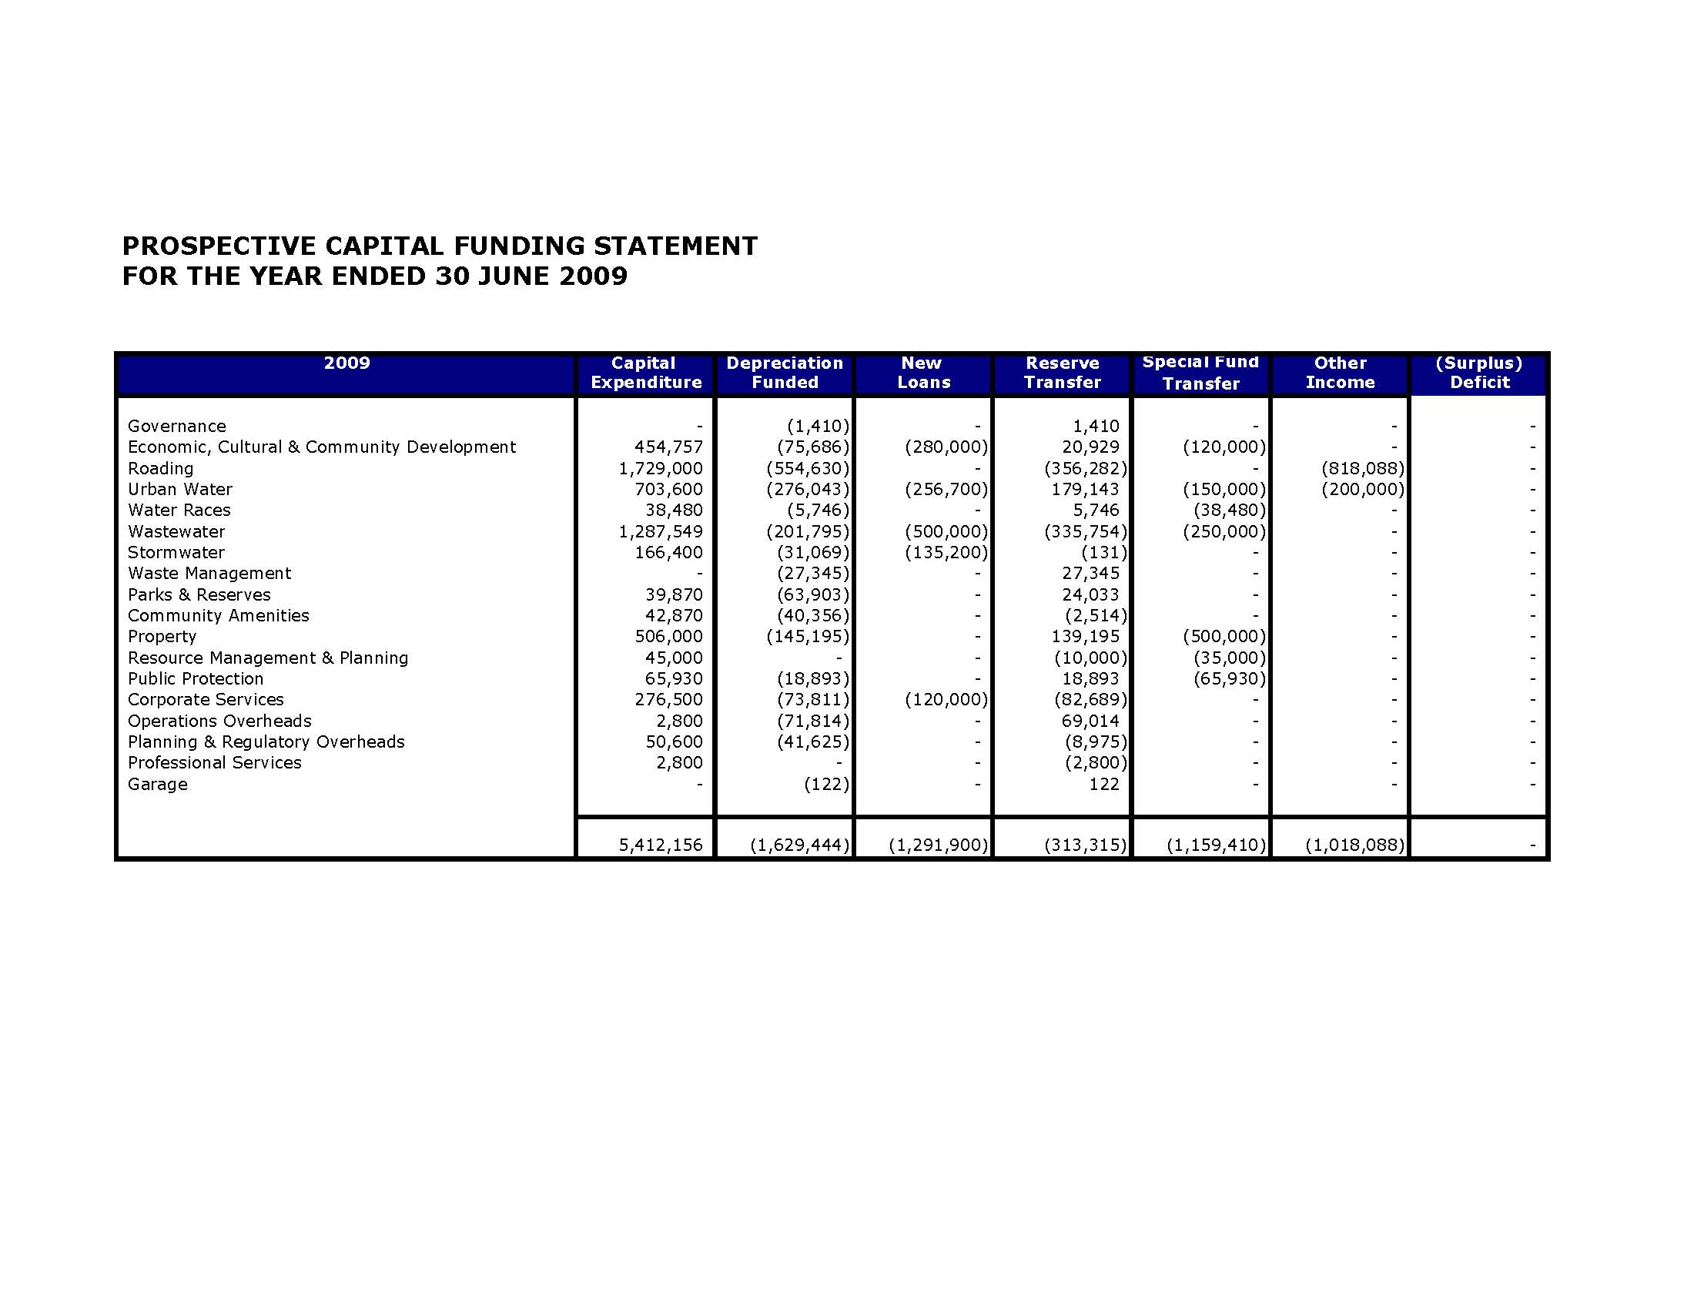

Funding Impact Statement
&
Fees and Charges

Funding Impact Statement

The revenue and financing mechanisms to be used to cover the estimated expenses of the Council are covered in the Revenue and Finance Policy.

The method and impact of both general and targeted rates is covered in “The Rating System” section which follows. The specific rating details given in the following pages are for the 2008/09 year.

Definition of Separately Used or Inhabited Part of a Rating Unit

Any part of a rating unit separately used or inhabited by the owner or any other who has right to use or inhabit that part by virtue of a tenancy, lease, licence or other agreement.

Rating System

Introduction

Various sections of the Local Government (Rating) Act 2002 require the Council to include a statement of the following matters in its LTCCP. These include:

- The basis of setting the general rate, ie. land, annual or capital value (Section 13).
- Any category or categories that will be used for differentiating the general rate (Section 14).
- The function or functions for which a targeted rate will be set (Section 16).
- Any category or categories of land that will be used to set a targeted rate on a differential basis or determine whether a property will be liable for a targeted rate (Section 16).
- Any factor or factors that will be used to calculate liability for a targeted rate (Section 18).
- The basis for setting charges for water supply by volume of water consumed (Section 19).

General Rates

The Council proposes to set a general rate on the land value of each rating unit in the District.

The general rate will be set on a differential basis over nine rating groups as follows:

- Urban Residential – All rating units used primarily for residential purposes in the urban area of the district.
- Urban Commercial – All rating units primarily used for commercial purposes in the urban area or located in the Carterton Character Area and commercial areas as outlined in the District Plan.
- Urban Industrial – All rating units depicted as urban industrial in the District Plan, including properties that have existing use right under the Resource Management Act.
- Urban Smallholding – Greater than One Hectare – All rating units in the urban area greater than one hectare.
- Rural 0 to 3 ha – All rating units in the rural area with land equal to or less than 3.0000 hectares.
- Rural 3.0001 to 10.000 ha – All rating units in the rural area with land area between 3.0001 to 10.000 hectares.
- Rural Greater than 10.000 ha – All rating units in the rural area with land greater than 10.000 hectares.
- Rural Commercial – All rating units, located in the rural area primarily used for retail or wholesale, or hire of goods to the public and includes licensed premises under the Liquor Licensing Act, café, restaurant, takeaway food outlets and other eating establishment.
- Rural Industrial – All rating units located in the rural area, depicted as rural industrial in the District Plan, including properties that have existing use rights under the Resource Management Act.

Uniform Annual General Charge

The Council proposes to set a Uniform Annual General Charge on each rating unit.

The Uniform Annual Charge is calculated as one fixed amount per rating unit.

Targeted Rates

Water Rate

The Council proposes to charge a targeted water rate of a fixed amount for an allowance of up to 300 cubic metres of water per year, on every separately used or inhabited part of a rating unit which has been fitted with a water meter or meters and is connected Council’s urban water supply system.

Additionally the Council proposes to charge a targeted water rate per cubic metre of water supplied, as measured by meter, for water consumed over 300 cubic metres per year. This rate will be invoiced separately from land rates.

The Council proposes to charge a targeted water rate of a fixed amount for rating units that are not yet connected but are able to be connected to the urban water supply.

Definitions:

- Connected means a rating unit to which water is supplied.
- Able to be connected means a rating unit to which water can be but is not supplied being a property situated within 100 metres of the water supply.

The purpose of this rate is to fund the operation and maintenance of the urban water supply.

Wastewater Rate

The Council proposes to set a Wastewater rate for each water closet or urinal connected directly or through a private drain to the Council’s wastewater reticulation system.

This rate is based on availability of service, with the service being connected.

All rating units used exclusively or principally as a residence of not more than one household shall be deemed to have not more than one water closet or urinal.

Stormwater Rate

The Council proposes to set a Stormwater Rate on all rating units within the urban area and is calculated on land value.

Refuse Collection and Kerbside Recycling Rate

The Council proposes to set a Refuse Collection and Kerbside Recycling rate for refuse collection, disposal and kerbside recycling on every separately used or inhabited part of a rating unit where Council provides the service.

Regulatory & Planning Service Rate

The Council proposes to set a Regulatory & Planning Service Rate for regulatory and planning services, on every rating unit in the District calculated on capital value.

Rural Water Rate

Carrington Water Race System

The Council proposes to charge a targeted rate on a differential basis, calculated on land area, on rating units within the Carrington water race system classified area as follows:

Class A Land area 200 metres either side of the centreline of the water race.
Class B Land area from 200 metres to 500 metres either side of the centreline of the water race.
Class C Land area irrigated.

The Council proposes to set a Rural Water Services Rate, on every rating unit situated in the Carrington Water Race Classified Area for provision of the service.

Taratahi Water Race System

The Council proposes to charge a targeted rate on a differential basis, calculated on land area, on rating units within the Taratahi water race system classified area as follows:

Class A Land area 200 metres either side of the centreline of the water race.
Class B Land area from 200 metres to 500 metres either side of the centreline of the water race.
Class C Land area irrigated.

The Council proposes to set a Rural Water Services Rate, on every rating unit situated in the Taratahi Water Race Classified Area for provision of the service.

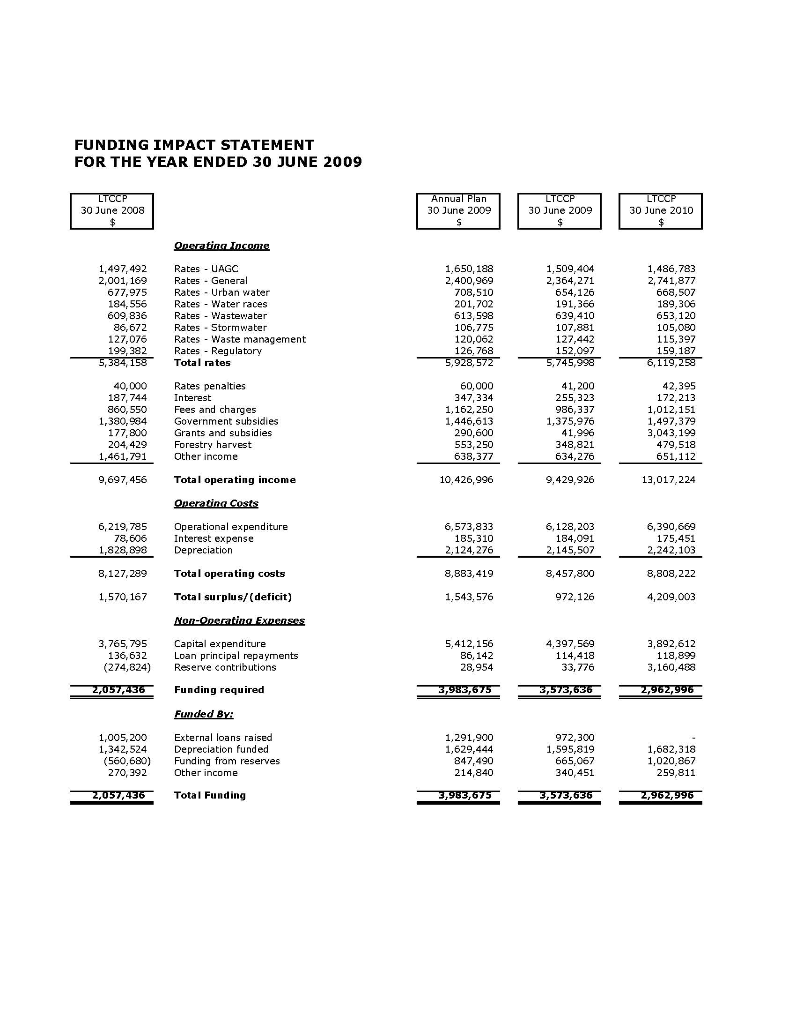

Rates & Charges 2008/09

These rates and charges should be read in conjunction with the Funding Impact Statement on the previous two pages.

General Rates | GST Inclusive
Urban Residential | 0.54245 cents in the $
Urban Industrial | 3.62141 cents in the $
Urban Commercial | 2.32283 cents in the $
Rural > 10 ha | 0.15453 cents in the $
Rural Commercial | 2.19216 cents in the $
Rural Industrial | 1.91422 cents in the $
Rural < 3 ha | 0.22350 cents in the $
Rural 3 – 10 ha | 0.11207 cents in the $
Urban Smallholdings | 1.06047 cents in the $
Regulatory & Planning Services | 0.00818 cents in the $ of capital value
Uniform Annual General Charge | $513.12
Water
Metered | $341.06
Serviceable (Half Charge) | $170.53
Metered Water in Excess of 300 cubic metres | $1.50 per cubic metre
Water Race
Taratahi Water Race
Class A | $8.40410 per hectare
Class B | $1.68080 per hectare
Class C | $67.56870 per hectare
Rural Water Services Rate | $140.50
Carrington Water Race
Class A | $41.20100 per hectare
Class B | $8.24020 per hectare
Class C | $67.56870 per hectare
Rural Water Services Rate | $175.00
Stormwater | 0.07077 cents in the $ of land value
Wastewater
Urban | $303.70
Rural | $303.70
Refuse Collection
Refuse Collection & Recycling – Residential | $65.54
Refuse Collection & Recycling - Commercial | $65.54
Schedule of Fees & Charges 2008/09

User fees and charges are used to recognise that there is a private benefit from the operation of a variety of services provided by Council to the community. User fee revenue reduces the rate revenue required to be collected from ratepayers.

The following schedule of fees and charges are for the 2008/09 year.

Health Licences
Café’s, Restaurants, Takeaways, Hairdressers, Catteries/Kennels | $75.00
Supermarket & Food Manufacturers | $100.00
Mobile Shops | $75.00
Motels | $75.00
Offensive Trade, Sale Yards, Camping Grounds | $100.00
Hall (Inspection Services) | $55.00
Noise Control – Recover all reasonable costs associated with second and subsequent noise complaints investigated.
Noise/Health related complaints under the Resource Management Act 1991 and Health Act 1956 – Recover all reasonable costs associated with investigating/resolving the matter.
Gambling Venue Applications | $75.00
Resource Consent Fees (Deposit Only)
Land Subdivision
- 2 to 4 lots | $1,000.00
- Plus each additional lot thereafter | $100.00
- Additional processing time above 5 hours – per hour | $70.00
District Plan Changes (Applicants are required to meet the full cost of processing applications.) | $5,000.00
Notified Resource Consents (Applicants are required to meet the full cost of processing applications.) | $1,700.00
Application for Land Use of a Minor Nature (ie. Relocated dwelling, building setback dispensation) | $300.00
Change or cancellation of consent conditions under Section 127 Resource Management Act. | $500.00
Certificate of Compliance & Any Other Certificates eg, Sec 226 | $300.00
Section 223 & 224 Certificates | $300.00
Monitoring Compliance with Resource Consents Up To | $1,000.00
District Plan | $85.00
Land Information Memorandum | $150.00
Land Information Memorandum – Urgent Service | $200.00
Other External Reports | Actual Cost
Infrastructure Contribution | $5,625.00
Roading Contribution – Urban | 2% of land value + GST
Roading Contribution – Rural | 3% of land value + GST
Recreation Reserve Levy – Urban | 3% of land value + GST
Recreation Reserve Levy – Rural | 2% of land value + GST
Rural Effluent Field Assessments  Labour in excess of 2 hours charges at $13.00 per 15 minutes | $105.00 per hour
Monthly Building Consent Lists | $10.00
Service Fees
Water Connection | Actual Cost
Sewer Connection | Actual Cost
Administration Fee | 50.00
Combined Sewer & Water Connection | Actual Cost
Standard Vehicle Crossing | Actual Cost
Applications for Water Race Draw Off | 56.25
Clearing Sewers (Property owner boundary to main) | Actual Cost
Road Reserve Damage Bond (Relocated Dwellings) | 500.00
Damage to Road Reserve | Actual Cost
Transfer Station Entry Fees
General Refuse
Car Boot | $12.00
Small Trailer, Ute up to 1.8m x 1.2m x 0.4 high | $25.00
Any load after this weight charged at $144.00 per tonne
Car Bodies – Stripped | $25.00
Greenwaste
Car Boot | $5.00
Small Trailer, Ute | $10.00
Large Trailer/Medium Truck less than 2 tonne | $20.00
Large Truck up to 6 tonne | $40.00
Any larger loads at the discretion of Council’s Operator
Dog Registration
Before 1 August
Urban – Entire Dogs | $68.00
Urban – Spayed/Neutered Dogs | $47.00
Rural – Non-neutered & Neutered Dogs – first two dogs, per dog | $47.00
Rural – Non-neutered & Neutered Dogs – all remaining dogs, per dog | $23.50
For certified seeing eye or hearing dogs, a fee of 50% of those stated above.
After 1 August – 50% of the fee will be added as penalty
Impounding Fees
Dogs, Sheep, Goats | $30.00
Cattle, Deer, Horses and all other animals | $60.00
Droving Charge – calculated on actual cost including labour and plant hire.
Sustenance Fee – Per Day | $5.50
Outdoor Swimming Complex
Entry Fee – Adult/Child – Per Person | $2.00
School Groups – Per Child Per Season | $5.00
Season Ticket (20 swims @$1.50) | $30.00
Cemetery
Plots
- Lawn | $500.00
- Child Under 1 Year | $100.00
- Child 1 to 15 Years | $150.00
- Cremation | $150.00
Extra Depth Charge | $30.00
Interment
- Lawn | $600.00
- Cremation | $100.00
- Child Under 1 Year | $100.00
- Child 1 – 15 Years | $150.00
- Servicemen | $350.00
- Widows of Servicemen | $550.00
Out of Town Burial Fee | $750.00
Saturday Burials | $850.00
Saturday Burials – Out of Town | $1,000.00
Disinterment | Actual Cost
No Burials on Public Holidays
Park Fees
Association Football – Per Ground | $500.00
Cricket Association | $835.00
Athletic Club | $500.00
Howard Booth Squash Club | $11.25
Carterton AFC | $56.25
Grazing Rights – General | $11.25
Rentals – Pensioner Housing Units
Porritt Place – Unit Per Week | $67.00
Dudson Place – Single Unit Per Week | $70.00
Dudson Place – Double Unit Per Week | $80.00
Fisher Place – Unit Per Week | $100.00
Wakelin Street – Single Unit Per Week | $100.00
Wakelin Street – Double Unit Per Week | $112.00
Carterton Exhibition Centre
For community groups using either facility on a regular basis | $8.50
For community groups using either facility on a sporadic basis | $12.00
For commercial users | $20.00
For the Horticultural Society per show | $30.00
Daily Rate | $85.00
Use of the Community Notice Board – Community Groups | Free
Use of the Community Notice Board – Commercial & Private | $5.00 per day
Holiday Park
Tent site and non powered site (2 persons) per night | $20.00
- Additional person per night | $5.00
Powered sites (2 persons) per night | $25.00
- Additional person per night | $5.00
Cabins – Peak Season Rates May Apply
- Budget Cabin (2 persons) per night | $30 - $35.00
- Fully Self-Contained Cabin (2 persons) per night | $70 - $90.00
- Additional Adult per night | $10.00
- Additional Child per night | $5.00
Library
Rentals
- Fiction Books | .50
- Magazines | .50
- CD’s & Videos | $2.00
Fines
- Adult Book – First Week | .50
- Per Week Thereafter | $1.00
- Children’s Books – First Week | .20
Reserves | .50
- Per Week Thereafter | .70
Inter-loans
- Per books, article or subject request | $5.00
- Charges from Other Libraries (At Cost - $2 non-refundable in advance $3.00 on delivery)
Replacement Cards | $2.00
Lost Library Book – Replacement Cost
Photocopying – Per Page
- A3 | .40
- A4 | .20
- School Homework | .10
- Double Sided – Add 10 cents per page to the above
- 20 or more copies – Librarian’s Discretion
Laminating – Per Page
- A4 | $2.00
- A3 | $3.00
Administration
Photocopying – Per Page
- A3 – Black & White | ,40
- A4 – Black & White | .20
- Double Sided – Add 10 cents per page to the above
- A3 – Colour | $4.50
- A4 – Colour | $2.50
Laminating Per Page
- A3 | $2.00
- A4 | $1.50
Rubbish Bags | $2.00
Replacement/Additional Recycling Bins | $11.00
Rating Information Schedule | $15.00
Street Index | $55.00

Building Consent & PIM Fees

Classification | PIM Fees | Total Fee Excluding BRANZ & DHB Levies
Minor Work
Solid Fuel Heater | $61.00 | $189.00
Minor Plumbing Work, eg. fittings alteration | $122.00 | $250.00
Minor Drainage Work, eg. drain alteration | $122.00 | $250.00
Drainage Work, eg. new minor , subdivision services and common drains | $122.00 | $641.00
Drainage Work, eg. new effluent disposal system | $122.00 | $543.00
Sheds, Garages, Conservatories, etc
Garden Sheds, Retaining Walls, Carports | $122.00 | $378.00
Decks, Swimming and Spa Pools, Conservatories, Pergolas and other minor works | $122.00 | $378.00
Minor Farm Buildings, Hay Sheds, Covered Yards 1 – 6 bays, etc | $183.00 | $439.00
Larger Farm Buildings (Covered Yards, Woolsheds) no plumbing or drainage | $183.00 | $634.00
Larger Farm Buildings (Covered Yards, Woolsheds) with plumbing or drainage | $213.50 | $958.00
Proprietary Garages Standard | $183.00 | $439.00
Proprietary Garages with Fire Wall | $183.00 | $537.00
Proprietary Garages including sleep-out – no plumbing and drainage | $183.00 | $537.00
Proprietary Garages including sleep-out – with plumbing and drainage | $183.00 | $732.00
Garages Custom Design | $213.50 | $567.00
Garages Custom Design with plumbing and drainage | $213.50 | $763.00
Residential Re-pile | $122.00 | $378.00
Residential Demolition | $122.00 | $378.00
Residential New Dwellings
Single Storey Brick Veneer Urban | $396.50 | $2,123,00
Single Storey Brick Veneer Rural | $396.50 | $2,562.00
Single Storey Weatherboard Urban | $396.50 | $2,220.00
Single Storey Weatherboard Rural | $396.50 | $2,684.00
Single Storey Stucco/Texture Coating/Ply/Steel/Block Urban | $411.75 | $2,379.00
Single Storey Stucco/Texture Coating/Ply/Steel/Block Rural | $411.75 | $2,867.00
Multi Storey Brick Veneer Urban | $549.00 | $2,367.00
Multi Storey Brick Veneer Rural | $549.00 | $2,806.00
Multi Storey Weatherboard Urban | $549.00 | $2,464,00
Multi Storey Weatherboard Rural | $549.00 | $2,928.00
Multi Storey Stucco/Texture Coating/Ply/Steel/Block Urban | $564.25 | $2,623.00
Multi Storey Stucco/Texture Coating/Ply/Steel/Block Rural | $564.25 | $3,111,00
Transportable Dwelling – Yard Built | $244.00 | $1,867.00
Note: Double units charges at single unit rate plus 50%. Dwellings with multiple cladding types are charged at the Stucco/Texture
Coating/Ply/Steel/Block rate.
Residential Dwelling Additions & Alterations
Internal Alterations | $122.00 | $378.00
Internal Alterations with plumbing and drainage | $122.00 | $476.00
Single Storey Brick Veneer | $122.00 | $793.00
Single Storey Brick Veneer with plumbing and drainage | $122.00 | $988.00
Single Storey Weatherboard | $122.00 | $891.00
Single Storey Weatherboard with plumbing and drainage | $122.00 | $1,086.00
Single Storey Stucco/Texture Coating/Ply/Steel/Block | $152.50 | $1,110.00
Single Storey Stucco/Texture Coating/Ply/Steel/Block with plumbing and drainage | $152.50 | $1,305.00
Multi Storey Veneer | $183.00 | $952.00
Multi Storey Veneer with plumbing and drainage | $183.00 | $1,147.00
Multi Storey Weatherboard | $183.00 | $1049.00
Multi Storey Weatherboard with plumbing and drainage | $183.00 | $1,244.00
Multi Storey Stucco/Texture Coating/Ply/Steel/Block | $213.50 | $1,269.00
Multi Storey Stucco/Texture Coating/Ply/Steel/Block with plumbing and drainage | $213.50 | $1,464.00
Note: All residential additions with multiple cladding types are charged at Stucco/Texture Coating/Ply/Steel/Block rate
Relocated Residential Dwelling
Note: If Relocation includes alterations and additions, add alterations and additions rate as above.
Relocated Residential Dwelling Urban | $427.00 | $1,098.00
Relocated Residential Dwelling Rural | $427.00 | $1,098.00
Commercial/Industrial
Use Commercial rate for large subdivision service installations
Single Storey Shop Fit Out | $152.50 | $787.00
Multi Storey Shop Fit Out | $152.50 | $982.00
Single Storey Multi Unit Apartments/Motels | $396.50 | $1,140 plus $293 per unit
Multi Storey Multi Unit Apartments/Motels | $549.00 | $1,684 plus $488 per unit
Minor Commercial Work, eg. signs/shop fronts/minor fit outs – no plumbing and drainage | $167.75 | $500.00
Commercial/Industrial <$50,000 | $323.30 | $1,488.00
Commercial/Industrial $50,000 - $100,000 | $445.30 | $2,074.00
Commercial/Industrial $100,001 - $150,000 | $567.30 | $2,660.00
Commercial/Industrial $150,001 - $250,000 | $689.30 | $3,245.00
Commercial/Industrial $250,001 - $350,000 | $811.30 | $3.831.00
Commercial/Industrial $350,001 - $500,000 | $933.30 | $4,416.00
Commercial/Industrial $500,001 - $1,000,000 | $933.30 | $4,807.00
Commercial/Industrial/Agricultural > $1,000,000 | $749.70 | $4,807 plus $288 per $100,000 value

Other Charges (GST Inclusive)

- BRANZ Levy - $1.00 per $1,000 and DBH Levy - $1.97 per $1,000 GST inclusive for work $20,000 or more.
- Unscheduled building, plumbing and drainage inspections $97.60.
- Structural Engineering or Fire Engineering Assessment/Peer Review cost plus 10%
The building consent fee does not include the cost of any structural or fire engineers assessments which may be required.
- Compliance Schedule change $122,00.
- Inspection hourly rate $122.00
- Re-inspection fee $97.60 per inspection.
- Certificate of Acceptance – Building consent fee for the applicable building payable on lodgement plus $122.00
- Reassessment fee (amended plans) $130.00 lodgement fee (includes half hour assessment) plus $122.00 per hour over and above first half hour.
- Building Warrant of Fitness audit inspection fee – Actual cost at $122.00 per hour.
- Vehicle crossing bonds will be assess for each application where required.
- Street, crossing, footpath and berm damage bond for buildings removed from site $500
- For land use development for residential, administrative, commercial and industrial purposes, $5000.00 plus GST per unit for linking with public infrastructure and services; plus 0.5% of the assessed value of any building development in excess of $1,000,000 plus GST. The assessed value of the development will be based on the estimated value of the building as stipulated on the building consent application.
- For land use development for additions and alterations for administrative, commercial or industrial purposes that connects with public infrastructure and services, 0.5% of the assessed value of any building development in excess of $50,000 plus GST. The assessed value of the development will be based on the estimated value (excluding GST) of the building as stipulated on the building consent application.
- The cost of forming of the parking spaces where a waiver from the District Plan parking requirements is sought, the cost of forming a parking space is deemed to be at the following rate per space $5000.00 plus GST.
- Access onto public road shall be designed or constructed in accordance with the provisions of Chapter 32 Appendix 5 at the stage of land development.

Trade Waste

Administration Charges

Category | Description | Rate  (Excl GST)
Connection Fee | Payable on application for connection to discharge. | At Cost
Compliance Monitoring | The cost of sampling and analysis of Trade Waste discharge. | At Cost
Disconnection Fee | Payable following a request for disconnection from sewage system. | At Cost
Trade Waste Application Fee | Payable on an application for a Trade Waste discharge. | Small Business (1 – 5) staff $100  Med Business (6 – 15 Staff) $190  Lge Business (16+ staff) $370
Re- Inspection Fee | Payable for each re-inspection visit by the WWA where a notice served under the Bylaw has not been complied with by the Trade Waste discharger. | $80 per hour
Annual Trade Waste Charges | An annual management fee for a Trade Waste discharge to cover the WWA’s costs associated with for example:  a. Administration  b. General compliance monitoring.  c. General inspection of Trade Waste premises.  d. Use of the Sewerage System.  This charge may vary depending on the Trade Waste sector or category of the discharger. | Small  Controlled $90 pa  Conditional $220 pa  Medium  Controlled $360 pa  Conditional $700 pa  Large  Controlled $800 pa  Conditional $1500 pa
Rebates for Trade Premises within the District | Reduction in fees provided for in Section 150(2). Section 150(4) of the LGA states that the fees prescribed by the Council to recover more than the reasonable cost incurred by the Council for the matter for which the fee is charged. In no event shall the resultant charge be less than the Council’s sewerage charge for the equivalent period. | Discretion of Council  As calculated by Council
New or Additional Trade Premises | Pay the annual fees and a pro rata proportion of the various Trade Waste charges relative to flows and loads. | As per charges in these tables

Tankered Waste Charges

Tankered Waste | Set as a fee(s) per tanker load, or as a fee(s) per cubic metre, dependent on Trade Waste category. | $120 per cubic metre or tonne (1000kg)
Toxicity | Payment based on the defined form(s) of the toxic substance(s) $/kg and/or $ per cubic metre. | Not currently accepted by WWA

General Information

Elected Member Directory

Name |  | Phone Number | Email Address
Gary McPhee  Mayor |  | 0274 575 363 | mayor@cdc.govt.nz
Elaine Brazendale  Urban Councillor |  | 06 379 6899 (H)  0274 413 557 | brazendales@infogen.net.nz
Ruth Carter – Deputy Mayor  Urban Councillor |  | 06 379 7467 – Fax  027 379 7467 | RutheCarter@hotmail.com
Barbara Durbin  Urban Councillor |  | 06 379 6860  027 493 0846 | barbdurbin@xtra.co.nz
Chris Engel  Rural Councillor |  | 06 379 8560  021 1835 899  06 379 8562 - Fax | waihakeke@xtra.co.nz
Jill Greathead  Rural Councillor |  | 06 379 6717 (H)  06 379 6193 (W)  027 4884 376  06 379 6198 - Fax | jill@enzedpcs.co.nz
William (Bill) Knowles  Urban Councillor |  | 06 379 8730  06 379 8711 - Fax | williewitch@xtra.co.nz
Brian Poulsen  Urban Councillor |  | 06 379 6112 | polecats@clear.net.nz
Grant Smith  Rural Councillor |  | 06 379 5341  021 468 264 | smithspread@xtra.co.nz

Staff Directory

Chief Executive Officer
Colin Wright

Support Services Manager
Julie Hallam

Operations Manager
Garry Baker

Planning & Regulatory Manager
Milan Hautler

Recreation & Community Services Assets Manager
Brian McWilliams

Carterton District Council
Administration Building
Holloway Street
Carterton

Opening Hours Monday to Friday
8.30 am to 4.30 pm

Phone 06 379 6626
Fax 06 379 7842
Email info@cdc.govt.nz

